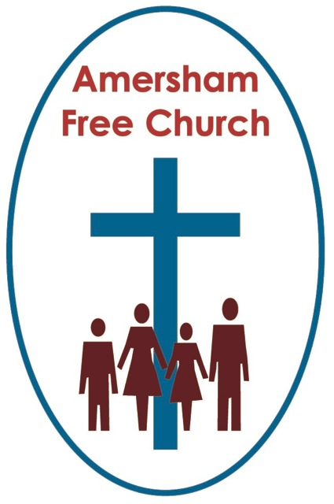
James 3.13-18
Mark 9.30-37
19th September 2021

Wisdom from Above

What would you do if gifted with a hundred thousand dollars?!
Well, that was the joyful dilemma that came Karen Armstrong’s way in 2008. She had become a well-known and much respected writer, especially on interfaith issues, and the TED organisation gave her the money so she could spend it on just one, life changing, idea. She chose ‘compassion’ as that idea because, after being immersed in the three Abrahamic faiths of Judaism, Christianity, and Islam, for so long she sees ‘compassion’ as being a common thread in each. So, in 2009 Karen Armstrong used her TED prizemoney to set up her new organisation called Charter for Compassion.
We sometimes talk of a Golden Rule. One found in many faiths, that we should not do unto others that which we wouldn’t want to have done to us. Or put more positively, with compassion at its heart, we should treat one another as we ourselves would love to be treated.
And ‘compassion’ is central to James’ thoughts about wisdom which was today’s first reading.
Parts of James 3 sounds as if he is on playground duty breaking up a spat between the boys in Year 5! So, he asks the rather pointed question, in a tone that seems somewhat exasperated: Which of you is wise or learned?
Sensing that every hand might, mistakenly, go up at this point he makes it clear that their behaviour is anything but wise. They are jealous, full of rivalry and have got into the habit of slandering each other. And these are the people who go to church!!
Stop it he says. This is not The Wisdom from above. This is not the way of a wise, loving, and compassionate God.
James seems here to be invoking an idea about Wisdom contained in the Jewish scriptures. The idea Erna talked about in one of her sermons over the summer.
In passages like Proverbs 8 Wisdom is spoken of as God’s Companion, making visits to earth seeking people in whom to dwell.
It’s an entrancing image. This seeking out by Wisdom of a receptive life where it can make its home and bring something of God’s Word and Spirit to that person.
No wonder we sang in church last Sunday: Spirit of the Living God fall afresh on me. May God’s wisdom dwell in my heart and life, be a welcome guest in my mind and rationale, direct my thinking and living so I may reflect something of God’s love and compassion.
Sometimes we get it all a bit confused and in claiming we are wise we stubbornly stand our ground as being ‘right’ and those around us are wrong. Such strident opinions can even look attractive, giving off the vibes, as they do, of rock-solid certainties and cast-iron beliefs. History abounds with people who thought they were in the right, to the extent they were even prepared for die or kill for the wisdom they so passionately thought they possessed.
That’s not wisdom as described by James in chapter three of his letter. He speaks of it in terms of being peace loving, considerate and open minded. He says Wisdom from Above is straightforward, sincere, rich in compassion and in deeds of kindness.
The word compassion teaches us so much about God because it describes someone who shares our suffering alongside us.
Sympathy is a great word too, yet it’s a little more detached. It sort of ‘looks on’ whereas compassion comes up close and holds out a hand.
The Bible is drenched in the idea that God is compassionate. God is not stoical like so many of the Greek deities of the ancient world, hard and detached from the everyday joy and pain to be found in any community. Instead, this is a God who weeps for his people, longs to embrace them, to be their guide and comforter. The God who is both our Father and Mother.
St Martin in the Fields has an inspiring social ministry in central London. For years now it’s been the beneficiary of the BBC’s annual Christmas Appeal. It offers short term accommodation, counselling, and support to the homeless and vulnerable who find the streets of the capital are a hostile place to be.
Sam Wells, the Vicar of St Martins, in his book The Nazareth Manifesto, talks of his own journey in understanding the ministry of this world-famous church. He acknowledges that sometimes the sort of care their Homeless Centre offers can look and feel ‘top down’. It’s something ‘done for’ those who come through the doors. There is a certain sort of ‘power’ we all acquire when we ‘look after’ other people. Sam Wells says he’s come to see it as vital that St Martins comes ‘alongside’ people instead of standing over them. He believes the most important word to describe any ministry of compassion, that seeks to take its inspiration from the nature of God, is the word with. Compassion is when we are ‘with’ someone in their pain, alongside and sitting next to them.
That’s not easy, and in some contexts, especially medical, say fixing a broken leg, help is probably best given in a clear-headed manner with an element of detachment.
Yet, in the context of his church’s ministry, Sam Wells is clear that sitting ‘alongside’ those who turn to St Martin’s for help is a vital part of the compassion being offered.
I suppose all of that resonates with the much-loved notion of God as Emmanuel, meaning God is WITH us. So, we seek to be WITH one another.
Desmond Tutu has written: None of us comes into the world fully formed. We would not know how to think, or walk or speak, or behave as human beings unless we learned it from other human beings. We need other human beings in order to be human. I am because other people are.
I don’t think James thought members of his church had really got the message about compassion.
He observed a sort of game of one upmanship that saddened him. This jealousy, rivalry and slander wasn’t wise at all, and it destroyed community. This way of thinking and acting meant you built yourself up at someone else’s expense. You used power to push people down.
Making another person feel small must surely be one of life’s most hollow victories and it’s not the way of Jesus.
Yet, in today’s Gospel reading it seems to be the way of some of Jesus’ disciples.
As they approach Capernaum, their Galilean HQ, rather like a suspicious parent who has just caught half the conversation from the back seats of the car, Jesus asked them what they had been talking about on the journey.
They’d been found out and sheepishly admitted they had been arguing about which of them was the greatest. So, no matter how much Jesus models the upside-down values of The Kingdom of God, about the first becoming last, or the necessity to trust with child-like faith, some of those closest to him still thought of faith in terms of power, authority, and privilege.
I was impressed the other day listening to the biographical programme Great Lives on the radio. Peggy Seeger was recalling the life of her husband of 30 years, folk singer Ewan MacColl and she said to Matthew Paris, the presenter, that actually her husband would never have dreamed of thinking of his as a ‘great life’ – that’s just not the terminology he would ever have used. He just thought of his life as an ordinary one, spent among ordinary people he loved and respected. He was ‘one of them’, and their stories were central to his folk singing.
In a way all of this is about how we fill the spaces in our lives.
Some of those disciples thought they were so grand they could fill the space completely by themselves. I suspect many in James’ congregation felt the same. No room in life spaces for other people.
I, inadvertently did that the other day whilst driving, just a stone’s throw away on the Rickmansworth Road. I wasn’t thinking and as we queued to get onto the roundabout, I filled up a space, rather too quickly and thoughtlessly, that stopped people either leaving or entering the car park. No one else could utilise that space, I had stopped them because I was filling it up myself. Well, it was a hot day and people had their car windows down, and I had my clerical collar on. So, shamefaced I heard someone in the car I was blocking say, Look at him taking up all the room, and he’s a Vicar as well! It’s always best to drive with your collar off!
I think the God we serve, who is full of compassion, always makes room for us in the circle. God makes space for you and I. This is what Bill Loader, the New Zealand theologian says: God’s very nature is self-giving, choosing not to take up the whole space, giving space for others to be, evolve and grow.
Humility. Kindness, Compassion – these says James, reflect the character of God and are for us, Wisdom from Above.
May it be so, in the name of him who always makes space for us and welcomes everyone into the circle of his love. Amen.
Ian Green, Amersham, 9th September 2021

