**Now I see!**

*Genesis 1:1-5, 27,Acts 9:1-16*

*4th May 2025*

We are still in the season of Easter, the time of Resurrection; A time of renewed hope and great rejoicing. As far as we are concerned the weeks of Lent are behind us and we do not expect to come across someone who is fasting for days as a result of his encounter with the risen Christ. But that’s what’s happened to Saul of Tarsus, one of the chief persecutors of the followers of the new Way. So, today we will reflect on this experience, not by way of a traditional sermon, but by looking at some artwork together. I propose to do this in the firm conviction that, as I said before at another place - art can be the result of divine inspiration and therefore it is capable of mediating the sacred to us in the same way as written or spoken word or music, or silence can. That, artistic interpretation of biblical texts may be a useful extension of our grappling with Scripture as it may challenge our well-used assumptions and help us to arrive at new & fresh insights. One way of doing this is to look for things in the artwork the artists leave out of the Biblical text, add to it or imaginatively replace under their own inspiration.

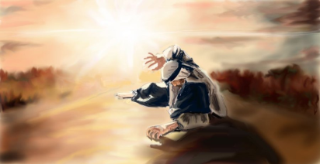

With this in mind, we come to our first picture, which shows the Apostle Paul before he became an apostle. Normally, we can detect the subject matter of any painting by seeing what’s in the geometric centre of the canvas. In this instance, there is no mistaking who is the main protagonist. Out of a busy story related in Acts 9 – as we heard in our reading – with plenty of other people being involved, our artist is choosing to focus on the figure of Saul. And only on him. No one else is to be seen. This is an immensely private affair.

This is a technique used by other artists and film makers too. Perhaps you remember one of the many TV adaptations of Jane Austin’s *Prime and Prejudice.* There is a dreamlike sequence in it when Mr Darcy and Elizabeth Bennett first dance together. As they dance the music keeps going but the crowd of the dance floor gradually fades out around them and it seems as if Mr Darcy and Lizzie Bennett are there totally alone engrossed in their own world.

Well, I think this is the kind of thing our artist had in mind. He captures the moment just after Saul falls to the ground having the shock of his life and being surrounded by blinding light. This is about him and Jesus and even Jesus is missing from the picture. This is about Saul and Jesus, but *it is all played out inside Saul himself*. There are many different ways of meeting God but the outcome is always the same: an inward change. It may result in coming to faith in the first place, or taking a sharp, new, deeper turn on the faith journey in a dramatic way. Some people can recall the exact moment when it happened to them, others testify to a gradual awakening to faith, yet others remember with thanksgiving their very upbringing by devout parents or a nurturing church community that set them on the path of faith. But probably most of us would agree that it is an intensely personal event, quite difficult to put into words.

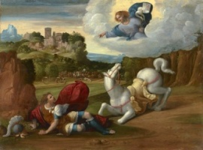

Our next picture is by the 16th c Italian painter Benvenuto Tisi, who captures the same moment in Saul’s life. Painted in 1542 the painting shows three dominant figures, forming a kind of triangle, but applying our previous criterion, we may find it difficult to decide where the artist’s emphasis lies. Saul is not in the centre, Christ is not in the centre, the horse is not in the centre, the other people are hardly visible, they only constitute the background. In fact, you could say that the centre is an empty space. But is it really empty? Not really – judging by the body language and facial expressions of both Saul and the horse, the space is not empty; it has been filled with the word of Christ: ‘*Saul, Saul, why are you persecuting me?’* A Word in a void! Conjuring up that very first Word in the Creation story we heard in our first reading: ‘*Let there be…’* and there was! And just as there, here again on the Damascus Road a new creation takes place at the behest of the divine Word. Later, the Apostle Paul himself acknowledges the connection when he writes to the Corinthians: ‘*For anyone united to Christ, there is a new creation, the old order has gone, a new order has already begun. (2 Cor 5:17)*

And sure enough, the artist incorporates this whole idea too. The soldier’s helmet at the bottom left of the painting indicates the past; the violent, self-assured crusader who was going to hunt down the followers of the risen Christ. Saul dumfounded and terrified fallen on the ground is the present, but the invisible Word in the centre points to the future saying: ‘*Get up and go… and you will be told what you have to do.’*

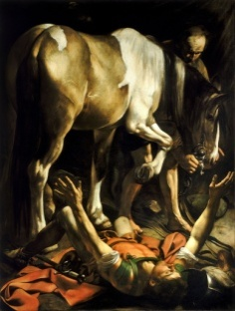

Caravaggio’s take on the subject in our next picture, comes from1601. Caravaggio has been the subject of much controversy both in his life time and since. And this picture had the same treatment by some art historians and religious viewers. Some of the objection seems to be that it ‘neglects the biblical narrative’. But then you could say that we look at the works of artists, because we believe they can show us something that perhaps words cannot. Pope Francis said *“We need artists to help us ask questions about time and about purpose. Are we pilgrims or wanderers? Does our journey have a destination, or are we directionless?” Artists have the task of helping humanity not to lose its way.”*

One of the most striking thing about this depiction is that it puts the horse in the most dominant position, whereas there is no mention of a horse in the biblical narrative. It may be the artist’s way of saying that the event is happening on a journey. Meeting God is possible at any time of life, at any point of our life journey. It is said about journeys of pilgrimage that they are ways of facing oneself, losing oneself, then finding oneself again in a different form. This seems to be true for Saul, who is depicted here quite unusually. He is lying on the ground on his back in the most vulnerable position being in danger of trampled on by the horse –a position, which, using the foreshortening technique, - is a major artistic achievement. His arms are outstretched and eyes closed. He is enveloped in light, yet finds himself in darkness. This is another great feature of Caravaggio’s paintings: the use of light and darkness, which are, of course also great Biblical themes. Where does the light come from? In the picture it comes from the top right hand corner. *Where does our light come from? In what light do we see the world?*

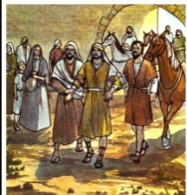

Well, Saul is now in darkness, but no longer on his own with his tremendous experience. Here, in this picture, he is upright again in well-lit bright surroundings having just entered Damascus. But what a difference! The former leading light and commanding personality is now at the mercy of those he used to order about; he cannot take a step on his own, they have to lead him by the hand. Meeting God may be a very personal, even private affair, but its intensity may not last long. With his blind eyes Saul has to face a new reality, which may be totally alien to him. Nobody can follow Christ on their own, this picture seems to say. The uplifting, or down-throwing experiences will teach you your need of others and afterwards there may be the great task of learning to relate to them in a different way. Saul was clearly a man of initiative, but he was also a man trained in obedience. He obeyed the Law all his life according to his understanding. To his credit he is now obeying the divine Word coming through Christ without questioning.

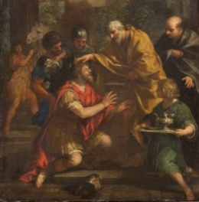

Which is more than can be said about Ananias, one of the central characters of our final picture. It was painted by Ciro Ferri, the Italian painter and sculptor in 1660 under the title: *Ananias Restoring Saul’s vision.* Ananias is nobody special. We don’t hear of him either before or after this particular event. All we know that he is a disciple of Christ and that he is open and listens inside to the voice of Christ. Yet, he is chosen to do a simple but crucial task, which sets in motion world-changing events. It is a sobering thought though that, in his capacity as an insider, a disciple he needs more persuasion to obey the Word than the arch enemy outsider, Saul. Isn’t this often the case with us, followers of Christ? We need as much transformation of our hearts as those we reckon to be outsiders, or even our enemies. But, of course, Ananias does obey and in the strength of his Risen Lord he is able to do the kind of healing, Jesus himself did in his life time. Saul’s eyes are opened. A great visual encouragement to us all: with an open listening heart we are all called to do some simple ‘doeable’ tasks, even if we don’t realize the full extent of their effects. And we are all called and enabled to heal each other on our journey of faith together. Let’s pray that it may be so.

*Erna Stevenson*