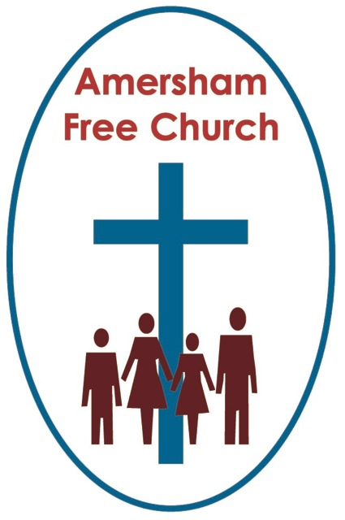
11th July 2021
Ephesians 1.3-14
Mark 6.14-29

Two Different Celebrations
Minister: Lord God –
our prayer is that the written word
will point us to Christ,
the Living Word.
All: So in his name we pray
and for his voice we listen. Amen.
At first glance there seems little to connect this morning’s scriptures.
One describes what surely must have been one of the worst birthday parties ever. The other may come across as a rather dense theological treatise.
In their own way both are celebrations. One was Herod’s birthday the other forms the customary celebration always found at the beginning of an ancient Greek letter. The tradition in those far off days being you began giving praise for the good fortune or position of those to whom you were writing.
Herod’s celebration turned into one of hate and death. Paul’s celebration of life at Ephesus was one of love and joy.
The gruesome telling of Herod’s birthday night of terror comes about in Mark as this ruler hears of Jesus and mistakes him, probably with a bad conscience, as John the Baptist risen from the dead. Mark then proceeds to fill in the back story of how John died.
Maybe this narrative had done the rounds and was well known, so much so that in its constant re-telling it became more and more terrible. Now, in its written form, it is truly horrific.
Herod was the son of Herod the Great, King around at the time of Jesus’ birth, and famous, in his case, for the Slaughter of the Innocents.
Herod’s family was complicated. He divorces his wife to marry his brother’s wife. This family is divided within and faces heavy criticism without. Yet, for all that Herod finds John the Baptist, who was deeply critical of this marriage, to be a fine preacher and one he enjoys listening to. Herod is conflicted about John, so although he’s imprisoned him, he also wants to protect him.
It was on Herod’s birthday, of all days, that things run away with him. In what seems to be a raucous party, with wild dancing that comes across as close to exploitation, Herodias – Herod’s wife who hated John and his criticism of her marriage, takes advantage of Herod’s oath to her daughter to give her whatever she asked for as a gift.
Mother and daughter connive and ask the king to make good on his word and give them the head of The Baptist.
This celebration had, for Herod, turned into a nightmare and for John it had become his day of execution.
Justice wasn’t celebrated that day. Neither was love, compassion, or mercy. Instead, through trickery and fickleness, Herod, like his father before him, ordered the slaughter of an innocent.
In this story, the only one that Mark tells in his gospel in which Jesus isn’t the main character, we do have a sense of things to come in the Jesus’ narrative.
For just like his cousin John the Baptist, Jesus too will be sentenced to death by a ruler, Pilate, who seems to hold for him a grudging respect, yet – just like Herod, Pilate is convinced by his family to make Jesus expendable.
Both Jesus and John lived, or actually died, as a result of their truth telling.
John told Herod his marriage crossed a line in the Jewish law and Jesus told Pilate nothing, thereby accepting the crowd’s title that he was King of the Jews, a title willingly given by those who lived at the margins, whose case, he championed.
Today we might describe this as Cancel Culture. If you disagree with someone why not just cancel them out, block them on your phone or unfriend them on Facebook? No need to engage or dialogue, just get rid of them.
Unlike her husband, Herodias never engaged with John to find out why he objected to her marriage, instead she just engineered his disappearance.
We don’t treat others as fully human when, if they disagree with us, all we want is to be rid of them.
Although none of us would condone ‘Hate Speech’, surely as an expression of our faith that all are made in the image of God, don’t we advocate ‘Free Speech’, even when it means that others express an opinion that differs from ours.
As I was writing this sermon my email pinged, as it often does, with a message from URC Church House that a fellow minister had died. As I read the notice it told me that The Revd Glyn Eatock had retired in 1999 to Lytham St Anne’s where, and here I quote, ‘he became a strong voice in his local congregation and in Amnesty International’.
Baptists and URC Christians have, traditionally, been some of the most faithful supporters of Amnesty since its inception. For part of our history is that at times others have tried to silence our voices. When non-conformist Christians like us advocated that worship could be done with homegrown prayers or reading the Bible in English, we were thrown out of churches and even burnt at the stake. So, I wasn’t surprised, in fact I was moved to read that The Revd Glyn Eatock spent part of his retirement speaking up for those who have no voice or who have mysteriously disappeared because they have tried to speak truth unto power, just like Jesus and John.
In days when I used to go into London on the Tube regularly, I often saw on the escalator poster boards advertisements for ‘The Play that Went Wrong’. Well, Mark 6 describes the Birthday Party that Went Wrong too, so that as the night progressed it became a celebration of hate and death.
Now, this morning we can contrast that with Paul’s opening words in the letter of the Ephesians which are a celebration of love and life.
We used to start and finish our correspondence with conventions and phrases such as ‘Dear Richard’, and end with, ‘Yours Sincerely, Catherine’. Today, on social media, it's all a lot more informal, with texts and WhatsApp messages beginning, ‘Hi Guys’, and ending with ‘See you later’, even if you’re not booked to meet up for months. (I sense I am now showing my age in this sermon!)
Well, in Paul’s day you always began a letter with a celebratory word or two, about what you perceived was good in the lives of those to whom you were corresponding.
So, as he begins Ephesians Paul celebrates that living ‘In Christ’ means his readers feel they truly belong to the Family of the Church as adopted sons and daughters, they are forgiven through the cross and they now live meaningful and purposeful lives as siblings with God as their Heavenly Father.
Now, we might read these opening verses of Ephesians chapter One and not think that’s a big deal, but it was.
That’s because there is so much potential for conflict here.
Paul was a Jew, yet he is writing to a Gentile church in what, today we would call, Turkey. He’s very much aware that a place like Ephesus is a crossroads on an international trading route. This church, like many before and since, is going to have to live with difference in its membership. Difference in language, culture, religious background, and expectations. So, Ephesians will become a book dominated by the theme that God can make these two groups of Jews and Gentiles into one. Into one people. One congregation. One body. And one church. Unity, even in diversity, is a big theme from this letter.
Paul uses the language of his day when he says these Ephesians are so blessed that they have ‘every spiritual blessing in the heavenly realms’. Perhaps we could colloquialise it by saying, ‘what matters most in life is yours because you are seeking to live a life of love that binds you to both God and each other.
Of course, none of this is easy and we Christians often make a dreadful mess of it all. Living together with difference has always been demanding for it requires humility, patience, and gentleness. And it’s one of our main tasks as a church.
A fortnight ago I was invited by a member of the congregation here to attend a meeting, sponsored by the Council of Christians and Jews, at the Maidenhead Synagogue. Like many others I joined the gathering via Zoom.
The speaker that evening in the Synagogue was the Bishop of Reading who spoke on the Eco-challenge now facing our world. Having worked for Oxfam before her ordination she was an expert on Climate Change, and it was a fascinating talk. But what struck me and was commentated on by an audience member in the Q and A session afterwards, was that the Bishop began her talk by greeting us as her Sisters and Brothers.
It was a great beginning. An Anglican Bishop, speaking in a synagogue to an eclectic mix of people from so many traditions, and yet, recognising us all as Seekers after Truth, she embraced us as Sisters and Brothers.

That’s the spirit, I think of Paul’s celebration as he begins Ephesians. Living together with difference is tough, yet if we see God in the other, and if we listen out for the voice of the Spirit in someone else, then it’s possible.
Herodias never spoke with John the Baptist, she just spoke about him. Instead of engaging she wanted him ‘cancelled’.
Paul, on the other hand celebrates that God can bring people together and make us one.
When the Commons was bombed in World War Two Churchill insisted it was rebuilt just the way it had been not, as both the Scottish Parliament and Welsh Senate have subsequently been constructed, as debating chambers in the round.
Many thought it might have been a backward move to once again have government and opposition benches facing each other. Yet visit the Commons today and the guide will be keen to point out they are still two sword lengths apart – an early form of social distancing!
So, instead of solving difference by the sword, the issues of the day are fought overusing words. We ‘parley’ in our parliaments. We talk. We debate.
In today’s readings one celebration coped with a difference of opinion using violence. The other celebrated otherness in naming love as the common denominator that binds us all together as those made in the image of God.
I know which party I want to go to!
And may the love of God be our ongoing celebration, and the constant source of our unity today, and always. Amen.
Ian Green, Amersham, 30th June 2021.

