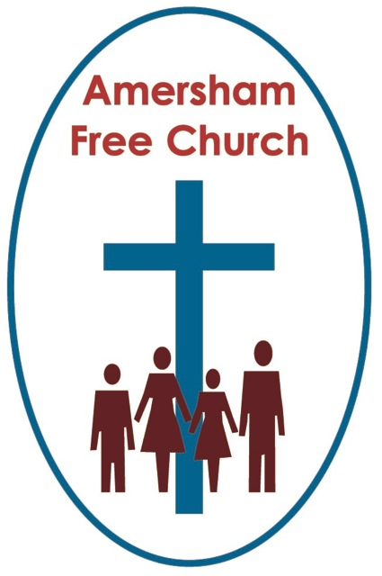
31st July 2022
Ecclesiastes 1.2, 12-14, 2.18-23
Luke 12.13-21

The Unholy Trinity of Me, Myself and I

Gracious God
May your Living Word come to us afresh this morning
So touch, we pray our minds and hearts with your grace and truth
Through Christ our Lord and in the power of your Spirit. Amen
Last week we learnt of the first thing Lee and Helen Kuchcynski, from St Helen’s, did after winning 3.6 million pounds on the lottery. Mr Kuchcynski said he went out and purchased a £17 backscratcher to replace his £8 one that had recently broken. The newspapers love a story like that!
Indeed, our news feeds constantly focus on narratives involving money. And, understandably, at first sight it seems to be the theme behind today’s gospel story of the man obsessed by his entrepreneurial dream of forever building bigger barns.
Such a parable begs questions like: what do we do with our money, alongside the equally important, yet rarely asked: what does our money do to us?
The writer of Ecclesiastes seems to be of the opinion that some of life’s questions just go round and round and come fresh to every generation. Their rather downbeat wisdom is that basically there is nothing new under the sun.

Certainly, in the current leadership debates we are hearing some very old and well-rehearsed ideas about tax and national finances.
I smiled when looking at a cartoon the other day of a couple filling up their car with petrol during those weeks when it seemed to go up by about 10 pence a litre every day. In the cartoon the husband said to his wife: Well, love, we can either fill up the car or buy Chelsea Football Club.
Here at church, behind the scenes, we’ve had discussions, just like those which will have been held in many homes, of how we are going to cope with a gas bill this winter that will be over three times higher than the one we originally budgeted for.
So, I think it’s worth saying straight away that today’s gospel story doesn’t say financial planning is wrong, it never says money is evil and certainly doesn’t imply being careful and prudent about our finances is in any way inconsistent with being a disciple of Jesus Christ.
In fact, money isn’t the real focus of the story at all. It simple illustrates that maybe the farmer, this bigger barn builder, was living a life that was not only out of balance but one that had lost focus.
Justin Welby, the Archbishop of Canterbury, hasn’t always been a clergyman. For 11 years he worked in the oil industry. In 1984 he became treasurer of the oil exploration group Enterprise Oil PLC in London, where he was concerned with oil projects in West Africa and the North Sea. And it was during this period of his life that he found the need for balance – the sort of perspective Jesus talks of in today’s parable – and so he started to attend Holy Trinity in Knightsbridge – and the rest, as they say, is history.
The Archbishop asked the question: What makes for a meaningful life?
Of course, there are many different constituent parts to any answer offered.
Money will be part of the equation because from it, good things can flow and be supported.
Perhaps an interesting, slightly ‘left field’, Trivial Pursuit question might be: What role did Mary Magdalene, Susanna and Joanna play in Jesus’ team of disciples?
Be interesting to know if you might be able to answer that because I don’t think we often speak of it. These three women basically ‘bankrolled’ Jesus’ three years of ministry. They were his financial backers. Such an important contribution yet it’s only slipped into the gospel narrative once.
They used their money well. They were generous and their support enabled Jesus to travel and preach. Judas might have looked after the cash, but Mary, Susanna and Joanna provided it.
St Paul, writing to young Pastor Timothy might have said those memorable words that: the love of money is the root of all evil. Yet he very much knew its value, setting himself up in business as a Tent Maker to earn the money that would finance his ministry. Today that fits into the label of being Bi-Vocational.
And, if you cast your mind back to an earlier story from the Hebrew Scriptures, there was another big barn builder in the form of slave turned Prime Minister of Egypt, Joseph; famous for his long-sleeved coat, sometimes mistranslated as one of many colours. It was his financial prudence, storing up grain in ever larger silos during the years of plenty that enabled the country to survive the years of famine.
So much of the bible is about providing food for the hungry, clothing the naked and giving shelter for the homeless. Whether such provision came from Temple taxation or individual philanthropy, the biblical understanding of community is one of a compassionate society in which the strong look out for the weak. And money plays its part in that. It’s a good part because money can be the agency of love.
Yet we asked the question earlier on, one that never goes away: What do we do with our money, and what does our money do to us?
It's often pointed out that into today’s story this particular builder of bigger barns loves the use of the personal pronoun. I think in three verses he says ‘I’ seven times, such as: I have not enough space, I will tear down barns, I will build bigger ones, I will say to myself eat, drink and be merry.
Someone has described such an ego centric mindset as the Unholy Trinity of Me, Myself and I.
The challenge behind today’s gospel is its interpretation because at one level self-motivation, ask any teacher writing those recent end of year school reports, is to be celebrated and maybe the character at the centre of today’s reading would have been the winner on either The Apprentice or Dragon’s Den!
Yet, when our focus is exclusively on making money and building those bigger barns it sometimes becomes clear to everyone but ourselves that we have lost the plot.
Now, all of this is, in a sense, the collective wisdom of the ages. You don’t have to be part of the Judeo-Christian tradition to either believe in balance or community when it comes to money. People of many different faiths, or no faith at all, might well advocate that we need both hard work and philanthropy.
So, what’s the specifically Christian element in today’s gospel?
Well, there are two places in the narrative where Jesus offers us either the motivation for, or the explanation of this parable.
He says in verse 15, just before he tells the story that: possessions do not give us life. And once the narrative is over he sums up its meaning in verse 21 saying this man was rich in money but poor before God.
So, maybe the key to today’s gospel is to seek to grasp what the bible means when it talks of God’s life and God’s values.
How can our life in any small way reflect God’s? How can we live a life that would please God? How can we enter into God’s life, share in God’s energy and be part of God’s purpose for our world?
The gospels offer us the life of Jesus as our guide.
Jesus, the one who weeps for others because he wants God’s abundant life to bless those on the margins.
Jesus, the one who knew the anguish of service, that it is giving that we receive.
Jesus, the one who spends a night in prayer, who at Gethsemane knows the confusion that the future often presents, and in the end walks into a new dawn trusting God even as the cross looms bigger by the hour.
Jesus, the one who believed in community so much that he kept on loving, forgiving and hoping right to his final breath.
The bible honours and celebrates such a life.
I was struck a fortnight ago by the language Bill Gates used as he announced his intention to give away even more of his personal fortune to his charitable foundation. He said he ‘vowed’ to die having fallen off the World’s Rich list.
To make a ‘vow’ sounds close to making a religious statement, it’s certainly a heartfelt statement of intent, one based on strong convictions about community and our place in it.
So, perhaps the only way for Christians to live is that we too make a vow, one of seeking to live, with the help of the Holy Spirit, as much as we are able, like Jesus.
So, in our relation to loving, in our relation to family, to work, to leisure, to church and community – and yes, even in our relation to money – we will strive to seek the mind of Christ and live like Jesus.
Perhaps on this occasion we’ll end with a word from Charles Dickens, for in his novels he too had a lot to say about money.
In David Copperfield we have that insightful quote from Mr. Micawber: Annual income 20 pounds, annual expenditure 19 pounds 19 shillings and six pence, result happiness. Annual income 20 pounds, annual expenditure 20 pounds nought and six, result misery.
Yet maybe the most Christian story he ever wrote was A Christmas Carol. In almost every respect Scrooge too was a builder of bigger barns living with that unholy Trinity of me, myself and I. Yet Dickens gave him Christmas Eve and the opportunity to change, a moment that’s missing from today’s parable. And Scrooge did change, immediately using his money to bring joy and happiness not only to his own family but also to Bob Cratchit’s. Dickens was no priest yet perhaps in a Christmas Carol he preached one of the finest sermons ever.
May it be so in the name of the Father, Son and Holy spirit. Amen.
Ian Green Amersham 29th July 2022

