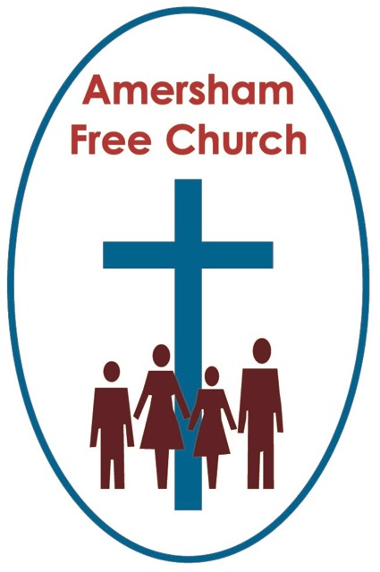

**Psalm 118   
Matthew 28.1-10**

**9th April 2023: Easter Day  
  
 The Two Marys: The First Evangelists.**

*Prayer  
Gracious God, we open the bible and long to receive your word.  
Open, we pray, our minds and hearts to receive that word with all its comfort and in all its challenge. Amen.*Some occasions call for a fanfare moment. A big statement that frames what comes next. Such beginnings grab our attention and make us sit up. Their message is: *This is important.*

At the late Queen’s committal in St George’s Chapel she had chosen two hymns to perfectly frame the service. They made a big statement as they were: *All my hope on God is founded* and *Christ is made the sure foundation.*Our late monarch spent a lifetime sending subtle messages and her choice of hymns, at this most personal of services, surely sent out a clear message of deep and committed faith and hope.

Matthew, in today’s reading, uses a literary fanfare with which he frames the story of Resurrection. For whenever Matthew puts ‘earthquakes’, either real or imaginary, into his writings it’s as if he’s saying *what comes next is of the utmost importance.*

In this year’s Gospel, Easter begins with an earthquake. An angel descends, rolls away the stone and the guards fall, as if dead, to the ground. Such is the drama of the moment.  
  
The angel then speaks to the two Marys. They become the first witnesses to resurrection. Not Peter or John, but Mary of Magdala and the other Mary.

Now, in Mark as the women report this breaking news the male disciples dismiss them, but not so in Matthew. He honours the first evangelists of the Christian Era, the two Marys; the first to speak Good News of Resurrection.

Not only that but Matthew constructs this account with great skill, for he knew his Jewish readership well.  
  
He knew that in their tradition breaking news always needed a double confirmation. Not one assurance that a document had been signed or a sight witnessed, but two.

Last year, during the centenary of the BBC, there was a programme about early news broadcasts. These were not the days of instant, rolling news. So, when a report came in, perhaps from Africa or India, it wasn’t put out until the BBC had it verified by another source. Only then were they confident in its authenticity and accuracy. A double witness was needed. And that’s what we have in today’s gospel.

The first encounter was with this shining, lightening like angel.   
  
Like the guards the colour seems to have drained from the faces of the two Marys upon seeing this messenger from heaven, so the angel reassures them, tells them not to be afraid and even invites them into the tomb to see the place where the body once lay. The angel speaks of a risen Jesus, one now going ahead of them, and instructs the women to pass on this message of resurrection and the instruction for the Galilean gathering.

Such a colliding of emotions and words. Yet it was not to end there for there was a second encounter, this one even more precious than the first, for it was with the risen Jesus himself. The message stayed the same, nothing new is added. This moment was obviously more about the encounter than the message.   
  
When I think of Easter I also sense a double confirmation.   
  
I mean the story itself inspires me with its hope and belief in new beginnings.   
  
Yet that story of Resurrection is also confirmed by the experience of Resurrection that so often comes my way.  
  
The blossoming of springtime. The rebirth of relationships when forgiveness is offered and received. The putting down of weapons and the taking up of dialogue.   
  
Are they not expressions of resurrection? Of God’s touch upon our lives, enabling us to find the peace, justice and wholeness which is God’s Good News for the world.  
  
I believe in resurrection because in so many ways it blesses our daily living.  
  
So, Matthew writes this crowning moment of his gospel by framing it with a fanfare and then underlining it with a double confirmation. For Matthew, today is a Red-Letter Day!  
  
Yet all of this could have been so very overwhelming, even terrifying.   
  
Many of us have known that sense of exhaustion that is part of bereavement. When someone dies, nothing feels quite like it did before to those who loved them most. So, the two Marys were carrying heavy burdens of grief on Easter Day. They didn’t wake up to sunshine, and perhaps neither have you on this 9th April.

We bring our whole selves to church Sunday by Sunday, and that includes our fears.   
  
And for the women at the tomb it all gets more complicated as the morning unfolds. Their fears increase.

So, it’s good to hear, not once but twice, those words of reassurance: *Be not afraid.* Spoken firstly by the angel at the tomb, and then by Jesus on the pathway. *Be not afraid.*I think it’s a central message of Easter. We hear it often in the Bible, often spoken by a God of Compassion to a worried people. Yet, it’s never more appropriate than on Easter Sunday.  
  
Because we wouldn’t want to become complicit in a *Polly Anna* faith, which somehow ignores the challenges and sorrows of everyday life. And we wouldn’t want to use Easter simply to brush our fears under the carpet, wearing a forced smile today but letting it drop tomorrow.

We come to church as we are, with sorrows as well as joys, and with worries as well as peace. And Jesus meets us here and says: *Be not afraid.*

Of course, we might well respond: *Why should I not be afraid?*

And the answer is usually about companionship, as God says: *Be not afraid, for I will be with you.*In today’s story, it’s: *Don’t be afraid. Take this news of resurrection to my brothers and say I will meet them in Galilee.*  
  
And so, on Easter Sunday the message is: *I will be with you.*

Now, we are not told to go to Galilee this morning because the Christian story of Jesus doesn’t see Easter as a full stop. In just a few weeks we’ll be gathering here on Pentecost Sunday celebrating the idea that the Spirit of Jesus lives on everyday in our world. Through prayer. Through love. Through compassion. Through those moments when women and men positively choose love over hate, light over darkness and hope over despair, something of God’s Spirit. God’s presence touches our world and once more we hear the words of Jesus: *Do not be afraid.*Over the years the image John gives us in his gospel of the Post Resurrection Jesus has become more and more important to me. It comes in the story of Doubting Thomas who says he will not believe in the resurrection unless he sees the nail prints in Jesus’ hands and the spear wound on his side. John paints a picture of a profound encounter a week later as Thomas and Jesus met, with Jesus pointing to his hands and side.

Today is a day when we proclaim some of the most important themes of faith, and one is that even on this day of Resurrection, because our Lord, as it were, still bears the marks of crucifixion, God not only knows about our fears, but as the Crucified God, the all Compassionate God, he walks alongside us in those fears, offering us both companionship and hope. Saying to us we are never alone, because at the centre of the universe there is one, who even with nail prints in his hands says: *Be not afraid.*  
Well, the two Marys, the first evangelists of the Christian Era, must have done exactly as their Lord commanded. So even though the authorities, says Matthew, immediately took hold of the story to spin it and kill it, these women left the scene, as Matthew says, in awe and great joy, and passed on the news to the disciples, who did indeed assemble for the Galilean Gathering and their own encounter with the risen Jesus.

I must close.  
  
I’m conscious that a year ago our Methodist friends gathered at St John’s for a final service on Easter Day. Yet, twelve months on, we at Amersham Free Church have been so blessed by those who have joined us for worship. Your presence among us has been a great blessing, and we pray a touch of resurrection has flavoured our fellowship together.

So, perhaps it’s appropriate to conclude with this story.  
  
There was, as many of you know, a great preacher in central London, a Methodist Minister called William Sangster, he preached to hundreds in Central Hall just opposite Westminster Abbey. He loved Easter more than any other of the Christian festivals. Towards the end of his life he became paralysed and speechless. He was asked one day what he valued most about his ministry, was it that full church, it’s central London location – none of that - and with a twinkle in his eye he wrote on a piece of paper: The most precious thing for me was being able to proclaim on Easter Day, Christ is Risen, Alleluia.

*Ian Green, Amersham, 6th April 2023*