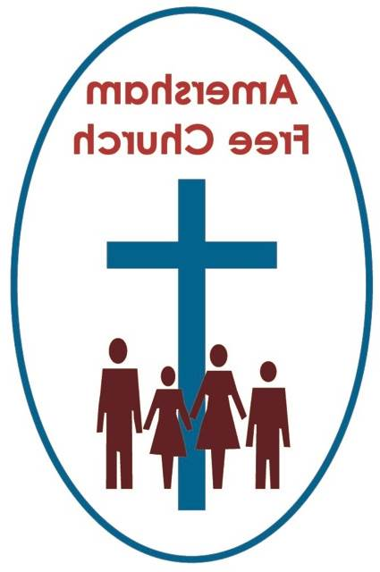
23rd May 2021
Ezekiel 37.11-14
Acts 2.1-21

The Spirit’s Vibrant Life
INTRODUCTION TO THE THEME
The United Kingdom is considered to be the best place in all Europe for wind turbines and last year they generated almost a quarter of our nation’s electricity needs, and so are considered to be something of an ecological success
I suspect they are like Marmite, aesthetically you either love or hate them. I confess to being rather a fan.
When we went as a group from AFC to Spring Harvest a few years ago I remember, from the beach alongside our accommodation at Skegness we looked out over the North Sea and saw a great mass of turbines forming one of those great sea wind farms you always look down on whenever flying back to the UK.
Whilst visiting Hauke, our former Time for God volunteer, in Saxony, a group of us went to an early morning tour of the family’s wind turbine on their farm, some were even brave enough, once togged up, to make the climb up it.
The wind isn’t always kind to us and in a storm it can prove terrifying and destructive.
We always recall, with affection, my grandmother saying on even the sunniest and calmest of days, when sitting in the garden; it’s a cold wind isn’t it?! I now find myself saying it in her place!
Yet, on Pentecost Sunday, we also recall that the coming of the Holy Spirit upon the apostles is described as that of a rushing wind.
The Jewish Scriptures had a word for it, ruarch, and it means the breath of God, and by extension his life.
And that’s what this day is all about, a celebration of God’s life among us and through us. It starts with God, like a wind turbine, and perhaps our churches and families, in fact anywhere where God’s life brings blessing, we are like points on the National Grid letting that life and energy flow out into God’s world.
Happy Whit Sunday!
We never see the wind, yet we feel its breeze and watch the trees swaying in its wake. On a cold day it icily whips our cheeks whilst on a hot one, it brings relief.
Those turbines we talked of earlier are just the latest example of our attempt to use wind beneficially. Wind, far from simply being a force to be reckoned with and feared can, in fact, offer life changing and enhancing possibilities.
A couple of years ago we watched the film The Boy who Harnessed the Wind. It told the story of William Kamkwamba from Malawi. His family were struggling to run their farm after years of drought and William, who loved engineering and fixing radios, lost his place at school because Mum and Dad could no longer pay the fees. Yet he smuggled his way back in and had lessons from his old science teacher. William became convinced he could build a windpump that would draw up water from deep below the ground. His father dismissed the idea as daydreaming, yet William persisted and eventually prevailed. This young boy, through science and determination, saved his family, their farm, his village, and the entire community.
The wind brought life.
Visiting Hauke’s family’s turbine made me aware of just how powerful wind can be. That one machine produced enough electricity for half of Rohrsen, where the Vogels live.
The Spirit’s activity is God’s activity, and the message of the Bible is that God’s character is supremely to be understood in terms of love.
So, as we picture that scene from the Pentecost story of a great rushing wind, we sense the power, the strength and the depth of this wind blowing on all and it becomes for us an image of the love of God spreading further and further in blessing upon our world. This isn’t the wind of oppression or fear but the wind of life and of energy. The Spirit’s vibrant love.
I think we have seen the power of love move in our world over this last year.
Twelve months ago, in May 2020, we would all have been at home listening to Pentecost worship via the audio service. In the bleakest of times love shone brightly in our world. Families stayed in touch, friends and neighbours phoned and eventually grandparents waved at their grandchildren through a closed window whilst blowing a kiss. Love triumphed and could not be quenched.
And that, I think, is the theological significance of the Easter Season in the Church’s calendar that comes to its close today.
On Good Friday Jesus was killed by those who could not tolerate the way he stretched out a hand of friendship to the poor and marginalised. They did not share his view that all life was sacred. So, they destroyed him because he challenged the religious and civic status quo. He became the enemy within. It wasn’t the first or last time that a phrase like, Who will rid me of this troublesome priest was uttered.
Some theologians describe the cross as the Death of Love. A haunting and disturbing phrase that says so much with so few words. The Death of Love.
Yet, that is not the end of the Easter story or its message. In the manner of his dying, with forgiveness, and through his rising, God in Jesus refuses to let love die. In the words of a much-loved Easter hymn: love lives again like wheat that springeth green.
For the next forty days until Ascension Jesus meets his traumatised disciples constantly offering them peace and love. And then at Pentecost this process is universalised as the Spirit erupts all over the world bearing that same peace and love.
This story of Pentecost, Whit Sunday as we sometimes call it, is cloaked in an abundance of Jewish symbolism that was adopted and adapted by the early Christians.
The forty days up to Ascension was a reminder of the forty years in the Wilderness after the Exodus. Fifty days after crossing the Red Sea tradition had it that Moses received the Law on Mount Sinai, and fifty days after Jesus broke bread in an Upper Room the apostles receive, as part of the new covenant, The Holy Spirit.

Another story connected to Sinai is that as Moses descended the mountain with the law, seventy tongues of fire also came down, representing the seventy nations of the world. So, it’s significant then, that on another fiftieth day event, Pentecost, once again those tongues of fire make a further appearance.
All of it is a continuum that pulls the Old and New Testaments together. Part of our Judea-Christian tradition.
The wind, the fire are all symbols and elements of life.
So we join together those manifesto words of Jesus: I have come to bring life, and life in all its fulness to those found in the Nicene Creed which describes the Holy Spirit as The Lord and Giver of Life.
For that is always the essential connection, that the Spirit enables us to continue the ministry of our Lord. Or as someone I read puts it The Spirit reminds us of the subversive memory of Jesus.
It's the message behind that wonderfully bizarre story of Ezekiel and the dry bones. Of God breathing over a scene of carnage and transforming it, drenching it with new beginnings and fresh life. A sort of Pentecostal moment, in itself.
And surely this collision of traditions also hits home when we realise that Pentecost was, long before we Christians came along, a Jewish Harvest Festival. A celebration of the life of the earth and growth. So, the very organic nature of this original event blends beautifully with the idea of God’s life-giving Spirit blessing the world.
At AFC we are privileged to have Dr David Watson among us, who has served over this last year on the government’s Vaccine Task Force. David has updated us on his work, and that of his colleagues many times over recent months and it’s been wonderful to know that his lifetime of experience has been put to good use by our nation.
He prompted me to watch a documentary last week on Channel Four about the Vaccine Task Force entitled Jabbed. I was so moved by the dedication and commitment I saw there by wonderful people who have made our jabs possible. One scene sticks in my mind as the deputy chair of the group was interviewed. He broke down on camera recalling the death of a dear friend from Covid. We saw a picture of this lovely man attending the deputy chair’s daughter’s wedding in January just before the virus struck. That sense of loss, he said, just spurred him on in the search for a vaccine. It energised and motivated him to save lives.
It’s been the theme of the last year. We have always known it, yet now we know it more than ever, life is precious. It’s about love and I think those of us with a faith would want to say, it’s a gift from God to be valued, treasured and honoured.
So, let the wind blow as today, on Pentecost Sunday 2021, we celebrate God the Holy Spirit, the Lord and Giver of Life.
May we treasure, honour and reaffirm that life in the days that now stretch out before us, seeking to live them in the power of God’s vibrant spirit of love. Amen.
Ian Green, Amersham, 13th May 2021

