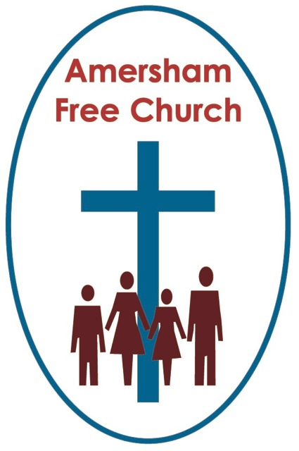
24th July 2022
Genesis 18.20-32
Luke 11.1-13

The Present Imperative Principle in Prayer

Gracious God – we open the bible and long to receive your word – open, we pray, our minds and hearts to receive that word with all its comfort and in all its challenge. Amen
It’s surely significant that the writers of the gospels, like Luke, regularly report Jesus at prayer.

Today’s reading is just such an example; so, before our Lord teaches his disciples about prayer, he prays himself; he’s a practitioner rather than a theorist.
What follows is a version of the Lord’s Prayer, well about two thirds of the one we use today. Maybe it was only ever intended to be a guide or an aid to prayer, and I for one, love to come across new interpretations of this prayer. Such a version, written by Mary Carpenter, found its way into the Diamond Jubilee service published last month by the URC, and it went like this:
Loving God,
we know that you forgive us our trespasses
as we must forgive those who trespass against us.
And yet how hard we find it to follow your loving example
in our day to day lives.
Help us to resist the temptations of revenge and retribution
and turn instead to the loving kindness
of forgiveness and reconciliation.
Help us to forgive others for their shortcomings.
Help us also to forgive ourselves for our own shortcomings,
for which we know you have already forgiven us.
Loving God, when we are brought low, you help us.
You save our eyes from tears and you keep our feet from falling.
You are ever-pardoning and ever-forgiving.
Let us reflect your love in our treatment of others,
and let us work for justice, reconciliation and forgiveness
throughout your peoples.

This morning, our subject is prayer – and our text is Luke 11 – the lectionary passage for today read to us earlier – a passage that speaks of good gifts and faithful perseverance.

Now it’s clear from today’s passage that persistence in prayer is commended. All this talk of a man knocking on his neighbour’s door in the middle of the night and never giving up is a lesson about persistence.
Don’t you just love those signs in very old cathedrals and churches that say: This has been a House of Prayer for, say, over 800 years. People, even those who would not claim to be people with faith, often say they feel as if prayer has been soaked into these buildings.
Keep on knocking, keep on asking and keep on seeking, says Jesus.
I see that a few weeks ago the Dean of Canterbury, Robert Willis retired. He’s a quintessential Englishman and rather donnish in his way of talking. Yet, during the Pandemic the Dean of Canterbury became a You Tube celebrity with his daily broadcasts of Morning Prayer. This was all very unexpected, and I think totally wonderful. Everyday about 14-16,000 people tuned in to see him sitting out the Deanery gardens in all weather, tea pot and rugs to one side, his inquisitive and mischievous cat on the other. The Dean wanted to be faithful in prayer. So, what started off as a necessity, locked out of the cathedral because of covid, he took to his garden and YouTube, and this daily morning prayer, in all weathers from Canterbury, became something of a much-loved tradition. People loved this daily routine, this persistence, this idea that even though we were losing so much of our daily routine in those months of pandemic, we couldn’t afford to lose that sense of prayer.
So, I just I notice from a passage like this morning’s that Jesus asks us never to give up praying. If you are keen on grammar you might like to call it the Present Imperative Principle. We don’t pray once – and then give up. He says: Ask, Seek and Knock. To many there seems to be an ascending order of intensity in that process. Certainly, the impression, from this and other gospel teaching, is that Jesus wants us to keep going in prayer – just like the former Dean of Canterbury, Robert Willis, in his garden, with a scarf and a cat.

I’ve lost count of the times we’ve mentioned Ukraine in our Sunday prayers this year – or we have lamented before God after another act of pointless gun crime in a school. I can’t remember a year when there hasn’t been a need to pray about a country that is going through famine, or an emergency caused by a natural disaster. I can’t imagine there would ever be a day in the future when I wouldn’t feel the need to pray for my family.

It’s that Present Imperative Principle – we’re not asked to pray just once and forget it – Jesus says keep on Asking, keep on Seeking and keep on Knocking.

A second principle – based on today’s passage – is to remember that when we pray God wants to give us his good gifts.

That’s why we ask for all that is of His will. The Lord’s Prayer puts it this way – Your will be done on earth as it is in heaven.
In today’s passage Luke says in verse 13: If you, bad as you are, know how to give good things to your children, how much more will the heavenly father give the Holy Spirit to those who ask him?
That’s God’s every-day gift to us – the gift of his living presence – the gift we call ‘The Holy Spirit’.
The point is that if loving yet flawed parents instinctively want the best for their children – how much more will our heavenly Father want the best for us.
The best is not an easy life – but one lived with love.
The best is not an easy answer – but one of integrity.
The best is not an easy faith – but a belief that is authentic.

This is the loving wisdom and kindness of God – this is the one who we seek in our prayers.
You know the gods of other nations were not so kind in that Ancient World of Jesus’ time.
The Greeks told a story of their god of the dawn, Aurora falling in love with a mortal, Tithonus. She asked Zeus, the king of the gods, to grant her a wish. He accepted and granted her wish that Tithonus become immortal. But this wasn’t either wise or loving – because Zeus had not granted Tithonus eternal youth – so in this Greek legend, he lived forever but got older every day.
And so, Jesus comes along – and against the backdrop of common stories like these says – Your Heavenly Father is different – he answers our prayers according to his loving wisdom – you can rely upon him, you can trust him, no prayer you ever offer will be wasted – and in his love, and by his wisdom he will answer and weave his peace and purpose into our lives.

The other day I was reading a book about how to lead prayers of intercession. The author said he was mildly irritated by unspecific prayers like: Dear Lord, please bless those who are suffering in Ukraine. Be bolder, he wrote, and name an outcome, a specific outcome that you’d long to see happen.
Now, I normally agree with this author, but I’m not sure he’s totally right on this one. For although I think it would be good for us to think long and hard about what we are praying for, the truth is sometimes I simply don’t know what’s best for people. In fact, the older I get the more I realise my solutions for people I love often don’t work at all and I’m constantly surprised and delighted that a better answer comes up.
So, if God is the giver of Good Gifts, maybe that’s a great place to start in prayer. As we picture in our minds eye a family member or an international crisis, our heart’s cry to God is that a family member or a country in need will be the recipients of God’s Good Gifts. I may not know what that specifically means, but as I name these people in my heart I’m seeking for them the blessing of God.
As that much loved Scottish Bible teacher William Barclay said: when we pray, remember: The love of God that wants the best for us, and the wisdom of God that knows what is best for us.
He wants the best for your personal pilgrimage.
He wants the best for your family and loved ones.
He wants the best for our church.
He wants the best for our country.
He wants the best for our community – that we may be a people not rooted to the material but inspired by the spiritual.

God longs to give us the Holy Spirit – his living presence with us every day – a presence of love, joy, justice, peace and courage. That is the way God answers our prayers – by giving us himself so that we face the joys and challenges of this new week never alone but with him walking alongside us and sharing the journey with us.
I must bring this talk to a close.
My first church was in Northamptonshire – the birthplace in 1792 of the Baptist Missionary Society. Incredible that, as many Baptists in those days were strict Calvinists who believed God didn’t need our help in bringing people to faith. Prayer – I believe changed that way of thinking. Every Monday for about 20 years the Baptist Association in Northamptonshire asked its members to spend time in prayer – alone, if necessary, together if possible. And from these prayer gatherings people’s mindsets changed. And after years of Asking, Seeking and Knocking, these 18th century Christians formed the first modern overseas mission agency, funded it, and sent William Carey as the first modern day missionary. Prayer changed them, their churches and their mission.

These Northamptonshire Christians prayed in homes, in chapels, out in the fields and alone walking to fetch water from the well.
Let no one tell you there is just one right way to pray. There are many ways.
The essential thing is that in our longing – and all that you long for is another way of saying all that you pray for – we consciously and deliberately seek God – seek his way, his presence and his Spirit – and in that seeking and longing time and again we will find ourselves changed and strengthened to face the future with a new sense of hope, courage and peace.

May it be so in the name of the one to whom we pray, the one who taught us to pray, and the one who prompts us to pray, today and always. Amen.
Ian Green Amersham 22nd July 2022

