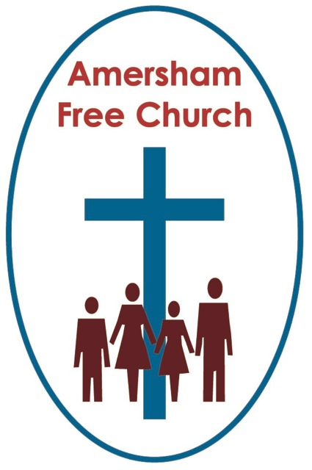
4th July 2021
Ezekiel 2.1-5
Mark 6.1-13

Prophets see a Different Kind of Future.
Minister: Gracious God, we open the bible
and long to receive your word.
All: Open, we pray, our minds and hearts
to receive that word
with all its comfort and in all its challenge. Amen.
Travel up the road to Bedford and you are in John Bunyan country. Indeed, the joint Baptist/URC church in the centre of the town is even called Bunyan Meeting.
The author of that English classic Pilgrims Progress was once a resident of Bedford’s Gaol at a time when non-conformist ministers were barely tolerated in our country. They were considered deviant and dangerous.
The church in Bedford has a stained-glass window commemorating Bunyan in gaol and a lady sent a postcard of it to Terry Waite whilst he was in solitary confinement. One of his first tasks upon his release was to travel to Bedford, visit Bunyan Meeting and say thank you to that lady, whose card he kept and treasured for years, saying Bunyan gave him hope and inspiration at his darkest moments.
In popular opinion John Bunyan has transitioned from sinner to saint.
Much like the Amersham Martyrs, whose memorial we passed on the COTHA walk last Sunday. Again, these puritan Christians were once thought of as so beyond the pale that they were burnt at the stake. In more enlightened and tolerant times they are immortalised on our town’s memorial as people of conviction and courage. They, like Bunyan have taken a journey from being loathed to lauded.
Rather like Jesus, these were people who looked at the present and declared it doesn’t have to be this way. And, like many prophets before them dared to believe in a Different Kind of Future.
So, what makes a prophet?
That’s a question we asked recently at the Ministers’ Reading Group I attend. I spoke about a review I’d come across of the book before us, in which the reviewer said the author of our book was ‘no prophet’. Well, for the next ten minutes I got roasted because no one agreed. I constantly had to stand up for myself and say: I’m just quoting someone else. Don’t blame me, I’m just the messenger!
Well, I think prophets are like the Advanced Scouts. They are trailblazers often with a big vision – so they usually need a few strategists to be following on behind to enable the dream to become a reality.
In today’s gospel Jesus describes himself as a prophet without honour in his own country.
As the narrative unfolds Jesus is becoming more and more visible and Mark chapter six describes his entry into the arena of public faith.
I remember being invited back to preach at the church I grew up in throughout the 60’s and 70’s and it did feel awkward. My former pastor was still there, but this time in the congregation with me now in the pulpit. I actually went into the vestry beforehand to pray with the deacons – a room that was to me rather like the Holy of Holies and one I had never been in all the time I was growing up. What a disappointment, it was just like any other room!
Well, in today’s passage Jesus attends synagogue in Nazareth, he’s come home to preach.
Imagine the scene; someone who used to come to this community of faith as a child, someone bar-mitzhered here, is now the morning preacher.
Well, it’s in the ‘roast preacher’ session after the sermon when it all goes pear shaped and Jesus is resoundingly and cruelly rejected. This is a candidate the Synagogue Eldership would never dream of asking back for a second interview or preach!
Biblical linguists tell us that this phrase used in verse three that they ‘turned against him’ is one used elsewhere in the gospels to describe a change of mind. People who might have believed, started out with a willingness to listen, and give it a go – but then decided to push it to one side.
In a way I think we all recognise some of the dynamics at work here in Nazareth. This was the local boy come home, and in that sense, Jesus was anything but a clean sheet of paper for this community. Perhaps they simply knew too much about him and all the baggage and prejudices of the past obscured any clear and generous mindset with which they could listen to him now.
Here are three possible rumblings that could have been gossiped along the back pew as he preached that day: Shouldn’t he have stayed at home once Joseph died and taken over the family business? Look at him preaching, and to think he comes from a carpenter’s family, that’s even below the status of a peasant farmer in our society. Others might have said, ‘This is Mary’s Son’ - and that’s the only time in the New Testament Jesus is ever referred to like that, and the only time in Mark his mother is named. Not that it’s a compliment – usually he would have been referred to as Joseph’s son – so the title they used for him that day just opened up once more the scandal and dubious origins of his birth.
It’s significant that in Luke’s account of this disastrous sermon at Nazareth it’s the content that is described as explosive. Yet in Mark it’s not so much what is said but who says it that lights the blue touch paper.
And maybe we all do the same thing in a way. We often judge and evaluate the message through the messenger.
By referring to him as Mary’s boy the congregation that morning infantilise him. They refuse to let him grow up preferring instead to keep him as junior to them. He’d have been accepted if he had toed the line and kept to his place. But having his own opinions, taking a fresh spin on old scriptures, this was all too much for closed minds.
Unlike him, the congregation that Sabbath morning, stubbornly refused to have their vision broadened and start believing in a different kind of future.
For years the world turned away as Nelson Mandela spent the middle years of his life incarcerated because he believed the world didn’t have to be the way it was.
When I was at college in London I saw protests outside the South African Embassy in Trafalgar Square just about every weekend. I remember feeling personally torn attending a prayer cell at college which longed for the end of apartheid whilst having an aunt and uncle living in Cape Town who I knew benefitted from it.
And then came the day of Mandela’s release. No longer the young, long haired radical, but the suited elder statesman in waiting. TV pictures the whole world seemed to be watching.
He became a friend to the Queen, a symbol of forgiveness and renewal as he too, like many prophets before him, yet this time in his own lifetime, made the transition from sinner to saint. And today, just like Gandhi, his statue stands in London’s Parliament Square.
Why this change from loathed to lauded? Well, maybe it’s just the case that we wake up and catch up. The prophet’s message doesn’t change but the ears of them who first heard it and rejected it do.
As Jesus preached in Nazareth’s synagogue there was something of a radical prophet about him. He pushed the boundaries and that made faith more challenging and less comfortable. He refused to accept the status quo or become subservient to a corrupted religious hierarchy.
No wonder today’s gospel has been paired in the lectionary with a passage from Ezekiel which warns any aspiring prophet that their message will almost certainly be rejected and they will need courage, conviction and faith to keep going.
Now although the second part of our gospel reading talks of taking off your shoes and shaking the off the dust if a village doesn’t accept your sermon, I suspect we would want to revisit the ways we respond to rejection today.
I suspect if we disagree about faith in our families or workplaces we’d want to keep the door open and continue the listening and the dialogue. Yet the point of the second part of the gospel remains, there will be lines in the sand for us that we cannot cross. It’s true for every person of conviction. There is a higher goal than simply achieving a contrived consensus that lacks personal integrity. The challenge is always to be authentic yet approachable.
I suspect that one way of doing that is to learn from Jesus.
Although there were moments of tension between him and the authorities, times when he stood his ground and paid the price. There were also many more times, I think, when he presented a prophetic vision of a different kind of future positively, he called it the Kingdom of God, or of Heaven. He painted accessible word pictures and parables that described an alternative way of living with God at the centre.

I love to imagine the response to his sermons. Maybe in a synagogue with professional hearers he didn’t score, but I sense out on the hills and down by the lake as he talked of a runaway son and a forgiving father, of a Sower going out to sow or a shepherd who always counted the sheep home, he scored a seven every time! He painted pictures that contained deep truths.
I think prophets have been doing that ever since. Not so much saying what we don’t believe in but talking about what we do.
A few years ago we spent an August in Washington, and it was the summer a new national statue of Martin Luther King was to be unveiled by President Obama just days after we left. We saw many articles about it in the newspapers.
Luther King’s best known, and much-loved prophetic speech was about dreaming. He dreamt of better days and painted a picture of inclusion that seemed real and possible.
Because that’s what prophets make us do. They show us what the Kingdom of God can look like. They help us dream.
Hang on to your convictions. Don’t get discouraged by rejection. Keep dreaming.
In the name Jesus who calls us all to believe in a different kind of future. Amen
Ian Green, Amersham, 23rd June 2021.

