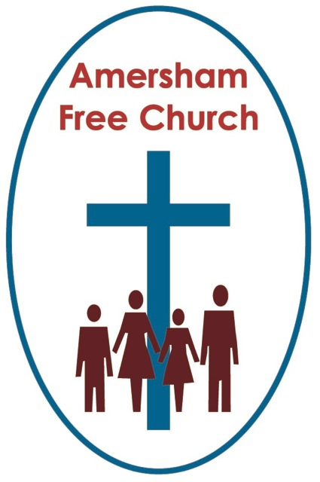

Isaiah 55.1-9
Luke 24.1-12
17th April 2022

Resurrection – before it became famous

Lord God our prayer is that you might touch my lips, open our hearts & transform our lives in the power of the Spirit and for the honour of Christ. Amen.
Last month, on a weekend visit to Oxford, we stood outside the Sheldonian Theatre in Broad Street with headphone guides on and learnt that this slightly odd-looking building, that isn’t really a theatre at all, but the ceremonial centre of Oxford in that it’s here that degrees are conferred, was the very first commission built by Christopher Wren. At that time, he was an Oxford Professor of Astronomy rather than an architect. He was little known, and this was his first public building. This is Wren before he became famous.
After that people began whispering his name in high places and come the rebuilding of London after the Great Fire, he was the architect of choice of just about every patron wishing to rebuild their parish church, even the commission for the new St Paul’s eventually landing in his lap. Once known only in Oxford he eventually became celebrated throughout England.
The resurrection starts with equally humble beginnings. What is now universally celebrated within the Christian tradition started off as the secret of the few. Today, across the globe, we sing Alleluia with such joy and hope, yet on that first Sunday those encountering resurrection sometimes even refused to believe in it at all.
So, let’s rewind the tape this morning and try to inhabit that world just over 2,000 years ago and see it particularly through the eyes of the women who went first to the tomb. Let’s try to imagine resurrection before it became famous.
Under Roman law the body of a crucified criminal could be claimed by anyone wishing to perform the duties of burial. In Jesus’ case that role was undertaken by Joseph of Arimathea, a high-ranking man in society and a member of the Jewish Council with which he now disagreed. He so dissented from their judgement to condemn Jesus that he uses his money and influence to give him a dignified burial. Joseph made sure Jesus never ended up in a pauper’s grave but in one freshly cut out of the rock.
Yet this all had to be done far too fast. The Sabbath would begin at Friday’s sunset, after which nothing could be done, none of the burial rituals observed until Sunday sunrise. Joseph arranged for half the rituals to be fulfilled, the removal of the body from the cross, and then the wrapping of it in a shroud and its laying in a tomb.
There were no professional undertakers in those days, instead these final acts of love were carried out by close relatives or even friends, often women.
So, Luke tells us, with the job only half done yet having noted the location of the tomb in the pervious chapter, these women, some named, such as Mary Magdalen, Mary the Mother of James and Joanna, along with others we simply do not know, came with spices and perfumes they had prepared on Friday but hadn’t had time to use.
Perhaps on automatic pilot with minds made misty with grief, there seems to have been no thought that perhaps this was all too late if the stone had already been sealed in front of the tomb.
What’s important is that for these loving women these actions, steeped in the burial traditions of the day, were intended to be a moment of closure and completion. It was all so sad, so important and so predictable. That was, until they arrived in the early hours of that first Easter Day, for what they encountered then wasn’t at all predictable and redefined many of the symbols and traditions around them. What they encountered then blew their plans apart and changed their lives forever.
Once at the tomb these devoted women are met by two messengers who ask a question before giving a command. The question is: Why are you looking for the living among the dead? The command is: Remember what he told you!
Now, of course, tombs are all about remembering for, in a sense that’s their purpose. They leave a fingerprint on history. So, if you are an ancestry buff finding a relative’s grave almost feels like an encounter across the years. It’s a place to remember.
But, that isn’t the kind of remembering advocated here. They were asked to remember those times when Jesus spoke of his death and then promised that after his dying there would be a rising again.
For it’s at this point that the narrative is switched from remembering the dead to encountering the living. It might have seemed incongruous, perplexing and confusing but because this Easter Day tomb was empty it became an unrecognised sign. Traditionally tombs are about grief, sorrow and mourning and these women were reluctantly now prepared for that. But now they found themselves outside an empty tomb with the stone rolled away. Now, on Resurrection Day, this tomb was a new sign, one of life, joy and hope.
It's the women in the Easter story today who become our best teachers. For we are told that, prompted by these messengers in dazzling garments, they did indeed start to remember that message of hope Jesus had told them. And remembering seems to have mingled with belief, trust and conviction on their part because in the very next verse these women are transformed into the first evangelists, running back to tell the eleven remaining disciples what they had seen.
You might have thought such news would have been greeted with euphoria instead these men dismiss the women’s words as nonsense.
So, what might we take away with us this morning as we reflect on these moments of the resurrection before it became famous?
Surely one response is to learn from that inadequate reaction of the eleven to the women’s news. Whether in church, community or in a family there is something precious when people share their stories. We can learn so much from each other and it’s often through listening to each other that we actually hear the voice of God speaking to us. Conversations, even informal and casual ones over a cup of coffee, can be holy ground. We share our struggles, our doubts, our fears, our discoveries, hopes and joys and it’s as if God occupies the space between us and blesses that moment with his presence.
Mistake number one on Easter Sunday is that the men didn’t listen to the women.
We miss so much when we fail to listen to each other, for it’s often in the sharing of stories that we hear the voice of God.
And the women’s story was surely worth a listen, and it’s one that has been repeated a thousand times since.
It's the story of resurrection. Of finding hope even in a place of despair. Of encountering new life at the very moment, you thought you’d come to the end.
Can we believe that today? That the God of resurrection draws close to us when the fragility of life seems overwhelming. So, at that moment when life seems to be crushed and we feel broken, God meets us, and we begin to be transformed. It’s not a single moment but probably hundreds of moments in our lives. Times when, as it were, like the women in today’s story we felt we were going to a tomb. A place of desolation. A struggling moment. And, at that moment, something of the life of God begins to touch us, hope is restored, and strength is regained. A resurrection moment. The sort the two Marys, Joanna and the other women had in the garden that first Easter Day.
And all of this leads us on to a redefinition of some of our symbols and traditions.
Just think of how that first Easter refashions our understanding of the cross and grave.
The cross was an instrument of death and torture, yet through Christ’s death, it is redefined for us a symbol of the best sort of love, self-giving and sacrificial.
The grave, given by Joseph of Arimathea, was meant to be the place where the story ended, and at which there could only ever be a wistful remembering of a life past and spent. Yet, because of Christ’s resurrection it becomes an empty tomb, a symbol proclaiming that life is stronger than death, even as love is stronger than hate.
I began with a story from Oxford and I’d like to close with one.
Whist there for just 2 days last month we attended Choral Evensong at Magdalen College and the service sheet had a quote from one of its most famous former professors, C.S.Lewis: He wrote: I believe in Christianity as I believe the sun (s u n) has risen, not only because I see it, but because by it I see everything else.
Maybe, especially on today of all days we could say the same about the resurrection. For if we believe in this new life that God gives, then all life is transformed by it. It challenges our old ways, our old ideas and some of society’s misplaced orthodoxies. Resurrection gives us new hope, new strength and a new way of seeing and listening. It’s God’s life meeting ours and it makes us cry: Alleluia.
May it be so in Jesus’ name, the one who lived and died, and lives again. Amen
Ian Green, Amersham, 16th April 2022

