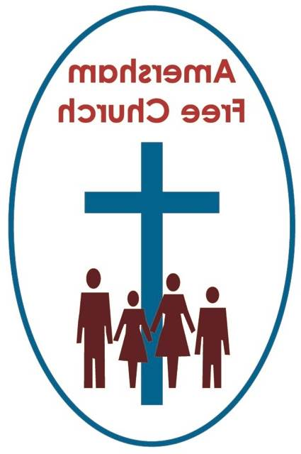
13th June 2021
1 Samuel 15.34-16.13
Mark 4.26-34

Flawed yet Loved
INTRODUCTION TO THE THEME
Whilst visiting Westminster Central Hall to attend morning worship one Sunday I, like thousands before me, took the opportunity to have a photo standing beside the statue of the founder of Methodism, John Wesley. He once described himself as being under average height and as his statue, a replica of one stating in St Paul’s churchyard, is of his actual size I somewhat towered over him.
We have all become aware recently that erecting statues is a tricky business and I suspect John Wesley would be horrified that so many have been put up in his memory. The one in Bristol has him on horseback and maybe that’s fitting as it’s said in his 30’s and 40’s he rode some 250,000 miles from one evangelistic meeting to another often preaching three times a day.
John Wesley loved God and people and it’s thought that in his lifetime he gave over £30,000 away to the poor. When he died it was said of him that he’d become the best loved man in England.
Yet he had his faults. His insistence, especially as Methodism grew in America, that bishops were not necessary in the ordination of priests caused a rift between him and his brother Charles who accused him of breaking up the bridge between them. And despite several attempts to make it work, his wife eventually left him claiming he was more married to his ministry than her.
All of us are flawed in one way or another.
The Archbishop of Canterbury got into trouble last month for saying that about politicians, and he should know because his mother was the one-time private secretary to Winston Churchill. Letters of complaint were written to the Church Times that Justin Welby was failing to give a moral lead when all he was saying is that every politician who has ever lived, whether they are immortalised in statues or not, has been a flawed human being just like the rest of us.
Our reading today from the Jewish scriptures is the start of the David story. This shepherd boy, this nobody in Jesse’s family, the younger son, rose to become Israel’s greatest and most remembered king. His name is mentioned more than a thousand times in the Old Testament and 59 times in the New. And in that the bible is remarkably frank and honest.
Contrary to the popular understanding that history is written by the winners, David’s story is a chronicle of both the good and the bad. His flaws and failings are not airbrushed out of the narrative. Rather we have a well-rounded account of a king who experienced national greatness as he led his nation to many victories, alongside an individual who messed up, both in his personal relationships and in his family life.
Like that famous painting of Oliver Cromwell, the bible gives us an image of David that is warts and all.
Yet, the message remains positive. Even as Jesus enters Jerusalem on Palm Sunday the crowd welcome him as one who comes into David’s city as David’s successor.
Hagiography is not only a good word to remember for Scrabble, but also the understanding we all need that sometimes we give undue reverence to our heroes. We make them out to be perfect when in fact they were flawed, be they our parents, children, friends, teachers, priests, or politicians.
So, I’m still glad I had my photo taken with John Wesley, we stand together as two flawed, yet loved, forgiven and blessed brothers in Christ.
FLAWED YET FLOVED
Samuel probably travels to Bethlehem a troubled man. He’s done this before, anointed a king, Israel’s first, King Saul, and although he was head and shoulders above everyone else, Saul had been a disaster. So, doing the same thing twice but now expecting a different outcome no doubt worried him.
Jesse’s boys were paraded before him in this monarchical beauty pageant and all seven were found wanting. Samuel asked if these were all his sons. The response is shocking. There was one more, the youngest but he was considered by his father to be of so little worth that he’d been allocated sheep watching duties instead of meeting Samuel.
These were the days when family hierarchy really mattered and being the first born determined your whole life. Later arrivals became less and less important till, by the time you got to David, you didn’t even get an invitation to what must have been the most significant family gathering Jesse’s family ever had.
Yet David is chosen to succeed Saul and is anointed as God’s servant and the nation’s forthcoming leader. And in all this Samuel blesses the moment with these words of wisdom and divine insight: mortals see only appearances, but the Lord sees into the heart.

This morning’s gospel speaks of a small mustard seed growing into a fine shrub. David had that seed of hope and potential about him. His father and brothers couldn’t see it. To them he was something of a nobody. But to God, and his servant Samuel, David was the right choice.
When I think back to the John Wesley statue, I’m reminded that, in his day, Wesley’s most important theological insight is generally thought to be in the area of personal holiness. In his day John Wesley broke new ground in speaking about personal, rather than ritualistic faith. Personal prayer and bible study became a hallmark of early Methodism and Samuel’s words speak into that: The Lord sees the heart.
Of course, we would do well to remember that the Jewish bible never portrays God being keen on the idea of kingship in the first place. The Israelites, however, campaigned for monarchy so that they could be like the other nations that surrounded them. God, so the story goes, reluctantly allows their request, Saul is anointed yet come the end of his reign we are told God regretted his decision.
There are just two moments when that’s said about God, that he regretted his actions. The first is just before the flood when he says he regretted making humankind, and the second is his judgement about Saul’s role as Israel’s first king.
Maybe this idea of God ‘regretting’ isn’t particularly helpful or straightforward. In as much as any human being can really know the mind of God, surely this was essentially the personal interpretation of God’s reaction given to us by biblical authors.
I don’t, for a second, think that God’s regret meant he hated either humankind or Saul. Does it not rather mean, that he was saddened by the actions, and the subsequent consequences, of humankind and of Saul?
Although it’s essentially the language of poetry when we use anthropomorphisms about God, isn’t it true that God still weeps with regret whenever you and I turn to violence instead of dialogue, when we advance our own cause at the expense of another person.
God wept as George Floyd was crushed to death, God weeps as more and more are made refugees fleeing Syria, I’m sure God has wept over Palestine and Israel as the bombs have dropped in recent days in tit for tat killings, a life for a life.
The scriptures say there were moments when God looked at the pain and suffering caused by us and he regretted that lake of love, kindness, and justice. And those moments have surely not gone away?
We seek to address issues of regret and disappointment in our services within the Prayers of Confession we include in the liturgy.
Confession may start with regret as we seek to make an honest appraisal of our lives and perhaps at these moments we sense God’s tears and the times he weeps over us.
Sometimes the words of our liturgies have in the past been rather dramatic, describing us as miserable offenders not worthy to gather up the crumbs under God’s table. Or maybe that chimes a helpful chord with you?
What’s important is that our self-examination is honest and our regret for any hurt we might have caused God and others is sincere.
The parable of the Lost Son and Forgiving Father teaches us that regret need not be a permanent state for either.
The son regrets his thoughtlessness and the father regrets his sense of loss, yet in that journey of repentance both end up moving closer and closer towards the other, so that in the end they run into each other’s embrace.
I think it wouldn’t be a bad thing to have that reading every week in church.
Regret that leads to confession and confession that ends in forgiveness and renewal. It’s the message and heartbeat of the gospel.
It was David’s experience too. He falls down repeatedly. He writes Psalm 51. In those moments of regret he turns to God and finds again the love he had rejected and the truths from which he had looked away. He discovers, repeatedly in his scared life, the grace of God.
We began our thoughts today thinking about statues. I suspect that fewer and fewer are being erected to commemorate a person. Modern statues more often commemorate or celebrate an idea or ideal. The fourth plinth in Trafalgar Square has had a variety of images on it in recent years; many controversial, all thought provoking.
I wonder how David might be commemorated in stone?
The truth is a statue is ultimately a piece of art that needs some interpreting because it tells a story picture than the image.
And that would be true, say of a crucifix. A small statue of Christ upon the cross.
In Baptist and URC churches you never see them because they are not part of our tradition. Crosses in non-conformist chapels are usually empty.
Yet, in a recent Radio 4 Daily Service I heard a moving account of why a crucifix, a small statue of Jesus on the cross, meant so much to a dying lady. She spoke so warmly of her crucifix and said, even though Jesus’ head was bowed, his arms were wide apart, open in welcome, as it were, to her. Whatever his pain and suffering on Good Friday, this crucified Christ was always there to welcome and embrace her in love.
It was a deeply moving interview and one full of deep theological insight. The God who regrets the times we turn away from him, like David, is the same God who in the Prodigal narrative, runs to meet us with the open arms of love, forgiveness and welcome.
For such a hope, thanks be to God. Amen
Ian Green, Amersham, 27th May 2021

