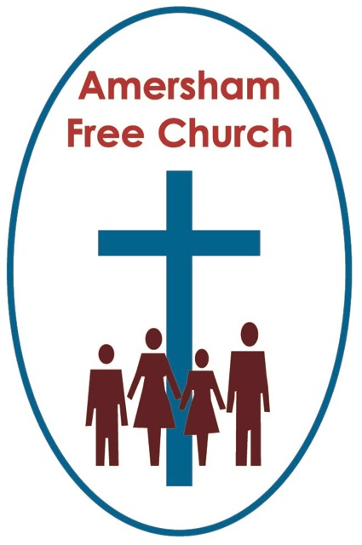

**Isaiah 60.1-6  
Matthew 2.1-12  
7th January 2024 Epiphany Sunday**

**Drawn by a Star**

I feel a bit precious when it comes to the star in today’s Epiphany Reading. That’s because as a group of us gathered the week before Advent last year to help Liz make the new church hall Christmas window, I was given the job of cutting out the star.   
  
I loved working with the scapple slicing through two sheets of black paper and gluing in the yellow cellophane in between. Every time I passed it over recent weeks I kind of nodded to it. It was ‘my star’. Rather wonderful, really, how working on a piece of artwork gives you a deep sense of connection to the subject being portrayed.  
  
This star is much loved in the nativity story. Back in 1614 the German astronomer, Johannes Kepla suggested that in 7BC three conjunctions between Jupiter and Saturn appeared in the night sky. But the truth is almost every scientific theory about the star comes unstuck at some point. Was it a coming together of Jupiter and Saturn, or Saturn and Venus, or maybe a comet?

Or perhaps it was simply a Jewish Midrash, that is a wonderfully colourful ancient story told, not as history, but as imagery containing deep and meaningful truths.

Well, I think with Liz’s permission I’m going to dub my efforts in this year’s church hall window a Midrash Star. A star that tells a story.

And that story is about a 900-mile journey that could have taken 3 to 4 months from Persia in the East, modern day Iran, all the way to Bethlehem. A journey of the so-called Magi – a group of people who caused great embarrassment to the early church because although they might have been Wise Men such a title meant they could also have been magicians, after all you only have to add a c to their name and you get the word magic. And astrogeology, star gazing, seeking wisdom from such sources, was outlawed early on by the Church. Somewhat embarrassingly, then, that some of the early adopters of Christianity came in via the most surprising of routes.

But that, in a sense, was always a longed-for dream of the thinkers and preachers of the Jewish scriptures, That Israel’s neighbours would walk towards the light and embrace the one God of their story. They wanted to be alight to the nations and so visitors from the East were very welcome, and in a sense were everything they longed for.  
  
The theme of Inclusivity is wonderfully apparent in the nativity story. Included in are shepherds, a young couple from a northern town, and now mysterious seekers after truth from Persia. All have a sense of belonging in the story, all are welcome as the narrative unfolds. There is a generosity of spirit here as rich and poor, young and old, Jew and Gentile come together under a star and find a common humanity.

We live in such divisive and screaming times that it always encourages me whenever I witness folk from different traditions embrace our common humanity. I saw that in a service I watched from the Synagogue in 5th Avenue, New York. I love the sermons of its Rabbi, Robert Cosgrove and last month I watched as that community received and embraced the Roman Catholic Cardinal of New York, who attended their Friday Night Shabat gathering because, in his words, at a time of rising antisemitism in the city, he just wanted to pop by as a friend.   
  
Of course, these gentle, almost self-deprecating words, masked a great generosity of spirit and warmth. And it was truly heartwarming to see Rabbi and Cardinal embrace as fellow seekers after truth.   
  
I’m so aware today that in welcoming friends into AFC’s membership that much of that has been made wonderfully possible because of the long history of COTHA, Churches Together on the Hill, Amersham. The now long-established relationship between our churches, St Michael’s, St John’s and AFC, facilitates a sense of deep respect and possibilities between us. Neighbours have become friends, embracing our common humanity and rejoicing in our shared tradition of seeking to be followers of Christ.

It started off so well at the Nativity. This coming together. This inclusivity. We might well ask the question with lament, when did we in The Church forget to see Christ in each other, when did we normalise discord and division?

The presence of the Magi in the narrative reminds us this morning that God can and does speak to us all in different ways and that living respectfully with neighbours means appreciating that it’s not just us, but also them that are living on holy ground.

At the centre of today’s gospel is the idea that Jesus was that Christ Light that did, and does, draw people. For many people, and maybe most of us are not versed in the language of theology, there is something about Jesus the man, and the message, that draws us in. We find ourselves seeking to walk in the way of Jesus. On day one the shepherds exemplify this, and maybe if it was four months later, the Magi do the same. Led by a star, drawn to the Christ child.  
  
The afternoon I spent in the studio at Radio Christmas a young student called Matthew came by after school to help on the production desk. He’d visited Radio Christmas a few days before and one of the staff members said they were aware that Matthew was just drawn to the production desk. He was fascinated by all those buttons and sliders, they said he couldn’t keep his eyes off the technicians as they faded presenters in and out and cut to either the news, adverts or music. So, they invited Matthew to come back a few days later after school and be trained up. That meant that half my show was produced by him, he queued me in and out and played the music like he’d been doing it for years.

I was struck by what the staff said, that Matthew was just drawn to the production desk.

Someone said something similar to me last century at my first church after a carol service. I’d never seen him before, but over the coffee and mince pies he told me he felt that night, in church, singing carols, he’d encountered truth. He felt drawn to it, and he started worshipping with us regularly afterwards.

Faith can be described as a search for encounter. A sense of connecting with ancient stories that contain eternal truths. And following a star isn’t a bad metaphor, indeed it’s a very hope-filled one. We have that sense of being guided and led towards truth, meaning, hope and connection.

Such longings are surely part of that shared humanity we were talking of earlier. Indeed, there had been visits by Magi and Wise Men both before and after this famous one for us in Matthew’s gospel. A similar visit is recorded as having happened to Herod in 10BC and to Nero in 66AD.  
  
We might even think of the Queen of Sheba visiting Solomon so that they could talk about deep things of faith and explore, with respect, the spirituality of the other.  
  
I rather liked the idea of a few years ago of churches holding Seeker Services. Yet maybe every service is exactly that, we come as seekers after truth, as it were following a star.  
  
Well, no sooner have the Magi offered their gold, frankincense, and myrrh to Jesus than they drop out of the story and tradition takes over.

Ever wondered why they were given those exotic names? It was so that they could continue to represent the tradition of inclusivity as Melchior is a Persian, Caspar an Indian and Balthazar comes from Arabia.  
  
And tradition says the Magi embraced the truths they discovered by starlight, becoming early martyrs to Christianity.

The season of Christmas we have just celebrated and the season of Epiphany which is upon us now are ones of enormous tradition, and we should be aware of the dangers of becoming dulled to their meaning through over familiarity.

The questions we might go home with today might be around this idea of inclusivity, of exploring the rich variety of ways God has, and continues to speak to us today, not only inside our tradition and expectations but also outside the expected and comfortable conduits of faith.

I recall the visit some of us made to Wesley’s Chapel on the City Road in London last autumn for Bishop Keith’s funeral service. We were much taken by the pulpit at the centre of this beautiful Methodist chapel and the plaque at its base proclaiming this was John Wesley’s pulpit.

It's the sort of label you might expect to see in a museum, but that’s the last thing Wesley’s Chapel is today. It’s a beacon of faith in central London, it pulsates with life and on Sundays the preacher of the day still stands in Wesley’s pulpit seeking to be a servant of God as they preach the sermon. That pulpit and church, this pulpit and church isn’t just about dead tradition that belongs in a museum. The star still shines over Wesley’s Chapel, and I hope and pray it does over AFC, so that we today may follow in the footsteps of the Magi as we too are drawn to Jesus, so that we can kneel and worship the one who is The Light of the World.

May it be so for us all in these opening days of a New Year. Amen.

*Ian Green, Amersham, 3rd January 2024*