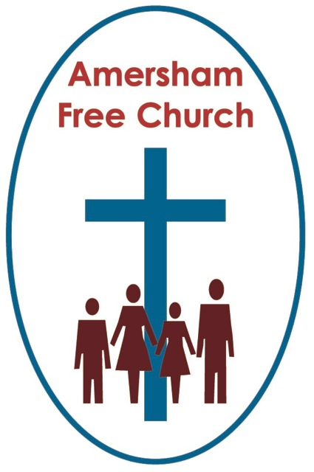
24th April 2022
Psalm 150
John 20.19-31

Just Doubting Thomas?
Minister: Gracious God, we open the bible
and long to receive your word.
All: Open, we pray, our minds and hearts to receive
that word with all its comfort
and in all its challenge. Amen.
We tend to sum people up with just a few words. Take Elizabeth the First, known in history as either Good Queen Bess or the Virgin Queen.
Thomas, that complex and intriguing disciple, is today inevitably remembered as Doubting Thomas, and his story crops up most years on this Sunday after Easter.
I think the first thing worth saying about him is that he is far, far more than just the doubter, and that like all of us his was anything but a mono chrome personality.
At times he was significantly courageous. Like the occasion when Jesus was being enticed down to Bethany to be with Mary and Martha as Lazarus lay dying. Word had got out that their village wasn’t safe for Jesus anymore, it being on the edge of Jerusalem and now infiltrated by the high priest’s spies. All of Jesus’ other disciples urge him to stay up north in Galilee, apart from Thomas. He breaks rank with this ‘Group Think’ and encourages Jesus to take a risk and visit his old friends at their hour of need.
Another snapshoot we have of him is the time when he questions Jesus about his identity and purpose. Jesus says, perhaps provocatively, you know me and where I am going. Thomas can’t let that pass and says that simply wasn’t the case. Thomas, even as a full-time disciple, still felt in the dark and confused. To which Jesus says: I am the way, the truth and the life.
I think we’re all grateful to Thomas for his questioning mind because it has given us one of the best known and much-loved phrases of the Gospels. Indeed, George Carey used to say when he was Archbishop of Canterbury: I believe the untidiness of asking questions is essential, and sometimes gloriously creative.
It simply isn’t true that Queen Bess was always good, just as it isn’t true that Thomas was always a doubter. All of us are contradictions. And most of us are never just one thing but a collection of conflicting attributes.
So what of today’s Gospel and this moment when a cautious Thomas is back with the other disciples and experiences resurrection a week later than the rest of them. Hence the story’s traditional placing in the lectionary today, seven days on from Easter.
In his isolation Thomas’ scepticism might have grown and become permanent. So instead of coping alone with his disbelief he joins the others. Now, on that first Sunday after the resurrection Thomas is in the room.

It may not work for everyone, but often being with others, in company with fellow Seekers after Truth, is a good place for us when our faith feels fragile. It’s probably why the New Testament urges us not to give up meeting together. Our prayer is that in gathering with our fellow pilgrims for worship, we hear God speaking to us as his body, as his family, and as his community.

When faith is burning low – being with our sisters and brothers in Christ can be a good place to be.

Well - he only had to wait a week – who knows perhaps they had already started to gather on Sundays for worship – and even though the doors were locked Jesus came among them greeting them with the words: Peace be with you.

I’d have loved to have seen Thomas’ face. A look of amazement, tinged maybe with an ounce of shame.

Jesus invites him to stop doubting and believe. And I guess Jesus has been saying that for a long time to many of us. And Thomas replies: My Lord and my God.

There’s no doubt that this response takes centre stage in today’s story. That moment when Thomas becomes a believer in the resurrection – a belief that transforms into worship. He’s made the journey home and is now, as it were, part of the Community of the Resurrection.
Yet I suspect it would be good for us just to pause the story telling at this point and ask the question what did it mean for Thomas to ‘believe’? Or, for that matter, what does it mean when we say he ‘doubted’.
Understanding the precise meaning of the words from the Bible is usually much harder than we give credit for, simply because Jesus or Thomas, in today’s story, were not speaking in English.
We know that on more than one occasion John describes the purpose of his Gospel so that ‘you may believe’.
And, in church, we tend to think we know what it means to ‘believe’. Indeed, we sometimes ask people to stand at the front at their baptism or reception into church membership and answer a question like: Do you believe in one God, Father, Son and Holy Spirit?
We often view this sort of belief in a cognitive sense. It’s about our minds and our intellects. But is it ever only about that?
When I was at sixth form college a great emphasis in our Christian Union group was laid on something called ‘Apologetics’. That process of trying to form coherent arguments about the validity of Christianity, to make it into a rational and believable faith. Indeed, as bouncy, and inevitably somewhat over-confidant, seventeen-year-olds we all thought one of the best forms of evangelism was trying to ‘argue’ someone into the kingdom.
Yet those who know a thing or two about biblical languages tell us that the word ‘believe’, when used in a passage like ours this morning, also includes the idea of trusting. It’s not just about the head but also the heart.
It's about believing someone because I also trust them – and that’s about being in a relationship with them.
It's as if Jesus’ challenge to Thomas could be read as: Do not be distrusting but trusting.
Risk and Trust go hand in hand. If we trust someone, we might well take a few risks in life with them. Or as that old ABBA song puts it: Take a chance on me.
Isn’t that what Jesus was saying to Thomas that Sunday night. Trust me Thomas, we can do this together, Trust me Thomas.
This invitation from Jesus to Thomas was far more than simply asking for an intellectual assent. It’s Jesus asking Thomas to take a chance on him, to do that risky thing and place his trust in Jesus, so that together they could walk into the future.
Now I just want to finish this talk with what I hope will be a word of encouragement to all of us who doubt from time to time.
It's often said that it’s indifference which is the enemy of faith rather than doubt. At least if one is doubting it probably means we are giving matters of faith some serious thought.
I suspect everyone doubts from time to time. We doubt, we trust, and then we might doubt again. That’s part of trying to live with integrity and an enquiring mind.
I just note this from today’s reading. Jesus enters the room that Sunday evening with the words Peace be with you. They needed to hear that as so much fear was still in the air. They had lived through tumultuous days, the days of crucifixion and resurrection. So, in this time before his Ascension Jesus took every opportunity of meeting with his friends offering them peace, God’s peace.
He’d done that the week before when Thomas is absent, he does it now when Thomas is present. Before he addresses Thomas directly, he offers absolutely everyone in the room, without exception and including Thomas, God’s peace.
Can we hold on to that today? You are not outside the love of God if you are a person with questions. God doesn’t reserve his peace only to those with obvious belief. He wants the whole room, the whole community and the whole world to have his blessing. Before we respond to God he reaches out to us, both to those who trust and those who doubt, he reaches out to everyone with his greeting and welcome of peace.
The modern hymn writer, Stuart Townend has encapsulated this beautifully in one of his songs that has a verse:

Come, all you vagabonds,
Come all you ‘don’t belongs’
Winners and losers,
Come, people like me.
Come all you travellers
Tired from the journey,
Come wait a while, stay a while,
Welcomed you’ll be.
Come all you questioners
Looking for answers,
And searching for reasons
And sense in it all;
Come all you fallen,
And come all you broken,
Find strength for your body
And food for your soul.
That’s the God who welcome us. The God who can cope with all our questions. The God whose greeting of peace is for absolutely everyone in the room.
So, like Thomas, the resurrected Jesus meets us all today and asks us to believe and to trust.
And may we, like him, respond with the words: My Lord and My God.
May it be so in the name of our risen Saviour, Jesus Christ. Amen.
Ian Green Amersham 23rd April 2022

