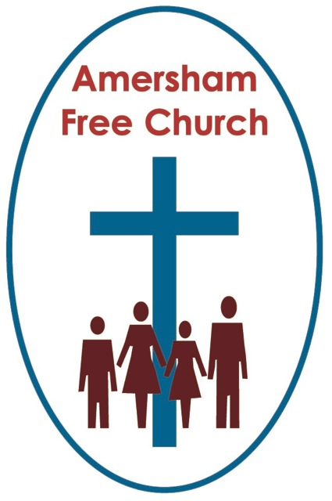
I Kings 1.38-40
Acts 2.1-4

A Weekend for Rejoicing
Jesus promised his disciples the GIFT of the Holy Spirit. And in The Creed we sometimes refer to the Holy Spirit as the Lord, the Giver of Life.
So, today on Pentecost Sunday, sometimes referred to as the Birthday of The Church, our thoughts are on gifts and the giver as we focus on the ministry of God, The Holy Spirit.
It's clear in scripture that the Holy Spirit is a blessing. The presence of God always is. And it’s just as clear that if we have known God’s blessing, we are called to share it and seek to be a blessing to others. This isn’t a gift to keep to ourselves but to generously offer to those with whom we share the journey of life. We are called to: Be blest, and then be a blessing.
So, fifty days after Easter, whilst still in a state of deep anxiety and uncertainty, the disciples, gathering behind closed doors, undergo a change of heart and mind that radically emboldens them. They speak now with a newfound confidence and in place of fear, cowering in secret rooms, they launch out taking a courageous witness.
Scripture says they had received the gift of the Spirit. Something of God seems to have touched their lives and made all the difference to their discipleship.
This is like a new springtime for the likes of Peter and Andrew, James and John.
After the trauma of Easter and the mixed emotion of Jesus’ Ascension it’s as if these friends of Jesus had buried their faith. They kept it quiet and lived a secret life. Yet on the Day of Pentecost, it’s as if the sun comes out and the buried seeds germinate and filled with new life, start growing, producing that Fruit of the Spirit that includes love, joy and peace. They have been blest and now they become a blessing. They go to the Temple and heal a lame man; they speak up for the marginalised and seek to liberate the oppressed. In short, now living in the power of The Holy Spirit they begin to live like Jesus.
And that has always been one of the best ways of sensing God at work, through the lives of love, compassion and integrity that we experience around us. We even talk of some people being a real ‘gift’ in our lives. Someone whose life has touched our own and made our journey brighter and given us hope.
Being full of the Holy Spirit is to sense our lives being touched by God’s love and peace. And just as we receive that gift, so we try to share that love and peace with others.
Now, of course, this year we have a wonderful collision here in church. For today Pentecost and Jubilee come together on this very special weekend of celebration. And I think this is no bad thing.
Pentecost Sunday is essentially a time when we say to ourselves that faith isn’t just about words on a page or doctrine in a book, it’s about God at work. The Holy Spirit is God at work. God at work in people. God seen in the life of a person. And when we can see that, we give thanks for the gift of that person.
This weekend we offer thanks to God for our Queen. Her life, like ours isn’t perfect, yet I suspect many people across the globe are offering thanks today for her life of such committed service and steadfastness. In so many ways her life has been given to us. She offered it, willingly and humbly, as a gift to Britain and The Commonwealth on her 21st Birthday in Cape Town.
On the day of her coronation in Westminster Abbey it was the Moderator of the Church of Scotland who presented the Queen with a bible, declaring these scriptures to be the lively oracles of God.
Isn’t it significant, don’t you think, that amongst all the gold and diamond encrusted gifts presented to her that rainy day at Westminster the Church of Scotland Moderator, in presenting the bible to the Queen, said it was the most valuable thing this world affords.
These scriptures speak of God, they tell the stories of Jesus, they sing of love and have hallowed pages narrating the integrity of struggle.
We only have to listen to the Queen’s Christmas Broadcasts to realise how much the bible has meant to her over these seventy years.
Yet the essence of the Spirit’s ministry is the lifting of truths found in scripture into a life in which such truths are then lived out.
God the Spirit fills us, emboldens us, motivates and inspires us to be his servants every day.
I mentioned recently that on her Accession Day, from Sandringham, the Queen, in her own hand, signed off the press release to the nation with the words Your Servant.
Although we know she must now live her days more quietly, this weekend we are thanking God for a Sovereign who, in her own reserved and dignified way, has sought to stand with us in moments of pain, whether that was laying a wreath with Princess Anne, at Dunblane just after the massacre, visiting a hospital in Manchester after the Arena bombing, or travelling with Prince William to meet the residents of Grenfell just days after the fire.
Our society is blessed when our leaders remind us of love. Our homes are blessed when those around us show us love. Our church is blessed when our life together is touched by love. Because God is love. So, the activity of God, the pulsating heart of God and the ministry of the Spirit of God is love.
This weekend our nation is giving thanks to God for the gift to us of Elizabeth the Second. A monarch who did not just accept the bible on her coronation day but has surely sought to live by it in all the days since.
A monarch who hasn’t stayed in her palaces and castles but has moved among us, and whose presence has given encouragement, whose words have offered quiet reflection and whose constant service has been done in an attitude of love.
Of course God’s Spirit is not only seen in the life of Kings and Queens. We have the gift of so many lives that in these seven decades since 1952 have blessed our lives with something of God’s love and life.
Just think of Watson and Crick discovering DNA in the early days of Elizabeth’s reign and the way that science has given so much hope to our world, never more so than in the last two years.
We give thanks for the gift of Martin Luther King who spoke with such eloquence of his dream of inclusivity.
We were inspired by the life of the 19 year old Wang Weilin who stood before a tank in Tiananmen square and showed such bravery in the face of oppression.
We were touched by the kindness that Mother Theresa and her Sisters of Mercy have shown to thousands who languished on the streets.
And in the year she died, 1997, a baby called Malala was born in Pakistan, who grew up to be the bravest of students, standing against the Taliban and insisting that girls like her have a right to be educated.
And over sixteen years of competing we watched with growing adulation as the Paralympian, Tanni Grey Thompson won no less than 11 gold medals.
These, are fellow human beings, have during these last seventy years been examples of the best of us. Their lives have been gifts to us of love, courage, commitment and integrity.
As the hymn puts it: All over the world, the Spirit is moving. God is at work, by his Spirit, in our lives.
For perhaps the greatest example of that is not to be found in a palace or reported on in a newspaper. The greatest examples will be the way you have been loved at home. The encouragement you have received from friend and family. The inspiration that has come your way working alongside colleagues.
God has blessed you and me – through you and me. The Spirit, at work in ordinary, everyday lives.
This is a weekend for rejoicing.
Be blest. And then, with God’s help seek to be a blessing.
For that is the ministry of The Holy Spirit.
And may that be our Pentecostal and Jubilee joy this morning - in the name of the Father, Son and Holy Spirit. Amen
Amersham, 4th June 2022

