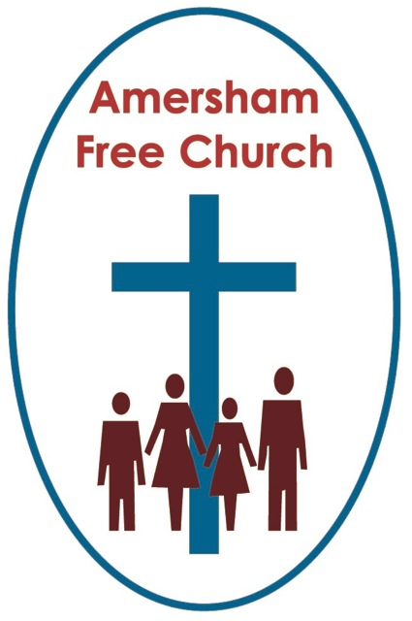
12th June 2022
Psalm 8
John 16.12-15

A Psalm for Star Gazers and Soul Searchers
My grandfather was always an encourager. My brother and I went to Junior school near where my grandparents lived and twice a week we’d go to their house for lunch. At a time when some of our classmates might have a gift of a football comic from their grandparents, my grandfather took out a subscription on our behalf for a Junior encyclopaedia, and once a month there would be the next instalment on the dinning room table for us to take home.
I loved those books as I did the nights I would often stay with my grandparents, going out into their garden and using my grandfather’s binoculars to look up into the night sky trying to spot and learn the constellations.
Today’s reading from the Jewish Temple’s hymnbook has been called A Psalm for Star Gazers and Soul Searchers.
And it’s surely one of the most loved and used. In the King James’ version, it begins: O Lord, our Lord, how excellent is thy name in all the earth.
Psalm 8 basically looks in one direction only, to God. It’s as if we are standing alongside someone praying, someone talking with God, pouring out their heart with praise and asking the tricky questions of life.
And praise is central here with the psalmist both beginning and ending his song in a spirit of overflowing thanksgiving.
So he kicks of with the affirmation that God’s majesty is praised as high as the heavens and he concludes: how glorious is your name throughout the world.
The beauty of creation often brings us to our knees. Perhaps words fail us as we reach a summit or look over a lake and as we smile in deep appreciation for simply being alive on this beautiful planet we say, ‘O my’.
Now, although I don’t get all my theology from The Vicar of Dibley, I cherished that moment when The Revd Geraldine gives all the money fundraised for a new elaborate stained glass window away to a famine appeal, and come the unveiling of the new West End window she reveals it’s made of clear glass looking out over a beautiful sunset.
On so many levels, including generosity to those in need and a deep appreciation for the beauty of God’s creation, that episode, well in my book at least, got it spot on.
Now, some bible scholars say there’s a rogue verse in Psalm 8, the second one, and in our church bibles it reads: from the mouths of babes and infants at the breast you have established a bulwark against your adversaries.
It's one of those verses that isn’t straightforward. There’s no obvious interpretation. How can babies and infants be an answer, or a source of strength against our enemies?
Well, in preparing for today’s sermon I came across one interpretation that rang bells with me. For another way of reading that word ‘bulwark’ is not to think of it as a strong weapon but as a song of praise, and that rather fits with these opening verses of Psalm 8 which are all about worship and thanksgiving.
So, it’s just this thought really, that as long as we get into the habit of thankfulness, so that even as babies and infants we develop the routine of praise, then we can face even the toughest and bleakest of times. Someone has put it like this: So long as we sing, even as youngsters, the chaos is silenced and meaninglessness is repudiated.
Well, that might just fit with an article that a member of the congregation passed on to me the other day all about the benefits of singing. In it the TV doctor, Michael Mosely says singing not only enhances your mood, but can actually benefit your immune system. The piece ended: As legendary jazz singer, Ella Fitzgerald once famously said: The only thing better than singing? Is more singing!
Verse 2 might just be saying this and a bit more. For the singing here, from babes and infants, is in praise of God. It's living with a thankful heart. The idea that facing life this way, trusting in God and counting our blessings will, how did the commentator put it: silence the chaos and repudiate meaninglessness. It’s a great idea, that living with thankfulness, and even singing about it, is one of the very best medicines of life.
Now, there is a central question in this Psalm. It’s one that every generation and most people ask, and in this beautiful piece of Hebrew poetry it’s phrased in a moment of contrast.
The singer or pray-er of Psalm 8 looks up into the night sky and for a moment is blown away by the sheer number of stars in the moonlit heaven. Who hasn’t had such a moment? I recall my first visit to the Lake District when we stayed on a farm with not a streetlamp anywhere. I just loved standing and staring out into the clear, yet black Cumbrian sky speckled with a thousand pins of light, and I too said: Oh my!
In December 2009 the National Geographic magazine expressed similar wonder with its cover photo of a sky billowing with stars and the headline: Searching the Heavens for another Earth.
I think my Junior Encyclopaedia said that if we condensed the size of the universe down so that our sun was the size of a tennis ball, then planet earth would be no bigger than a grain of sand 27 feet away, with our nearest star 1,400 miles away.
Yet we look up, and our star gazing leads to soul searching because at that moment a troubling contrast comes into our mind, how does today’s reading put it: When I look up at your heavens, the work of your fingers, at the moon and the stars you have set in place, what is a frail mortal, that you should be mindful of us?
And that is the question: What are we? Who are we? What’s our role? What’s our place?
One of the many reasons I love the Judaeo-Christian tradition is that it holds the big and the small together. God is thought of as the Great Creator, yet God also cares for every individual and invests us with worth and dignity.
Sarah Rhodes’ wonderfully simply, yet tremendously profound hymn puts it this way: God who made the earth, the air, the sky, the sea, who gave the light its birth, he cares for me.
Of course, today’s Psalm sometimes ‘gets it in the neck’ from critics who blame it for stoking the human ego with all this talk of humanity being made a little less than gods, and our role described as that of having ‘dominion’ over creation.
History teaches us how easy it is to misappropriate those ideas with little regard to their original meaning.
Perhaps it sounds a little blasphemous in a Jubilee year to say that, as the story is told in the Jewish Scriptures, God wasn’t that keen to set up a monarchy. Just because other nations had kings didn’t mean God necessarily approved of Israel having one.
So, the understanding developed in Jewish society that monarchs like David and Solomon were ‘given’ dominion over their people by God. It’s as if God gifted them with this temporary authority not for their own benefit and comfort, not to boost their ego, but so that they could become a channel of his blessing, they could rule with his justice and in his name. The only intended outcome of being given ‘dominion’ is that a King might make the life of his subjects better.
Now, viewed like that, the idea that God makes us, how does the church bible’s put it, ‘masters’ over creation isn’t the cue for us to do what we like with the planet, it’s the understanding that we are to care for it like God does. And in that way, we share with God, we participate with God in the evolution of our world.
What a responsibility! What a privilege!
Psalm 8 has a very high view of humanity. So, as it asks that central question: What is a frail mortal, that you should be mindful of him? The answer really becomes an invitation. An invitation for us to join God in this ongoing process of creation. And that becomes our vocation.
Can we rise to the challenge of ordering, shaping, stewarding and caring for the planet, our God given home, in a God given way?
Such an understanding of life, and our part in life, spills out into everything from agriculture and industry to the arts and medicine. In all these processes that make up life on Planet Earth, can we make a contribution that thinks of others, that honours the interconnectedness of nature, that makes provision for the future and learns to work with the wisdom and mind of the divine that is in every seed.
The TV programme Repair Shop is currently getting viewing figures of around 5-7 million. In these days of so much TV choice it is deemed to be one of the BBC’s biggest success stories at the moment.
Again and again people bring in faded family treasures to the Repair Shop so that, once brought back to their former glory they can be passed on to the next generation, with stories about why previous ones loved these objects so much. And in that there is a beautiful picture of ‘dominion’. That we hold these treasures just for a moment, doing our best to see that others will be blessed by them in the future. And that is part of what it surely means to live in community.
Today, along with the writer of this temple hymn, we have reflected upon a Psalm for Star Gazers and Soul Searchers.
A psalm that speaks of living a thankful life. A psalm that begs the question: Who am I? And comes up with answer: I am blessed to be here, here in God’s world, and my task in everything I do, is live this life honouring the world around me, caring for it and those with whom I share this journey reflecting the character of God in all I seek to do.
For Star Gazers and Soul Searchers have but one song and it goes like this:
O Lord our God, how glorious is your name throughout the world.
May such an understanding of the universe and our place within it be constantly focused on our Creator, Redeemer and Sustainer, the Trinity of God, today and always. Amen.
Ian Green, Amersham, 10th June 2022

