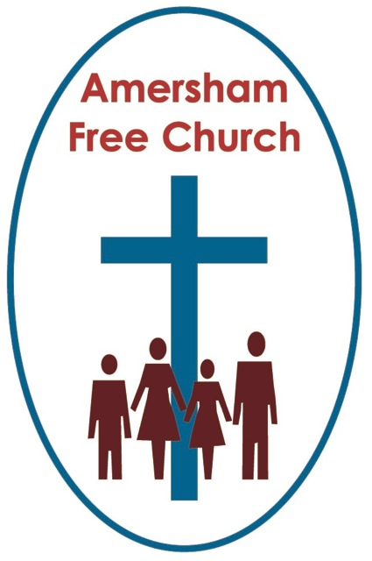
2nd October 2022
Jeremiah 7.1-7
Revelation 21.1-4, 22-25

Church – wider and local

So, it’s Happy Birthday to both the URC and our AFC building.
It rather rained on the URC parade yesterday as the Anniversary Service in Westminster Central Hall was cancelled due to the train strike. However, despite that disappointment the fact remains that 50 years ago the Congregationalists and Presbyterians in England joined forces in a prophetic act of ecumenical co-operation and formed the United Reformed Church.
Ten years earlier, our visionary predecessors here at AFC, took possession of this church building, and we are grateful to Michael Autton who has sourced and displayed some photos of that event, now on display in the Carey Room for the next month, do have a look!
Part of that research was the discovery of the order of service from Sunday 30th September 1962 showing the first bible readings used in this Sanctuary. Both, I guess, specially chosen by AFC’s minister, The Revd Neville Clark.
The Jeremiah passage reminds us that coming to church or temple has never been enough. We need an inner integrity that gives faith both energy and staying power. There are other passages like Jeremiah in the Bible regularly warning us that attending any House of Prayer has to be accompanied by a desire to pray.
The Revelation reading is something of a warning, even to those gathering in a gleaming new Sanctuary that ultimately any chapel or even cathedral is just a foretaste of heaven and a glimpse of eternity.
Alfred Ellis, the Baptist Union solicitor, along with some friends set up Amersham Free Church in 1907, soon buying a plot of land in Sycamore Road for £150 and building the first AFC there in 1912 for £583!
It’s wonderful to read how the church grew and needed an extension, before moving to an even bigger site here on the Woodside Road in 1962, into a building that cost £75,000.
Alfred Ellis and his companions were not alone in founding a ‘Free Church, in that Edwardian period. It was a time of tremendous growth amongst Baptists, Congregationalists, Presbyterians and Methodists and there was a drive even to form a ‘Free Church’ of England denomination. That never came about, but other ‘Free Churches’, often combining in one congregation the Baptist and Congregational tradition grew up in places like Letchworth, Hampstead Garden Suburb and, of course, here at Amersham on the Hill.
The discovery of that order of service of 30th September 1962 is fascinating because it indicates a style of worship that for chapel goers was quite liturgical – and that tradition has remained at AFC for the last 60 years, one that has rather bucked the trend which over this last half century has seen churches become increasing informal using songs rather than hymns. Back in 1962 there are elements within the service we still recognise such as that moment of silent reflection we have every week after the sermon. The Intercessions, then as now, come as a response to the sermon. And at that opening service there was an openhearted and broad view of ‘The Church’, with representations from the local Anglican and Methodist churches, and national leaders from the Baptist, Congregational and Presbyterian traditions all being present.
It's as if AFC, combing as it did various denominations into its DNA got there decades before the inauguration of the URC. Not for the first time the local prefigured the national. And that always encourages me, for there is a dynamic in any local congregation. A dynamic in which we sense the moving of the Holy Spirit prompting us, challenging us and moving us forward. I recognise it’s the Non-Conformist in me that believes the best motivation in church life isn’t because a bishop or church hierarchy tell you to do something, but rather it’s when a group of people, meeting and worshipping locally believe the Lord is leading them to do a work for him in this place and at this time.
I also smiled when I read the 1962 order of service that between the dedication event in the church hall and evening service in the sanctuary there would be a ‘cup of tea’ served. It sounds so modest, but I know other reports describe it as an impressive spread.
During that first service the congregation used a Dedication Prayer, today we are just going to use a small, and slightly amended portion of it. In its longer form it laid out an understanding of church life that we still adhere to today. It speaks first of worship, a worship that is gathered around the reading of scripture, scripture that points us to the Lord Jesus Christ, who life, death and resurrection is remembered and celebrated in the sacraments of baptism and Holy Communion. And all of this, is imaginatively emphasised architecturally here in the chancel with a band of brass encompassing the font, baptistry and communion table, signifying their importance among us.
That dedication prayer 60 years ago gave thanks for the Reformers of The Church, indeed some of their names were chosen for the side rooms, such as Cartwight, Carey, Wesley and Owen. These were church leaders who belonged to the Reformation. Who prayed for a vibrant church, one based not on social standing or tradition but based on an individual faith and a corporate understanding of us being the Family of God.
Touchingly that dedication prayer also acknowledged the sacrifice of local folk here in Amersham who made the building of this new Sanctuary possible. People who gave of their time and financial resources to make this great project become a reality.
I remember talking to Mary Norris who told me how hard her father had worked, as Church Secretary, to get Neville Clark, who’d only been minister at Rochester for three years, to come to Amersham and lead the congregation. Neville Clark belonged to a group of younger ministers, The Revd Don Black was another, who formed the Cassock Club. A group of Baptists who believed in liturgical renewal. Hence all this thought about what a sanctuary is for and how it should be used.
As the building neared completion in 62 the builders donated the cross that has been hanging here for 60 years and the architect the chalice that we have used at every Communion Service since. All of that gratitude is summed up in the dedication prayer that offered thanksgiving for the artists, builders and pray-ers who brought this new building to birth.
During the Pandemic, one afternoon, I sat here all alone. It was eerily quiet, as was the whole world at that anxious time. In the silence of that moment, I felt as if the building was lovingly calling us all home, waiting for us, willing us eventually to return. For a time, our prayers and praises were said and sung elsewhere, yet what a joy it was to return and be enveloped once more in these walls of prayer and worship.
So, is it just a building?
Well, in a way it is. For the church is ultimately the people not the bricks and mortar. Yet it was born in prayer. It was built with love. It was intended to be a beacon of service. And within its walls, dedicated 60 years ago a promise has been kept. For at that evening service the congregation prayed in hope that here God would meet with us so that, and these are the words they used that night:
Broken lives would be restored.
Burdens of sorrow lifted.
Strength consecrated.
Love hallowed.
That the shadow of death would be turned to the morning of resurrection.
And that all goodness may find encouragement.
In my view these were inspired longings.
Well, God has never once failed us in these last 60 years as a local church, or these last 50 as a national denomination.
And so, we walk into coming days, resolved to play our part, in the power of Holy Spirit, in continuing this tradition of heart felt worship and loving service, as we seek to be God’s People, in this place for this time.
May God help us fulfil our vow, which we make today with thanksgiving for the past and hope for the future. Amen.
Amersham, 30th September 2022

