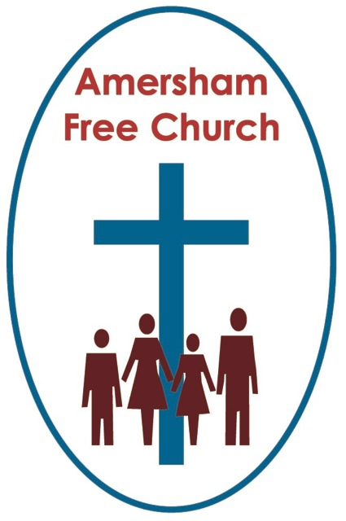
Sunday 19th April 2020
John 20.19-29

There’s more to Thomas than just doubting!
It’s often on this Sunday, the first after Easter, that the lectionary takes us to the story of ‘Doubting Thomas’. Yet there is so much more to Thomas than just his doubts.
Thomas, like all of us, is a work in progress.
We don’t know over much about the disciples, yet occasionally we glimpse just something of their idiosyncratic personalities. James and John, maybe, had a temper and came from an over ambitious family, always wanting top place at the table. Judas seems totally convinced by the power politics of religion, whilst Peter speaks before he thinks and, somewhat charmingly, never seems to learn from previous mistakes so lurches from one blunder to another.
Thomas asks questions. Not, I think, the biggest sin in the book. In fact, quite the opposite and perhaps one of the best characteristics to be found amongst any of the twelve.
He showed that side of himself in John 14.

The disciples are with Jesus, he’s just washed their feet and in true rabbinic fashion is teaching them, and they are discussing what he’s saying.

In order to comfort them Jesus speaks about heaven; his Father’s house having many rooms and says: I am going to prepare a place for you. He ends this encouraging episode with the phrase: You know the place where I am going.

Now that should have been a happy conclusion. So, I rather smile at the gentle audacity of Thomas when he throws in a question that disturbs the waters. He says: Lord, we do not know where you are going, so how can we know the way?
Thomas reminds me of that Jewish tradition of children asking questions at Passover. Why do we do this? What happened on that first night?
Jesus responds to Thomas with those wonderful words: I am the Way, the Truth and the Life.

Well, for all his supposed impertinence I find this an attractive side of Thomas. For whilst it’s true that constant interrogation is annoying – such as: Are we nearly there yet, from the back of the car - there are occasions when everybody benefits from a good question and Thomas is often bold enough to ask them.

God, I think, has made us this way. He’s given us enquiring minds that search for truth and long for reason.

You and I will be asking many questions at the moment. God can take our questions.
The Psalmists knew that. Some of the songs they wrote were Laments. Laments that asked real questions about suffering and the confusion of life. Yet, Laments that usually end with an affirmation that even in their most confused moments these ancient musicians and singers still choose to trust in God.
Never give up asking the questions. That, I think, is a great lesson taught us by Thomas
I began this talk by saying there’s more to Thomas than his doubts and, in fact, I think that one of his finest moments, when his faith truly shone, was when Jesus received the chilling news that his great friend Lazarus was dangerously ill down south in Bethany.
Thomas was the only disciple who urged Jesus to go and visit.
The others urged him to stay up north in Galilee, recognising that Bethany’s proximity to Jerusalem would be personally dangerous for Jesus at this time.
We don’t often talk of Thomas’ courage, preferring instead to define him as a single sided character rather than a multifaceted personality capable, like most of us, of great faith before lunch only to be followed by nagging doubts before tea!
On hearing that Lazarus is dangerously ill Thomas is impressive, urging Jesus to not delay and make the journey to Bethany straight away. He does more than that even, he offers to go with him.
This is Thomas at his very best – this is the Courageous Thomas of the gospels.
Over these last few weeks I’ve detected in myself that I oscillate almost every day between fear and hope. So, I take heart from today’s reading that it’s OK to be a follower of Jesus and yet still have a faith that is a jumble of unending questions alongside a deep desire to walk purposefully alongside my Lord.
The one doesn’t cancel out the other. Thomas taught us that.
So, during these days we bring our Laments and our Hymns of Faith, we ask our questions and place our trust in Jesus. For I sense, there’s a bit of Thomas in each one of us.
And may his beautiful words become ours as we too greet the risen Jesus as the one who is both, ‘My Lord and my God!’.
Ian Green Amersham 14th April 2020

