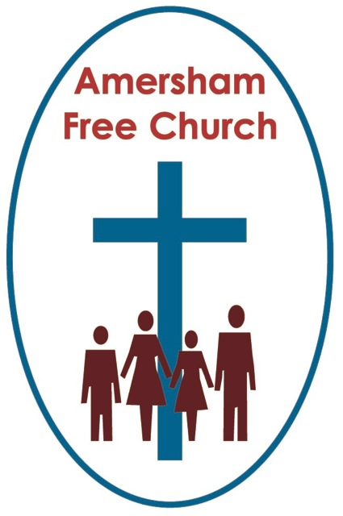
Psalm 32

Matthew 4.1-11
1st March 2020

The Joy of Forgiveness
Gracious God – we open the bible and long to receive your word – open, we pray, our minds and hearts to receive that word with all its comfort and in all its challenge. Amen.
One parade service, in another church a few years ago, I had one of those ideas that seemed good at the time, but which tuned out, in practise, to be an absolute disaster.
Always keen to involve the youngsters, one Sunday I set up a flip cart at the front of the church and introduced the prayer of confession by saying: Boys and Girls, if any of you have committed any sins this week, just call them out, I’ll write them down and we’ll use the list as a basis for our prayer. My youthful naivety, for this was the first church in which I served, was meet with a predictable long stony silence. Not one Scout or Guide wanted to publicly confess their misdemeanours before a full church, probably containing their mum and dad.
Today’s lectionary reading from the Jewish scriptures, Psalm 32, is one of seven penitential psalms often read in services during Lent. It’s a psalm that has much to say about the value of confession and the joy of forgiveness.
Like most of the Psalms this one would have been sung by the temple choir, antiphonally, one side chanting one verse, the other responding with the next.
Lent prompts us to reflect upon our lives. I suspect we won’t be spending forty days in the Wilderness like Jesus, but we can use this season as a spiritual discipline to step back and contemplate where we are going in life. It’s a season for asking some probing questions and coming up with honest answers. And such inner journeys can bring us to a realisation that we need to deal with some of our buried issues, maybe turning over a new leaf, bringing an unhelpful habit to an end or seeking a new beginning with a family member or friend.
Don’t worry, I promise to leave the clip board in the church office this Lent, but this is still a good season for confession.
Although confession starts in a moment of reflection doesn’t it have to go somewhere? This dawning realisation leads me on to the conviction that I have a responsibility to put things right when I’ve gone off kilter.
Confession really is a verb, it’s a doing word and one that, with God’s help, can bring about restoration and renewal.
I’m sure that’s where the origins of passing the peace at communion comes from. It’s the idea that Paul puts before us that before we take bread and wine, we take seriously the idea of seeking to live harmoniously in the Body of Christ, so before breaking bread we offer a hand of reconciliation to anyone with whom we have a broken relationship. We not only confess our sins, we seek to put right the harm and hurt they may have caused another. Confession needs to active and grow into restoration.
So, today’s Psalm starts with the words: Happy is the one whose sin is forgiven.
That word Happy or Blessed is the one that starts Psalm 1 and is the word that prefixes all the Beatitudes of the Sermon on the Mount. It’s a word that describes a life blessed by God, a life that has found a sense of peace and equilibrium in God.
So, the psalmist has a great conviction running right through this temple song and it’s this: if you stay silent, verse 3, our sins and transgressions eat us up. The psalmist puts it more poetically: our bones, he says, waste away.
Keeping the bitterness going because we have been wronged or refusing to say sorry when we have been the wrong doer, such stalemates do our souls no good.
The psalmist’s prescription for better mental health is there in verse five, a verse all about confession of sin to God and consequently sensing an immense release from guilt.
It is hard, isn’t it, to put into words the joy we feel at being forgiven. Maybe we’ve held back, but then we find the courage to speak honestly with a person we love but who we’ve let down and our apology is met by their graceful, life giving response of forgiveness, suddenly we feel we are no longer at the sad ending of a story but at a wonderful moment of new beginnings.
It's that moment when the Prodigal Son returns home to find a forgiving Father enfolding him in those welcoming arms. It’s the moment felt by Peter on the beach remembering his fireside denials of Easter yet encountering the Jesus who gives him a second chance with the commission to ‘feed my sheep’.
Such moments can be the most profound and precious of our lives as our failures and sins are met by the grace and forgiveness of those we have wronged, and in their response, we met the love of God.

Our journey through every Lent leads us to the cross of Jesus. Everyone executed this way suffered an horrific and barbaric end so Christ’s words from the cross seem incongruous: Father Forgive.
He doesn’t curse those who crucified him, he forgives them and all involved in that corrupt and flawed legal process that led him to that hill outside Jerusalem’s city walls.
I think the Christian idea of resurrection is made possible through the way Jesus died with forgiveness on the cross.

Maybe those who inflicted the cruelty of crucifixion thought they had silenced a rabble rouser and won the day. Yet, by offering forgiveness instead of hatred, Jesus shows us how life can be lived.
Early in World War Two, in November 1940, Coventry was bombed under the codeword ‘Moonlight Sonata’. Its medieval cathedral was raised to the ground. Two charred timber beams from the roof were strung together and became a makeshift cross upon the battered altar. Three roof nails were twisted together to become the Cross of Nails that stands today upon the new Cathedral altar.
Just six weeks on from its near destruction, on December 25th, 1940 the Christmas Morning service was broadcast from Coventry by the BBC on national radio. By then two words had been inscribed on the altar front, now standing open to the elements in the bombed-out cathedral: Father Forgive. Provost Dick Howard pledged in that radio service not to seek revenge for the bombing but promised after the war that his cathedral would work for reconciliation.
So began the Fellowship of The Cross of Nails, active today in Britain, America, Germany, Holland and South Africa. A Fellowship striving to do three things: to heal the wounds of history, to learn to live with difference and to celebrate diversity. The Cross of Nails Fellowship works with hundreds of primary schools in and around Coventry promoting these values of peace and reconciliation.
And isn’t Coventry’s story really one of resurrection. A resurrection that Provost Howard saw was only truly possible if it began with forgiveness. The beating heart of the Cathedral today is that old altar, left open to the sky as a permanent memorial, with the words Father Forgive still clearly visible, first inscribed in the dark days of 1940.
So much becomes possible when we forgive.
That’s the message, I believe, of this morning’s Psalm.
I was at a meeting the other day with a high church colleague who, with tongue in cheek, lamented a choir who had sung an anthem in church during Lent with an Alleluia. That, I was told, was bad form. No flowers and no alleluias in Lent, they are reserved for Easter.
Well, I sort of get it. But I think it’s wonderful that Psalm 32, a penitential Psalm for Lent ends with a kind of alleluia. The psalmist just explodes with praise and thanksgiving in its concluding verses, having received forgiveness the only response is: Rejoice in the Lord and be glad.
A few weeks ago we had a group of school children visit the church. They sat on the floor down there and Janet, our church secretary, engaged with them about what the font meant and why we sang hymns and said prayers. I was on my way to a funeral but sat in for part of the session and was struck by how often, in answer to a question, the youngsters would say: we say prayers because we have done wrong things, we are baptised because we have done wrong things, and God is cross with us for those wrong things.
Janet responded beautifully, always emphasising that actually church isn’t about feeling guilty but feeling loved by God. She constantly put the positive in the face of a rather negative understanding of God expressed by these eight-year olds.
Perhaps Lent has an equally bad press at times. Yet it’s so much more than just about feeling guilty.
This morning’s psalm reminds us that forgiveness is always a process. It involves pain, reflection, a longing for justice, encounter and confession. And if we are prepared to follow this process through, however tough and demanding that may be, it offers us the prospect of something that is liberating, constructive and full of new beginnings.

It's the message of Coventry.
It’s the message of the Cross.
It’s the message of Psalm 32.
And, it’s the message of Lent.
May it be our experience in these Spring Days of 2020, in the name of the Father, Son and Holy Spirit. Amen
Ian Green, Shrove Tuesday 2020, Holland House Retreat Centre, Worcestershire.

