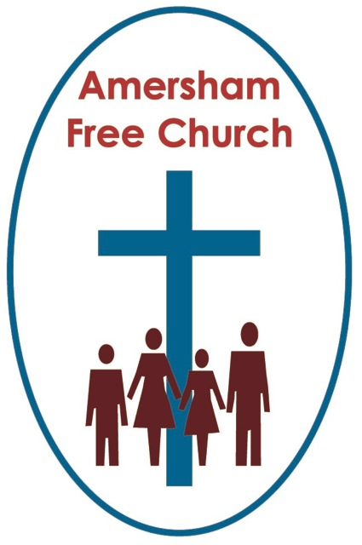
10th November 2019
Luke 20.27-38

Enigmatic Answers

Lord God – our prayer is that the written word will point us to Christ, the Living Word – so in his name we pray and for his voice we listen. Amen.
One of my favourite American TV series of all time is The West Wing. Seven series chronicling the Presidency of Josiah Bartlett, perhaps the best leader America never had.
In one episode, whilst talking to his frustrated advisors he reminds them that although they campaigned in poetry yet, he says, ‘we are forced to govern in prose’. Well, maybe it’s just a euphemistic attempt to justify pragmatism at the expense of conviction, but at least it has a ring of honesty about it. The strange thing about using that quote in the West Wing is that Bartlet’s presidency is at it’s best when he remains poetic. He is often depicted as a leader who used uplifting oratory to undergird his often-mundane, yet necessary legislation.
Jesus, I think spoke more often in poetry than prose. It’s the style of the parables and often the genre he adopts in rabbinical debates. He’s enigmatic in the answers he gives, so much so that they need a lot of teasing out, and even then, we are sometimes left wondering what he really meant.
Maybe this sense of mystery struck you as today’s lectionary gospel was read.
Jesus has now arrived in Jerusalem from the north. He’s taken many opportunities, En route, to criticise the Temple and there’s no doubt that it’s leaders, some of whom were Sadducees, were pretty fed up with this upstart from Nazareth.
Sadducees were sophisticated people, often coming from priestly families, even aristocratic in background. They filled the priesthood and they did so with a highly conservative and reactionary mindset, so maybe it’s not surprising they felt annoyed by Jesus and his teaching.
So, they come up with a very specific question about heaven. To us I suspect it seems bizarre.
Their question was based upon a piece of teaching from Deuteronomy 25 all about marriage and the idea that in a family a widow should marry the brother of her deceased husband.
In those far off days families were their own economies. You often married from within this wider family, thus keeping the wealth and status of that particular group in the ascendency.
But this piece of relatively straightforward teaching, this custom of a man marrying his brother’s widow is taken to extreme lengths with the question: if this happened seven times, then come heaven who are the real husband and wife?
Of course there is some background behind the Sadducees’ attempt to trip Jesus up with their Conundrum of The Day! It’s the simple truth that they didn’t believe in an after-life at all. So, in a sense their question was anything but an authentic enquiry.
The reason for this was the fact that the Sadducees viewed only the first five books of the Jewish Scriptures as being truly canonical. For them the Torah: Genesis, Exodus, Leviticus, Numbers and Deuteronomy contained God’s word and because it never mentions resurrection they didn’t subscribe to the idea.
The Pharisees and Scribes took another line. For them the rest of the books, including what we call the Writings and the Prophets, were highly valued and in these we do encounter the idea of an after-life, even if it might have been one developed originally from Persian thought and teaching.
This is the one and only time the Sadducees appear in Luke, and actually they died out as a separate group in the religious life of the nation after AD 70, and that’s perhaps why the evangelist has to remind his readers of what they stood for, because by the time this gospel was read many might have forgotten who they were and what they once believed.
So, the Sadducees ask a question about an idea they didn’t believe in to trip Jesus up because he seemed to be attacking the traditions of the Temple, where many of them served.
But a further idea is also floating around in today’s passage.
By the time Luke wrote his gospel around AD100 another way of thinking was much more prominent. It was the idea that an after-life offered both justice and judgement. Between AD66-70 Rome quashed a nationalistic uprising with such force and brutality that the Jerusalem Temple was raised to the ground and the people were dispersed. As a result, it was the Pharisees’ view of an after-life, rather than the Sadducees’, that won the day.
People were comforted by the idea that those who had suffered much in this life would find justice in the next and those who had acted brutally would be brought to judgement. That’s not what Jesus is teaching here, but it probably is the context in which Luke is remembering and recalling the ‘run in’ he had with the Sadducees.
So what are we to make of this rather strange encounter?
Well I think one issue that emerges from this conversation is that of language.
In our scientific age we want verifiable answers – and that includes answers about heaven. What’s it like? Who’s going to be there? Does it exist? Will I meet up with loved ones? And if I get there will I spend eternity as a young, middle-aged or old me? Such questions pose similar conundrums to the one asked that day by the Sadducees.

In today’s reading Jesus doesn’t answer any of those sorts of questions which may indeed disappoint us.
Instead Jesus deflates the Sadducees balloon somewhat by pointing out that one of the reasons for marriage here on earth – and this was especially true in his culture at that time – was to do with lineage. From marriages there were children, from children there was lineage, the name lived on, the family grew and supported each other and so there was security and permanence.
But, says Jesus, heaven is not to be thought of in these earth-bound terms. For a start the woman in the posed question was thought of as property, first of brother number one through then to brother number seven. That’s not the way it is the Kingdom of Heaven, says Jesus.
So he begins to use a different sort of language to describe us and heaven and says in verse 36 that we will be like the angels, we will be children of God – it’s beginning to sound a bit like the language of poetry rather than prose.
I suspect I’m a bit of a Sadducee myself when it comes to heaven. By that I mean I don’t think about it too often and much of my belief system if I analysed it would, I think, be about God and neighbour in this life rather than storing up all my hopes and dreams for the one to come.
Yet I’ve never not believed in heaven – I just don’t think I can define it accurately or tie it down specifically. I think of it in terms of mystery – a new reality which this side of death I cannot and never will fully grasp.
This, I suggest is what Jesus was saying to the Sadducees in today’s gospel. Urging them to stop playing such a pedantic game in that pointless quest of using an earthly paradigm to describe a heavenly reality which has no equal in either the language or experience we know today.
But to leave it there would be, I think an utterly inadequate reflection on this reading – because it’s not where Jesus leaves his hearers.
Instead, to these Torah loving Sadducees, he cleverly quotes back to them a story from the Torah. He reminds them of Moses standing at the burning bush worshipping – reaching out to Yahweh and calling him the God of Abraham, Isaac and Jacob.
In one sense that could just be a role call from history but put it together with the next verse: God is not God of the dead, but of the living: and in his sight all are alive... and we begin to build up this picture of hope.
These patriarchs represent different generations, yet they all found their ultimate confidence and security in God. It’s God who holds us all together, a community on earth and in heaven. God is at the centre of this Judaeo-Christian understanding of heaven. It’s a message of love, life and hope.
In the story of Moses at the burning bush he says God IS the God of Abraham, Isaac and Jacob, not God WAS their God, past tense, but IS their God, present tense.
Using the language of poetry Jesus is opening up the idea of the love and life of God touching the past, present and the future – and holding it all together in an unbroken continuum. It’s an invitation for us to trust that whatever is before us and those we love, we are constantly and faithfully held in the love of God.
In his lovely book critiquing the Narnia stories, The Lion’s Tale, Rowan Williams has this one liner: Death is profoundly serious – yet less than final. Perhaps you’d all like to go home write an essay with that title and bring it back – for Erna to mark next week!
That sense that there is a future beckoning us beyond the grave – not one we can scientifically analyse or specifically predict – but a future which Jesus says is like a room being lovingly prepared for us, is the reason why white stoles are regularly worn and Easter Day hymns often sung at funerals as we come together, even in our grief, not with glib answers but trusting in the love and grace of God.
I think it’s worth affirming that belief on a day such as this - Remembrance Sunday. I think it’s worth affirming that belief during this season of All Saints when many of us will be carrying in our hearts the loss of someone we hold dear.
From today’s gospel Luke portrays a Jesus who speaks to us of the God of the Living, whose love holds us in both this world and the next.
May such a hope fill our hearts both for ourselves and those we love, in the name of the Father, Son and Holy Spirit. Amen.
Ian Green, Amersham, 4th November 2019

