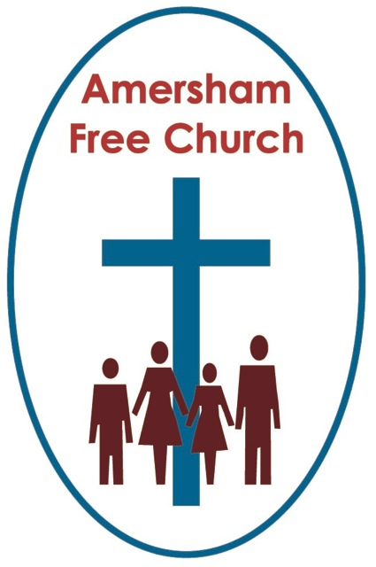
Habakkuk 1
Luke 17.5-10
6th October 2019

Waiting – a vital part of prayer and pilgrimage.

Lord God – our prayer is that the written word will point us to Christ, the Living Word – so in his name we pray and for his voice we listen. Amen.
There are some books from the Jewish Scriptures that we rarely hear from in church. So, it’s good this morning to be guided by the lectionary to one of them as we think about a couple of verses from the first two chapters of Habakkuk.
We know very little about this writer. He probably lived 700 years before the birth of Christ at a time when Israel was being over run by the Babylonian empire. Some have suggested, because chapter three reads rather like a liturgical psalm, that Habakkuk was a clergyman, maybe a Levite working in the Temple and used therefore to singing psalm like liturgy.

What we do know from this morning’s first reading is that Habakkuk bears his soul to us. He’s honest and open in the questions he asks, both to his readers and to God. Habakkuk is, like many of us, simply mystified by the problem of suffering.

We too ask similar questions like him, yet rarely, I think, have they been phrased with more eloquence and honesty.
He prays in chapter one: How long, Lord, will you be deaf to my plea? Why do you not come to the rescue? Havoc and violence confront me and the wicked hem me in so that justice is perverted.
It’s often said that prayer has many different languages. Sometimes we use words whilst at other times we sit in silence. Yet, however we pray most of us will have known times when we wonder if our prayers have been heard by God.
Habakkuk is obviously striving to be faithful to God and therefore he prays about his situation. Yet we meet him, in the opening chapters of his book, overwhelmed by pessimism. He makes a list, a litany of injustice – its all around him, he feels like a victim, he feels crushed with all the trouble, wrongdoing, destruction, violence, fighting and quarrelling. What’s more he can no longer turn to stable institutions for help, he feels that justice is being defeated.

Perhaps the numb of his prayer is this: to Habakkuk it’s evil that seems to be triumphing over goodness, darkness is swallowing up the light and deceit has wiped out truth.
Would that, at times, feel like a synopsis of all history? The school bully wins the day, the dictator celebrates a hollow election victory, and the powerful in the developed world fail to hear the cries of the poor in the majority world.

Habakkuk finds it difficult to make sense of this world – and he’s angry with God, because he feels that God doesn’t listen.

Some of the psalms read rather like Habakkuk’s prayer. We put them in a specific category and call them the Psalms of Lament. Indeed, Jesus even prays one on the cross when he cries out: My God, my God why have you forsaken me…
In other words, the scriptures (perhaps especially the Old Testament) really do prompt us to be honest in our faith. If we are finding the going tough or belief difficult, we are encouraged to name that before God and each other.
Hymn writers and composers of prayers are brave when they sometimes attempt to encapsulate the doubts we have and the questions we ask. Any journey of faith includes asking questions and then, sometimes. doubting the answers. Faith is a journey and a process, it rarely stands still because we must apply it to new experiences all the time. Faith grows, matures and changes with us. And in all of this I think Habakkuk teaches us it’s better to shout at God than walk away from him.
The Iona Community has done much when it comes to honesty in hymnody. John Bell and Graham Maule have used their gifts to write hymns which embrace our doubts at the same time as affirming our faith.
We are going to sing one in a few moments that begins: We cannot measure how you heal or answer every sufferer’s prayer. That’s honest. Those we love will sometimes die early or linger in pain unbearably long.
This hymn is full of gently asked questions. Yet it is also full of non-triumphalist faith. So, the second line runs: Yet we believe your grace responds where faith and doubt unite to care.
I sometimes wonder if this understanding of faith is really appreciated outside the Church. I’ve often been struck by friends who say they have no faith themselves yet they expect me to be a stereotypical Christian finding prayer easy, belief straightforward and exercising clearly defined moral choices.
The reality, at least in my own journey of faith, is far more open and nuanced. Prayer remains a mystery, belief is accompanied by constant questions and modern-day ethical dilemmas can rarely rely on a simple verse being plucked out of the bible to solve them.
So, what is to be done? For that we go to chapter two of today’s reading and hear Habakkuk declare: I will stand at my post, taking up my position on the watch-tower, keeping a look out to learn what God says to me.
I just love that picture of a faithful, if troubled, servant of God not abandoning his post and his faith but patiently listening out for God even in the midst of all this personal angst.
Habakkuk says he will wait upon the Lord.
I think a really important aspect of prayer and faith is that of waiting, patiently and attentively waiting.
We may not find that either easy or comfortable. We may have the personality type that prefers certainties and actions.
Yet ‘waiting on God’ has always been part of the treasured spiritual traditions handed down to us. It has something of the wisdom of the ages about it. Isaiah even writes that those who ‘wait upon the Lord will renew their strength and mount up with wings like eagles’.
Waiting is a faith concept not simply restricted to Advent.
It’s often in the waiting that our prayers find an answer.
Waiting is about not walking away in a huff with God when we feel our prayers go unanswered. A deeper wisdom is to stick with the questions, to linger with the doubts and to own the pain that comes from suffering. Yet in all this to also remember that we don’t hold these things too tightly. As we wait for an answer, a new perspective, a fresh sense of peace or strength can come our way. But for that to happen we need to recognise the value of time passing. With a sense of patience that needs sustained discipline we let the waiting do its job. We don’t rush it, instead we embrace it because waiting is often a process through which God seems to work in our lives.
Maybe it’s important at this point to do away with the concept that waiting is essentially passive. It’s not an invitation to inactivity. Even as we wait, like Habakkuk, we remain at our posts – he on his watch tower, we with our families, colleagues or fellow worshippers.
We carry on loving, serving and worshipping even as we wait.
And that’s the paradox in all this. Those who have questions may still preach sermons. Those who have received no answers can still say prayers and those who have doubts may still sing Alleluia.
The essence of waiting is that slowly, often un-noticed, change happens, and healing takes place.
Sometimes the situation changes and the difficulty of the challenge slowly fades. More often it’s us who change. As we live with an issue our perspective alters and maybe an action that might help, but once thought by us to be impossible, becomes something we can now actually contemplate.
And maybe in all of this we better understand the meaning of God and of love as we wait upon him in our prayers.
In today’s Gospel reading from Luke 17 the disciples ask Jesus to increase their faith and he says to them that even if theirs is no bigger than a grain of mustard seed they could do great things.
He was obviously trying to encourage and build them up. He seems to instinctively know that most people don’t have an inflated idea of personal faith. Yet here is Jesus telling us that life is enriched by even a pinch of faith and trust in God.
Every seed needs to be planted. And for months in the soil it will seem as if nothing is happening. Slowly in spring little green shoots will appear. The waiting will not have been in vain.
We said at the beginning of this sermon that prayer has many different expressions and languages. And maybe there are times when we pray and straight away sense a connection with God that is both reassuring and enabling. For such moments we give thanks.
Yet there are, for many of us, other moments too when our fears, confusion and questions linger. These can, potentially, be the times of greatest, if slower, growth. Times for us to ‘wait upon the Lord’, and in that process, lasting a month, year or a decade, we sense change. And with the change comes strength, new perspectives or deeper understandings and the awareness that God the Holy Spirit has walked alongside us guiding us into a new pathway.
Waiting – it’s a vital part of prayer and pilgrimage.
The German pastor theologian Dietrich Bonhoeffer didn’t reach his 40’s. He died, aged 39, just before the war ended at the concentration camp in Flossenburg. We can only ponder what he might have become in the world Church.
As he waited in his cell for execution, he penned a hymn for New Years Day 1945 entitled: By gracious powers so wonderfully sheltered. The third verse contains a profound sense of trust, made even more so when we realise the context in which it was written. Bonhoeffer must have had many questions even as he prayed to God on death row, yet without denying his fears and struggles he was able to write;
And when this cup you give is filled to brimming
with bitter suffering, hard to understand,
We take it thankfully and without trembling
Out of so good and so beloved a hand.

May such honesty, alongside such trust, characterise our waiting on the Lord, in the name of the Father, Son and Holy Spirit. Amen.
Ian Green, Amersham, 20th September 2019

