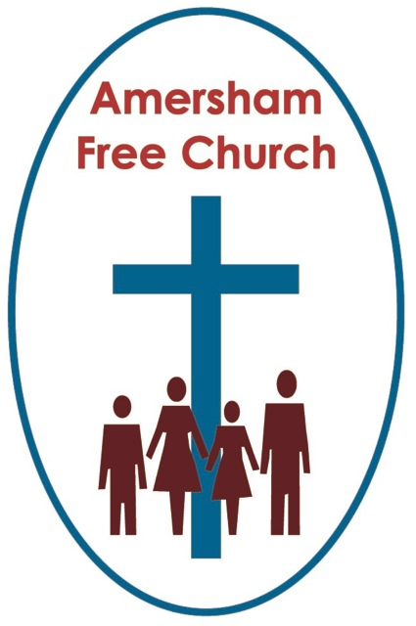
1st September 2019
Hebrews 13.1-8, 15-16
Luke 14.1,7-14

The Terror of the Seating Plan!

Gracious God, we thank you for your word in scripture and made flesh in the Lord Jesus Christ. Help us now to catch your voice and speak, we pray, to our hearts and minds. In Jesus’ name. Amen.
I sometimes feel sorry, say at weddings, for fellow guests looking at the seating plan when it comes to the reception only to realise they’ve been put next to me and will have to spend three hours talking to the vicar!
Last month, whilst on holiday in Austria, we walked into the hotel dining room and introduced ourselves. Rooms 305 and 307, we said. The waiter then looked at his crib sheet, smiled at us and took us over to the other side of the room. This is your table, he said. You will sit here for the rest of your stay!
So, we knew our place. Indeed, the table even had a folded card on it with the words ‘Family Green’, so low betide anyone else trying to usurp our given position.
Two thousand years ago and, when it came to meals, it was all very similar. The Ancient Middle Eastern world put great value on shared meals. Theirs wasn’t a culture that promoted food ‘to go’! Meals were gathering points in the day and a collective experience. Time to reconnect with family and feel a sense of belonging.
Community meals were especially important and not just for the food. At a village wedding or harvest celebration everybody had a specific place set for them. There was an accepted protocol which meant your age, your occupation and your family background dictated your place in the community.
We know from the documents discovered in the middle of last century, that the Dead Sea Community revised the Order of Precedence for their members every year. So, there’d be that day, annually, when you discovered whether you had gone up or down in the sight of your superiors.
In some ways our egalitarian society couldn’t be more different. We’ve moved a long way from Mrs Alexander’s hymn with that verse which goes: The rich man in his castle, the poor man at his gate, God made them high and lowly and ordered their estate.
I read recently the complaint of an old duke as he moaned about the likes of Mary Peters, the Irish athlete, being given the Order of the Garter. He said he couldn’t believe that these days the honour was being given to those who did their own washing up!!
Jesus lived at a time of strict, enforced and definitive hierarchy and in today’s gospel he radically challenges the assumptions behind such conventions.

Now, I’m not sure having Jesus round for supper would be an easy ride for any of us because he regularly seems to disrupt the proceedings. This was the third time he’d been invited back to a Pharisee’s home.
There are at least two ways of viewing these invitations. The first is to see such meals as entrapment opportunities; of getting Jesus onto one’s own territory in order to discredit him and make him feel uncomfortable.
Another viewpoint is to read these meals as moments amongst would be friends because, in the early days at least, Jesus was seen by many well-meaning Pharisees as one of their own, someone (how does the phrase go?) with whom they could ‘do business’.
Disagreements amongst friends can be the most painful of all divisions.
There comes a moment when the banter subsides and both parties suddenly wake up to the reality that on a particular issue, they hold contradictory views. It’s normally at this point in family meals when I try to diffuse the tension by asking if anyone world would like coffee!
A few years ago I met up with a former colleague and we spent the evening talking. As the night wore on, I became more and more uncomfortable about the direction of our discussion. Our paths had first crossed when I was a much younger minister and he an already well established one. My memory was that we once held similar views. But now I was increasingly uncomfortable with some of his very strident theological positions. Had he changed? Had I? I suspect both of us had and it felt sad to realise there was now a gulf between us that was uncomfortable.
Inevitably it all comes down, as it always has, as to how we read and interpret the bible.
Sincere Christians, and I suspect this would be equally true, say, of Jews and Muslims in their tradition, can read the same passage of scripture yet come up with a variety of meanings. Some take a literal view whilst others try to put the words in their original context or genre of literature.
Biblical interpretation was a key role for Rabbis. They would often have a phrase in their teaching that went like this: You have heard it said….but I say to you….
Alternative interpretations were not exceptional but the norm.
Yet, for all that, the new interpretations Jesus gave to familiar texts seemed to prove too much for many Pharisees and maybe that’s what’s happening here. Seated at supper Jesus talks of taking the lowest seat or inviting those to dinner who had no means of repaying such hospitality. He radically reinterprets scripture and in so doing makes it more inclusive, open hearted and generous. Gradually Jesus is forming a theology with intentionally blurred boundaries and for those who loved rules with sharp, clear edges, this teaching wasn’t welcome.
In today’s reading from Hebrews, which contains some wonderful sayings, the first verse talks about that mutuality of love which every Christian congregation needs to aim for when it says: Never cease to love your fellow Christians. And that takes a great determination of the will when our interpretation of scripture leads us to different positions, whether that’s on marriage, the stewardship of creation or our understanding of the atonement.
I’ve mentioned this before in a sermon so I’m getting a bit like BBC2 with lots of repeats! It was the morning after a Church Meeting at which, in another church I hasten to add, there had been a robust debate about the qualifications needed to become a deacon. There were a few tense moments that evening because not everyone agreed with each other. But we seemed to just about hold it together by the time we said The Grace at the end of the meeting. Next morning a lady rang me up and said she wanted to join the church. But, I said to her, you were at the meeting last night, didn’t the disagreement put you off. No, she said, it’s because of the disagreement I want to join. Why? I said! Well, she replied, you disagreed with one other, yet you remained friends – so, I’d like to join!
Living with differences of opinion and interpretation yet staying together in respect – it’s a worthwhile goal for any congregation.
I read recently that a current day world leader was brought up to believe that you were either a winner or a loser. You know Jesus doesn’t talk like that. He says, in effect, don’t choose the top table. And don’t invite those to your dinner party who can return the invitation.
In Church there aren’t winners and losers, just human beings who sometimes fall over but then can find help in standing up again and being welcomed back home by the generous and accepting love of God.
However, let’s put the cat amongst the pigeons at this point in the sermon and ask the question: actually isn’t Jesus speaking about a winning strategy in today’s lectionary gospel? Isn’t this a rather subversive strategy he’s advocating here. Deliberately start at the lowest end of the table because you’ll be more likely to picked out as being in the wrong place and be put on the fast track to the top table. It’s a ‘cunning plan’ based on a humility that is totally insincere.
And this is where biblical interpretation kicks in because Jesus couldn’t possibly mean that if this teaching of his is to be consistent with all the rest.
If we were to blend the idea from today’s gospel of taking the lowest seat or throwing a party for those who couldn’t throw one back with the epistle reading urging us to never cease loving our fellow Christians, don’t forget to show hospitality and remember those in prison for you are vulnerable too, don’t we begin to get a picture of humanity at its best which is open hearted and generous in spirit in the treatment of others.
The bible talks of two commandments which we should never lose sight of: Loving God, first and then loving our neighbours as we love ourselves.
So, this inclusive love always wants the best for others. We don’t want our neighbours to be losers, we’re not glad when another feels pain or messes up. Instead there is a dynamic in faith, an energy in belief grounded in a love for God, neighbour and self that brings dignity and inclusiveness into our understanding of community.
Well, just time for a closing illustration which I think sums up what Jesus is saying in today’s reading and what the unknown writer to Hebrews is also underlining later on in the bible.
It’s from one of the best children’s talks I know and I love sharing it at an Assembly or to Junior Church. It’s that Japanese character for a person. It’s just two flowing downward brush strokes connected at the top, rather like our capital A without the bar in the middle. It’s such a beautiful letter, two strokes supporting each other – the word for a person, because that’s what people do, we rest on each other, we support one another and in that sort of loving we find a sense of God in the community we experience together.
So, next time you’re at a wedding, why not take pity on the person having to sit next to the vicar and swap places with them!
In a few moments we will all be guests at the Lord’s Table. An open table, one of welcome and grace. May the welcome of God, expressed in bread and wine, go so deep into us that we’ll leave church this morning wanting to live in God’s love and share his open generosity with all who we meet this week.

May it be so in the name of the Father, Son and Holy Spirit. Amen
Ian Green Amersham 28th August 2019

