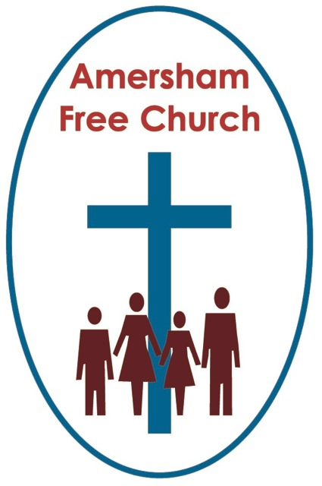
Luke 11.1-13
28th July 2019

Lord – teach us to pray

Gracious God – we open the bible and long to receive your word – open, we pray, our minds and hearts to receive that word with all its comfort and in all its challenge. Amen.
In our gospel reading this morning one of Jesus’ disciples asks: Lord, teach us to pray.

I suspect we all ask that from time to time.
Prayer means different things to different people and is expressed differently in various traditions. Yet, however we form the words or hold the silence the act or attitude of prayer becomes sacred ground. Maybe in our own pilgrimage we’ve gone through a personal evolution when it comes to prayer. There is, quite simply, no size fits all.
When John Hapgood, a former Archbishop of York, was a boy of eight years old, he wrote a letter to God – this was revealed in an article about him in the newspaper, so it must be true! – and in the letter he invited God to come and stay in the Habgood’s home where he could have the spare room. The letter ended, ‘I think you would enjoy yourself. Love from John.’ He then addressed the envelope – and remember this letter was posted – ‘Our Father, which art in heaven…’
John Hapgood grew up to be one of the best, open minded and radical thinkers in the Church of England, yet I suspect he eventually decided that even as Archbishop of York he didn’t actually know God’s post code!

Our Father…so begins what is probably the most famous prayer in the world.

It was common practice for Rabbis to give their students a short prayer. A gift. A prayer to recite, to use, to treasure. Maybe that’s what is going on here in Luke 11. John the Baptist, it seems had given his followers just such a prayer and now the disciples of Jesus make a similar request, a prayer of their own.
It seems he’d already led the way by example because the evangelists record those times when the disciples had seen him go off at dawn to find a quiet place and pray.
For a time, the committee of the Baptist Union Retreat Group always spent a few days every January, around the Feast of Epiphany, at Burford Priory in the Cotswolds. It was a Benedictine House and the day would be punctuated by calls to prayer. It was quite an odd sight to see us Baptists cross the frosted lawn at dawn and twilight to join the monks and nuns in the chapel. By the end of our stay that rhythm of prayer had touched our non-conformist hearts. We had begun to appreciate the space this sort of praying offered us, the perspective with which it graced our lives and the feeling of shared identity it bestowed upon all staying or living in the house.

The disciples see The Lord Jesus at prayer – they catch the atmosphere and then ask him for a prayer.

Mahatma Gandhi once said; Prayer is the key of the morning and the bolt of the evening. Maybe that rings true for you as you commit the day to God when you rise and prayerfully reflect on all that’s happened as you retire.

The Lord’s Prayer begins in a very warm-hearted sort of way. In fact, how you begin a prayer often characterises its tone, even content. Some prayers have a very formal feel to them if they begin with say: Almighty God. But if you begin with the designation Loving and Compassionate God the chances are you’ll end saying a very different sort of prayer.
It’s not obligatory to call God Father; in fact for a whole host of reasons we may not want to do that too often, but here in Luke 11 that’s how the Lord’s Prayer begins and the story that follows it is also about a father. In the gospels of Matthew, Mark and Luke the authors have Jesus refer to God as Father some sixty-five times and in John it’s a hundred.
The important thing is to put thought into the way we address God today. It’s surely good to be creative here and use phrases and names that evolve out of careful thought. We might address our prayers to a Loving and Generous God, or the God who is a Challenging yet inspiring Companion, or at times it might ring true to speak of a God of mystery.
In the Old Testament story about the Exodus God speaks to Pharaoh about the people he is holding against their will in Egypt. The Jewish scriptures want to make a contrast here, so they say of Pharaoh that he treated the Israelites as no more than slave labour by callously using them to build the vanity monuments to his glory. To Pharaoh they were ‘things’. The contrast comes in the story as God calls the Israelites ‘my children’ and says: I am their Father, they are mine.

It’s a theme running through both the Jewish and Christian tradition, this idea of a meaningful connection with God that is more than ritual and deeper than dogma. A connection that touches the heart as well as the head, that has something to so with desire and trust. The Lord’s Prayer introduces us to the idea that such a connection feels like the freedom, security and honesty we find on our best days in the context of a family. Hence the designation here of God as Father.

Now what follows in today’s reading teases out something of the nature of God as much as it does the practise of prayer.
The story that follows in Luke 11 takes some reading because it uses a negative narrative to reinforce a positive truth.

It’s the dead of night and someone in the street has an unexpected knock at the door from an unscheduled caller. Although this visit isn’t in the diary the householder wants to be hospitable but there’s nothing in the cupboard. So, he goes next door and he knocks up his neighbour to ask if he has any bread, he asks for three loaves.
His neighbour isn’t best pleased and shews him away, dismisses him because the household has gone to bed, the children are asleep, and the animals have all been stabled.

Yet, the breadless man simply won’t give up and Luke hints that the story ends with the door eventually being opened and the bread given, not so much out of friendship but because of the man’s persistence.
It is, in some ways, a rather negative story to push home a positive aspiration. At this point in the text the focus isn’t so much on God as on us. It is an illustration of persistence and as such, in this context, it encourages us to keep on praying.
We all need to hear that from time to time. To keep on seeking to live a prayerful life.

When we have prayed so many times before for peace in Syria or Jerusalem - this is no time to give up. When we have prayed so many times for trade justice between us and the two thirds world – this is no time to give up. When we have prayed so many times before for a member of our family we love and is going through a tough phase – this is no time to give up. Keep on praying says the bible.
This post Lord’s Prayer story employs the technique of contrast to make a point about God.

This is what William Barclay, that one-time Scottish Bible Teacher says of this passage: If a churlish, and unwilling householder can in the end be coerced by a friend’s shameless persistence into giving him what he needs, how much more will God, who is a loving Father supply all his children’s needs? …

So, what is the father like in the second story? He is a generous father. He is a loving father. He is the one who wants only the very best for all his children. Vs13: If you bad as you are, know how to give good things to your children, how much more will the heavenly Father give the Holy Spirit to those who ask him!

There is so much locked up in that verse and maybe one of the main things it teaches us is that prayer helps us live a life that reflects something of the love of God. That’s what the gift of the Holy Spirit is about. Jesus promised his disciples The Spirit so that something of God’s presence could live on in the world, something of God’s presence of love and light could bless our world. Isn’t that, in a way the essence of prayer. Prayer is that growing awareness that love never gives up or dries up.
In this understanding to stop praying is pretty much the same thing as to stop loving. To pray for someone is to want the best for them.
Bishop Spong says it much better as he reflects on that phrase from the Lord’s Prayer from Matthew, it’s actually omitted in the truncated version we have here in Luke, but I still think it’s worth a mention today.
Spong says in praying: Thy kingdom come, it means we long for the presence of God to touch our lives and our world in such a way that we live fully, love wastefully and become all that we are capable of being.
Just love that triplet: live fully, love wastefully and become all that we are capable of being!
Almost fifteen years ago one of our children had a burst appendix that turned into peritonitis. During an anxious three weeks going back and forth to Birmingham Children’s Hospital, a lady in the congregation caught my arm one Sunday and just said: We are praying for your family Ian.
Her words rang in my ears every time I drove up to Birmingham. It was just that enormously encouraging thought that people back home were praying for us, and in doing so we were encircled by their love and care, by folk who wanted only the best for us and we were pleased they never gave up.
No, it’s not time to give up praying for Syria and all those who live with Civil War, it’s not time to give up praying for those at home who are struggling with life and it’s not time to stop praying about the planet and our part in being good stewards. Because it’s never time to stop loving and caring for other people and that’s an essential part of what prayer is all about.
To pray ‘Thy Kingdom come’, in the bishop’s words is to live fully and love wastefully – surely that’s a task that takes a lifetime.
Well we must close. And let me do so with this story. The daughter of Karl Marx once confessed to a friend that although she had never been brought up with even the slightest trace of any religion at home, the other day she said, I came across a beautiful little prayer which I very much wish could be true. And slowly the daughter of Karl Marx began repeating in German, ‘Our Father, which art in heaven…’
May prayer be for us an expression of unending love and undiminished hope in the name of Father, Son and Holy Spirit. Amen
Ian Green, Amersham, 17th July 2019

