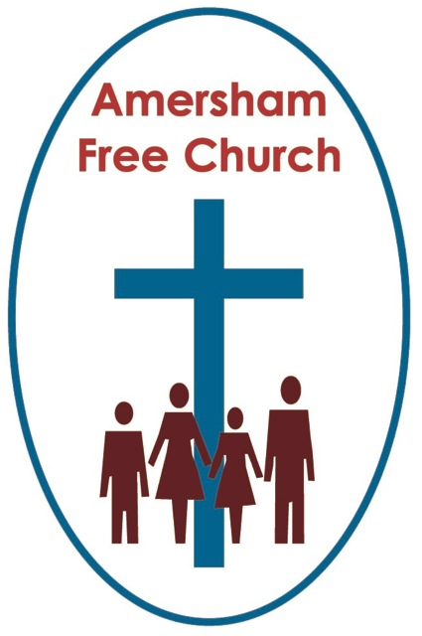
7th July 2019
Galatians 6.1-10

Carry one another’s burdens

Lord God our prayer is that you might touch my lips, open our hearts & transform our lives in the power of the Spirit and for the honour of Christ. Amen.
St Paul puts it this way: Carry one another’s burdens, and in this way you will fulfil the law of Christ.
William Wordsworth – the Lakeland poet – says much the same thing with these words: ‘the best portion of anyone’s life is not their fame and success, but ‘their little, nameless unremembered acts of kindness and love.’

I certainly think that puts life, in both inside and outside the Church, in some perspective by offering us the thought that probably what matters most is, perversely, what most never see about us. The way we’ve quietly supported our family and friends, the time we’ve offered up to a person in need, the way we have tried, in the power of the Spirit, to be a carrier of burdens – and then by definition, the blessings we have received when others have helped us carry our own. It’s a two-way thing – and we often need more grace to receive than give.

Now Paul, and this may surprise some of his critics, is being very pastorally sensitive as he signs off – somewhat intriguingly in his own large handwriting – this letter to the Galatians.
In the opening verse of today’s lectionary reading he sets the scene: ‘If anyone is caught doing wrong’. That’s the context. He’s talking about relationships within the church here – the faltering dynamics of a congregation, or maybe even a group of congregations in an ecumenical covenant! And in this context when someone has fallen over and messed up they are, says Paul, to be treated with empathetic compassion – indeed at such moments we are called upon to actually help them carry that burden of failure and disappointment.

This surely fits in with the rest of this letter, a letter all about living in the liberating orbit of God’s grace rather than the suffocating legalism of stale religion.

Of course, such teaching challenges every congregation.
Fellowship is relatively easy and smooth at times – but there are moments – moments when we get it wrong.
18th Century Baptists even thought playing billiards on the Sabbath was a grave mistake and you’ll find entries in church minute books declaring such folk as ex-communicated.
That’s simply not the spirit of Galatians 6.
When people in our churches mess up, says Paul, we must do everything in our power to gently restore them...

We read that phrase in 3 seconds, but we might spend many years with a fellow pilgrim walking with them on that difficult road, helping to carry their burden.
I remember slipping up once. Now that’s woken you all up! But this isn’t confession time. I slipped up on some steps coming out of a friend’s home. We were on our way to church – it was the first time I had met them, we’d just moved into the area. As I slipped I crashed through a plate glass window by the side of the steps. My first thought was to get up and pretend nothing had happened! But something had – my finger was cut and I had to go to the Naval hospital in Portsmouth and have it sown up.

What an introduction – one of the most embarrassing moments of my life. But I tell you this, when I slipped up – I needed people round me.

And that is surely the essence of what Paul tells us here. When a person slips up, don’t push a burdened person away, but deal with them gently.

We are losing that wisdom as a society. We use sledgehammers. Our newspapers rush to judgement. The person on the Clapham Omnibus makes a knee jerk reaction to every news story – we can’t cope with subtle arguments anymore. Well the church needs to be different. We need to listen carefully, often with sympathy and always with patience. And instead of rushing to judgement we must do our best to – verse 1 – restore a person gently.

We will have our methods. An open door. A listening ear. A warm greeting – the sort that says I know your situation but I’m here as a friend.

We sometimes state the obvious by saying we Christians aren’t perfect – just forgiven – but that truism means that maybe tomorrow I’ll be the one who needs to share a burden – I’ll be the one who’s messed up and needs to be dealt with gently.

Perhaps as you listen to St Paul’s injunction at the end of this letter your mind goes back to that gospel incident – wasn’t it the women who had been caught in adultery and Jesus stands at the edge of the self righteous crowd and utters those now famous words, Let him who is without sin cast the first stone.

Of course, the Christian community should be a place where ethics and right relationships are taken seriously. It should also be a place where Christ like forgiveness is shared generously.
Now I’m really just focussing on one verse this morning rather than the whole passage as read to us – and that’s verse 2 of Galatians 6: Carry one another’s burdens, and in this way you will fulfil the law of Christ’.
Jesus talked of all the religious laws of his own day being fulfilled in the desire to love God and neighbour with all our heart, mind and strength.
Our pilgrimage, whether we are Anglicans, Methodists or just mixed up Free Church Christians, is essentially to be followers of Jesus. Our search for truth, our quest for love and our hope for meaning has led us to the life, death and resurrection of Jesus. And in that life, as we have listened to the stories of Jesus, in that death as we have explored the deep and life changing message of the cross and through the resurrection as we have encountered a hope that fills us with energy and peace, we believe we have encountered the love and light of God.
And at the centre, upon the cross there is the Jesus who forgives, the Jesus who cares for his mother and entrusts her to John, the Jesus who, thinking more of the one beside him than himself, tells the penitent thief; today you will be with me in Paradise.
This is the Jesus who, living and dying, thought of others and helped to carry their burdens. This is the law of Christ – to love and to serve with generosity of spirit.
So, Paul writes: Carry one another’s burdens, and in this way you will fulfil the law of Christ.
How are we doing when it comes to burden sharing? In our families, community and churches?
This is not about invasive help or creating unhealthy relationships of dependency but a ‘coming alongside’ with understanding and generosity.
And that can happen amongst churches just as much as in churches. Ecumenical Covenants like that of COTHA have a sense of relationship at their core. The relationships formed amongst the ministers of COTHA as we share those clergy lunches at Barracuda. The companionship of travelling through Lent together in one of Erna’s film courses. The burden, which is actually a joy, we willingly share with each other of being a corporate expression of the Body of Christ here in Amersham on the Hill in 2019 – all of us having that shared goal of being signposts to God and his love.
We share this ministry together and I suspect that in the future, in a demographic vulnerability that is common amongst us, we’ll want to be in contact more, support more and burden share more because we are stronger together as members of one Christian family under Christ.
Of course, in all our relations, at home and in the community, we could do better. But we must never give up that understanding and aspiration that church and life are best expressed and experienced not merely as organisations with rules but as communities with love.
We must never give up the ideal that in such a community burdens are shared.
Sixty years ago Joseph Hertz, who was born into a Hungarian Jewish family and eventually became Chief Rabbi here in Britain during the war years, put it like this: ‘We are never nearer the Divine than in our compassionate moments’.

Six hundred years after Christ the Greek slave and story teller Aesop put it like this: A blind man and a lame man happen to meet at the same point on a very bad piece of road. The blind man asked the lame man to guide him through the difficulties – ‘How can I do that?’ he said, ‘I am scarcely able to drag myself along – but if you carry me my eyes will be your eyes and your feet will be mine’. ‘With all my heart’, replied the blind man – ‘Let us serve one another…’
And some twenty to thirty years after Christ’s death the theologian/pastor, St Paul puts it like this: Carry one another’s burdens...
May that be done by us, and may that be done for us – in the name of the Father, Son and Holy Spirit. Amen.

