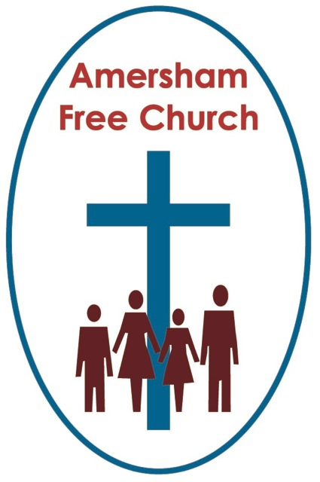
Psalm 8

John 16.12-15
16th June 2019

Creation – We’re in this together

Minister: Let the words of my mouth
All: And the meditations of all our hearts
Minister: Be acceptable in your sight
All: O Lord, our rock and our redeemer. Amen
Earlier this year we popped back to Malvern, where we once lived and served, for the RHS Spring Show. It felt like a starting pistol to a new season, the winter had passed, and warmer, softer days were now before us. Now I’m no gardener, but am very pleased to be married to one, but even for me going around the Floral Marquee came close to a spiritual experience. There was such a sense of resurrection and new life about the displays. Nature had performed its annual miracle with a spring display that warmed the heart.
The Psalm appointed for today is Psalm 8, an all-time favourite for many people.
Its opening verses are ones of praise to the Creator and the psalmist seems to almost explode with worship as he looks around him – this is what he writes, sings or prays: O Lord our sovereign, how glorious is your name throughout the world! Your majesty is praised as high as the heavens…

You could, of course, select a dozen psalms and read opening remarks just like these. It seems these ancient writers of temple hymns in the Jewish scriptures found creation an inspiration and that led them to a theology that looked beyond the creation to the Creator. That meant they ended up not praising the sun but the maker of the sun, not bowing down to the moon but the God who made it.

Sarah Rhodes’ wonderfully simply, yet tremendously profound hymn puts it this way: God who made the earth, the air, the sky, the sea, who gave the light its birth, he cares for me.

Psalm 8 is attributed to David so maybe it was his time as a shepherd boy that gave him his love for nature and maybe he was reflecting on spring days spent out in the Judean countryside as he wrote the opening and closing verses of this song of praise: O Lord, our Lord, how majestic is your name in all the earth!

But, not everything is rosy in the garden and sometimes it seems as if nature is sending us another, very different message. We call them natural disasters.
To many people these moments of earthquake or cyclone seem to negate any notion of a good God.

Maybe part of the reason for that is our perspective and from where we view these events. I’m no scientist but I do know that earthquakes, for example, are not disasters for the crust of our planet but simply a natural phenomenon that enables the tectonic plates to adjust themselves and so stop earth from literally exploding apart.

What we learn by hard and often tragic experience is that nature cannot be completely or conveniently tamed by us. It has an awesome, yet often predictable power. Sometimes we choose, for a whole variety of often-understandable reasons, to ignore this power – wealthy communities carry on developing small towns into major cities despite the uncomfortable reality that their location may be six feet below sea level or poor communities establish fishing villages on a vulnerable coastline. And then perfectly natural things happen that bring human disaster. On those sad occasions – just as in happy moments, say when we walk up a mountain on a clear day – we realise just how small and vulnerable we are against the global forces of nature.

Of course, the psalmist too lived in the real world. David knew that the history of his nation was often one of failing harvests that led to village migration or even wholesale national evacuation to neighbouring Egypt. Although the term ‘natural disaster’ had not yet been invented he knew from experience the awesome power of nature.

Even so he takes this view – and it’s the one that Jews and Christians hold today that God is our Creator and that we often discern his character, his goodness and his power in the works of his creation – how does David put it: You have set your glory above the heavens and from the lips of children and infants you have ordained praise.

Just before Advent this year the Baptist Union Retreat Group has asked me to conduct a midweek retreat up in Worcestershire at the beautiful Holland House Centre in Pershore. I love the modern chapel that’s been added to this ancient house. Behind the altar is a large floor to ceiling window and through it can be seen a magnificent oak tree perfectly framed. For the architect of this sacred space the message was simple really – if you want a good sermon about the greatness of God, just look out of the window!
Now there is a part two in today’s psalm. If the first part is about God and nature, the second is about us and our role in the scheme of things. We need humility and resolve as we read the second part.
Humility because this hymn recognises the tremendous power and influence we humans have over the planet. How does verse 5 put it: You have made us little less than a god, crowing our heads with glory and honour.
Our ecological responsibility couldn’t be more obvious in the words that come next as the psalmist talks of the human race being masters over everything that is made because everything is in subjection under our feet.
The call in the Genesis myth story of Creation is that God has made us stewards of this world.
Towards the end of the last century in 1988 bishops from all around the world came to London and Canterbury for their regular Lambeth Conference. During their time together that year they came up with a document entitled The Five Marks of Mission. I think it’s a great piece of work helpfully listing the core tasks of the church –here they are:
- Proclaiming the Good News of the Kingdom
- Teaching, baptising and nurturing new believers
- Responding to human need by loving service
- Seeking to transform unjust structures of society
- Striving to safeguard the integrity of creation and sustaining and renewing the life of the earth.

It’s that last one that particularly catches my eye this morning. I thought it was a brave one to put in. We can often restrict our view of mission – we sometimes confuse it with the word evangelism – and whilst that’s part of our task its only one aspect. What the bishops were trying to do way back in 1988 was to say that the ecological question of how we live in greater harmony with nature is one of the most important any Christian can ask. Looking after the planet is part of our mission – people of no faith may do that because they simply feel it’s the right way to live – we do it for that reason AND because we also believe it’s a direct command from God to be good stewards of his creation.

Back in Malvern, the scene this spring of my spiritual moment in a flower marquee, the Priory Church there, in its churchyard has the grave of the daughter of the Victorian scientist Charles Darwin – the family were visiting the town when she was taken ill and died. This is what Darwin once said about you and me: Man has become, even in his rudest state, the most dominant animal that has ever appeared on this earth. And I guess that none of us would disagree with that statement.

We are very powerful – in Darwin’s words very ‘dominant’ -and so we must constantly ask the question: how do we use our power? How do we rule with dignity? What does it mean to be good stewards?

Now I never thought I’d be quoting President Trump from the pulpit, but I was fascinated to read of what he said about his tea time appointment with the Prince of Wales during his recent State Visit. Apparently, their conversion, scheduled for 15 minutes over ran to 45. This is what the President said: I'll tell you what moved me is Prince Charles’s passion for future generations he's really not doing this for him. He's doing this for future generations. He wants to have a world that's good for future generations. He's Prince Charles, he doesn't have to worry about future generations in theory, unless he's a very good person who cares about people. And that's what impressed me, maybe the most, his love for this world.
Perhaps none of us should underestimate the power of meeting over Earl Grey and scones!
What does being a good steward mean to you and me?
For some of us in the congregation it might mean supporting the Traidcraft Stall. For some of our children it means they are on the eco committee at school. For one of our Baptist Regional Ministers recently it meant giving up the car and doing all his visits to churches and manses (when he could) by train. For a good many of us it means we wholehearted support charities and agencies that strive to bring hope to our neighbours in the non-developing world.

It’s down to earth Christianity.
Today’s appointed Psalm blends praise and action and makes one the inspiration for the other.

Charles Kingsley put it like this: Never lose an opportunity of seeing anything beautiful. Beauty is God’s handwriting. A wayside sacrament, welcome it in every fair face, every fair sky, every fair flower and thank Him for it, the fountain of all loveliness. And drink it in, simply and earnestly, with all your eyes; it is a charmed draught, a cup of blessing.
To that we might add – and in response to such beauty let us commit ourselves to being responsible and visionary stewards of the planet which has been entrusted to us.

May in be so in the name of our Creator God, that Trinity of creative love we celebrate today of Father, Son and Holy Spirit. Amen.
Ian Green, Amersham, 12th June 2019

