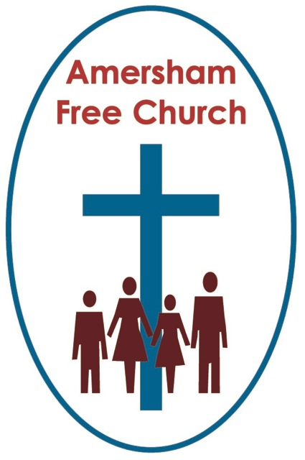
John 14.8-17, 25-27
9th June 2019

The Godly, Universal and Peaceable Spirit

Gracious God – may your Living Word come to us afresh this morning – so touch, we pray our minds and hearts with your grace and truth – through Christ our Lord and in the power of your Spirit. Amen
I see that the gym next door to the church on Woodside Road is currently advertising a sign-up deal promising ‘Transformation in Three Months’. That may just be a little over optimistic in my case!
Pentecost has something to do with inner transformation.
Ever since the resurrection the apostles never stayed in a truly optimistic or confident mode. They wavered between raised spirits when with Jesus to low spirits, gathering behind closed doors in his absence.
It was hardly the vibrant start up catalyst for the Church we might have expected. Yet, it was through this rag bag group that God worked after the Ascension.
Pentecost transforms them. It seems to enliven and embolden them. At its heart is surely the energizing concept that all Christian service is a partnership as our gifts and commitment are blessed by the presence and enabling of God’s love and strength.
In John 14 Jesus speaks to his disciples of the gift that will soon come upon them: Here’s what he says in verse 16: and I will ask the Father, and he will give you another to be your advocate, who will be with you forever – the Spirit…
So, the first of three descriptions I’m pondering in today’s sermon is that of a Godly Spirit.
Jesus was gone and he had been at the centre of their world for three years, in fact he had shaken their world to such a point it could never be the same again.
Some have described Pentecost as a sort of second coming of Jesus. Jesus showed us God in one place at one time and the Spirit does that in all places, for all times. It’s through the Spirit that God once again becomes incarnate among us.
John, in his gospel, describes a deep relationship between Jesus and God. He has Jesus call God ‘Father’ no less than 125 times in the gospel. This wasn’t a detached and purely cerebral partnership, in fact the Greek word used here is one that describes an inward, enduring personal communion.
Isn’t that part of what it means to live a Spirit filled life. It means faith is more to us than merely assenting to the right dogma or doing ritual in the right liturgical way. Faith touches heart as well as head and becomes for us too an ‘inward, enduring personal communion’.
To live in the glow of Pentecost is to cherish, and even become involved in, those ‘God moments’ of life when something of the love at the centre of the universe breaks though into our own existence.
On the Sunday of the recent half term, whilst on holiday in the West Country we, I think, stumbled on such a moment in a Methodist church. This was a church that gives a warm welcome to a number of folks with learning difficulties. During the final hymn a steward appeared from nowhere with a box of small percussive instruments that she gave out to these folk. Their faces brightened and there was enthusiastic shaking of tambourines and bells.
It was a small, yet immensely generous and inclusive gesture and became for me one of the most important parts of the service, a God moment, a Spirit filled expression of love.
This wasn’t about dogma, doctrine or ritual – it was about sharing the sort of welcome Jesus once gave in Galilee and making that a Godly reality there in the Methodist Church in Minehead.
Today we are celebrating the gift of a Godly Spirit. We are also, I think, pondering the implications of a Universal Spirit.
There is, at first sight, a strange verse in today’s passage. It talks about God enabling the likes of you and me to do even greater things than Jesus.
Now I don’t know how you respond to that? But I wouldn’t need to dwell on my life journey too much before concluding that my CV hasn’t quite got the same punch as Jesus’.

However, that’s probably the wrong way to read this verse because doesn’t it mean we’ll do something greater than Jesus because collectively we’ll be an expression of his body here on earth not just in one place but in every place.
In the words of that Pentecost hymn ‘All over the world the Spirit is moving’. Jesus was time and place bound. The age of The Spirit blows apart such restrictions as Spirit filled disciples live for Jesus in England, Egypt and Estonia all at one and the same time.
Yet our understanding of this Universal Spirit isn’t just about location but also of time.
I read a comment this week that said: The Holy Spirit is the interpreter of Jesus’ words’. Now I like this because it reminds us that we are not simply called to repeat Jesus’s words by rote, we are called to interpret his words, to ground them in our own contexts so that they become alive with meaning and relevance in our own day.
This means faith isn’t a sterile and uniform tradition but a lively and evolving interpretation of Jesus’ words for each succeeding generation.
For the Christians of Wilberforce’s day it meant working through the teachings of Jesus in relation to the abolition of slavery. For us today the challenge might be grounding the words of Jesus and seeing their relevance to issues as diverse as sexuality to climate change.
And in this the Holy Spirit becomes our teacher. A Universal Spirit for this and every age.
We are currently showing some architect’s drawings of the proposed 1962 building here at AFC. They are a moment in time captured in a frame. They represent some of the dreams and aspirations of those who worshipped and served in the old chapel in Sycamore Road as they asked themselves the question: How is the Spirit guiding us as we enter the second half of the 20th century? And, under the leadership of The Revd Neville Clark, they sensed that God wanted them, in this place at that time, to erect a new church building as a place of worship, welcome and service.
This Universal Spirit moves amongst us today. It’s with our link Missionaries as they serve the people of Mozambique in Beira, it’s with us here in Amersham in 2019 almost 60 years after this sanctuary was first used because All over the world the Spirit in moving…
Well, as part of his farewell discourse Jesus, in promising the gift of the Holy Spirit, speaks of a Peaceable Spirit.
He puts it like this: Peace is my parting gift to you.
Now, I think we need to be careful how we use that word ‘peace’ in a faith context. I would suggest this Spirit of Peace has something that is both passive and active about it.
Regularly people enter churches saying a sense of peace envelopes them. It’s attractive and refreshing. And maybe, quite wrongly in my view, there is the idea that going on a quiet day or weekend retreat is all about finding a serenity that’s impossible in everyday life.
Whilst it is certainly true that stillness is at the centre of the retreat movement, it is, however, never exclusively just about that.
It’s rather like Classic FM constantly talking about smooth classics or relaxing music. I have been known to shout back at the radio when the announcer tells me to sit back, sip coffee and enjoy a bit of Bach!
Tchaikovsky didn’t write his 1812 overture, or Beethoven his fifth symphony to relax you but to stir us up and inspire us to equal determination in grasping life with passion. Forget the slippers and Ovaltine and listen to an Elgar march on the headphones while striding out on a windswept Exmoor!
John sees a Spirit filled community as a peaceable community and maybe he had this in mind.
He and the Christians he wrote to in his gospel lived under the Pax Romana, literally the Peace of Rome. This so called ‘peace’ tempered the Mediterranean world and created a context for effective government and prosperous trade. Yet there was a downside. The Pax Romana was brutal in its own way, it was a peace brought about by a superpower, it was a peace that depended on force and domination.
The Peace of the Spirit, that peace which needs to flood our churches and characterise our lives is different.
This peace takes it cue from Jesus. It’s an activist’s sort of peace coming from that beautiful Jewish word: Shalom. It’s a peace that seeks God’s goodness and wholeness not just for oneself but for one another. It’s never merely about the passive inner stillness to be found on a retreat or in the silence of a medieval church, it’s also about the search for justice and wholeness at the centre of Christian Aid campaigning. It’s a peace that, whilst finding a personal equilibrium also passionately seeks and works for the welfare of others.
The prayer, by Thom Shuman, on today’s notice sheet puts it very well in its last verse:
We have heard the rush of the Spirit's wind, who would shatter our complacency, and give us voices for justice and righteousness. We will go to sing songs of strength to the weak, to whisper words of love to those who know only hate, to shout for the renewal of all people everywhere.
Well, today is Pentecost Sunday. Maybe if you were in France today you would have heard trumpets blowing, a tradition reminding worshippers of the breath of the Spirit resting upon the disciples. In Italy you might well have had rose petals drop upon your head, thrown from the gallery, as you leave church, reminding worshippers of those tongues of fire that first Whit Sunday.
Here at AFC we have listened in other languages to bible readings and prayers and we have thought of the Godly, Universal and Peaceable Spirit filling our lives, our church and our world.

May it be so, in the name of the Father, Son and Holy Spirit. Amen.

Ian Green, Amersham 6th June 2019

