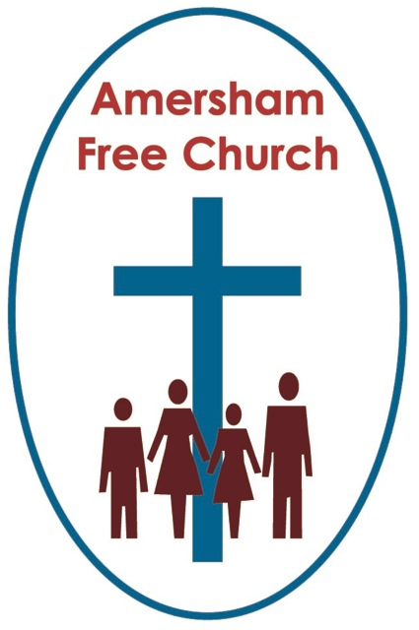
Psalm 30
John 21.1-19
5th May 2019

Denial to Affirmation
Gracious God – may your Living Word come to us afresh this morning – so touch, we pray our minds and hearts with your grace and truth – through Christ our Lord and in the power of your Spirit. Amen
We find ourselves on the shores of Galilee this Sunday morning and two wonderful events break in and change an ordinary day into one never to be forgotten.
The first is that miraculous catch of fish. Jesus stands on the beach directing operations and the boats almost sink as they became full to overflowing with a haul that surprised even the most seasoned of fisherman.
Yet what happened next is, in its own way, no less miraculous and life changing as Jesus reinstates a wayward and headstrong disciple, affirming Peter’s worth and recommissioning him for future service.
This post Easter gospel narrative takes us from denial to affirmation and the reinstatement of Simon Peter is a celebration of love and grace.
We may not encounter God at work in our fishing today, but surely all of us will have moments in our lives when reconciliation, both offered and received by us, will mean that something of God’s love is still touching our lives, as it did Peter’s, some two thousand years ago that morning by the lakeside.
This moment of reconciliation was an important one for Jesus.
Ever since that night when he passed through Pilate’s courtyard and heard Peter deny him, Jesus’ relationship with Peter had been fractured. On the cross Jesus had offered forgiveness to those who crucified him but only now does he get the opportunity to offer it to possibly his closest friend.
Strikes me that these so called ‘post-resurrection’ appearances by Jesus were seminal moments for all concerned. Without them there would have been a lack of resolution which might just have crushed the life out of the disciples and that, surely was not what resurrection is all about.
Yet that is so often what broken relationships and unresolved quarrels do to us all, they crush us and drag us down with a festering, untreated wound.
Of course we all know, and might even have experienced, those heart breaking situations when maybe something like a separation or a divorce, a professional parting of the ways, the end of a friendship or even a change of church, has been the healthiest option for all concerned.
Yet, I suspect, we all know the importance – whenever possible, of keeping a door open so that a relationship or situation can be resolved. And Jesus was surely doing that here. He hadn’t closed the door on Peter. This wasn’t the end for them. At the lakeside Jesus keeps the door ajar and invites Peter to walk through it once again.
The words of the hymn say it like this: Put peace into each other’s hand, and like a treasure hold it, protect it like a candle flame, with tenderness enfold it.
Jesus offers Peter forgiveness and grace, he deliberately and purposefully puts peace into his hands.
It’s a moment of new beginnings –and it’s what the resurrection is all about.
And, of course, this moment of reconciliation was of such importance to Peter.
By now, this most intrepid and hot headed of all disciples was back in the water. It dawns on him that it’s Jesus on the beach and yet again he leaps out of the boat, plunges into the water and runs to meet him.
I think the reconciliation between these two is one of the most important in the gospels. In the passion narratives Jesus has already shown such grace in forgiving those who crucified him; their deeds against him were horrendous yet, in reality, he barely knew them as real people. They were officials doing a grisly job.
In medieval times those about to be beheaded at The Tower often paid the axeman. An act that absolved their executioner of any personal responsibility for their demise.
Yet what had become broken between Peter and Jesus was on another level. Theirs was the pain of a breakdown of the deepest friendship. Peter, after all, had proclaimed Jesus as ‘The One’. For a time, Jesus must have felt Peter walked the closest to him, understood him, spoke the same language and got it. Yet it all turned to ashes around Pilate’s courtyard fire as the cock crowed three times.
In that process which today we call ‘Restorative Justice’, those who have wronged another person, often through meeting together, come to an understanding of what they have done. They begin to see how their actions impinged on the life of another.
I sense, in a way, that is what is going on at the beach that morning. In asking Peter if he loves him, a poignant three times, it’s evident that Jesus isn’t brushing Peter’s denial under the carpet, this isn’t whitewashing his failure to be loyal or saying it didn’t matter. In a way this was a facing up to the past even as Jesus makes Peter aware that the failures of yesterday don’t have to determine the outcome of today. Peter surely gets it and understands why he’s being asked the question three times.
On the beach Jesus offers Peter a new beginning. There can be grace. There can be forgiveness. There can be reconciliation.
In a sense this is Peter’s resurrection day. This is the moment when he too comes back to life again – it’s a resurrection to new trust, loyalty and commitment.
Now, this morning we’ve said this moment was important to Jesus and to Peter. I want to end with the thought that it was also important to the other disciples and to the story of the fledgling Church.
What you select to put into your diary, your Christmas letter or your photo album usually has importance to you. We all make a relative judgement about what we leave out of these and what we include.
I suspect John felt this encounter between a shame filled disciple and a welcoming forgiving teacher was more than just a personal ‘make up’ session – it was then, and remains today, a wonderful example of what reconciliation can look like in any community. Isn’t this John’s way of saying to his readers: this way of peace, this spirit of generosity, this open-hearted forgiveness needs to be our way of life too. The church of Jesus Christ must live like Jesus Christ. So, although we will fail at this perhaps many more times than we will succeed, our aim must always be that we are in the process of becoming a Community of Reconciliation.
In 1996 the Truth and Reconciliation Commission was established in South Africa to consider human rights violations committed between 1960 to 1994. Desmond Tutu was its chairman.
The Commission held hearings in many different centres, In Cape Town it was at the university, but in Johannesburg it was at the Methodist Central Mission and in Randburg at the Rhema Bible Church.
I find that interesting and I hope significant, that these churches were chosen as appropriate places to talk about truth and reconciliation.
We’re not always good at it and one of the oldest jokes in the book has more than the ring of truth about it when it tells of the man on a desert island building two churches so that he could happily say ‘this is the church I go to’, and sneeringly say of the other, ‘but this is the one I don’t’.
Two weeks after Easter we come across a story from the gospels that challenges us to make resurrection a reality in our own relationships; to keep the door open, to offer a second chance, to do everything in our power to be part of that process of restorative justice.
We do it because, how did St Paul put it in one of the Bible’s greatest poems about love in 1 Corinthians 13: we do it because…Love keeps no record of wrongs.
We do it because – because Jesus did it.
May it be so in the name of the Father, Son and Holy Spirit. Amen.

Ian Green, Amersham, 2nd May 2019

