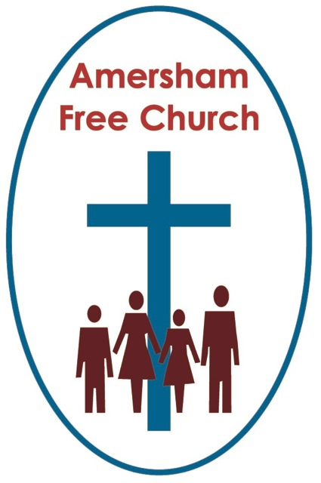
23rd December 2018
Luke 1.39-45

God in Ordinary
Gracious God, we thank you for your word in scripture and made flesh in the Lord Jesus Christ. Help us now to catch your voice and speak, we pray, to our hearts and minds. In Jesus’ name. Amen.
I wonder where we’ll meet God over the next few days?
Will it be in church or around the dining room table, will it be in the verse of a carol or the greetings of a grandchild?
I think it’s a real tragedy if we think the essence of Christmas is exclusively locked up in cathedrals, churches and chapels.
Today’s gospel has this wonderful meeting of cousins as Mary escapes to the hills to visit Elizabeth. Both are part of the Christmas story. Elizabeth will bear John the Baptist and Mary will give birth to Jesus of Nazareth.
In their male dominated age, it’s truly remarkable that their stories remain in tack by the time Luke’s gospel is accepted for the canon of Scripture. Two women who say ‘yes’ to God, two women who experience the divine in the ordinary, in carrying a child and giving birth to a baby boy.
Earlier this month, exactly one hundred years after some women got the vote, Manchester unveiled its statue to the Moss side born suffragette, Emmeline Pankhurst. Only the second woman after Queen Victoria to be immortalised in bronze in the city.
So this morning, so close to Christmas filled with shepherds, wise men and male autocrats like Caesar and Herod, the lectionary puts Elizabeth and Mary centre stage.
It’s their humanity we are celebrating today. They were to be mothers. It’s a birth we’ll be celebrating on Christmas Eve.
And isn’t that the point. The story of Christmas as exemplified in the lives of these two people is a celebration of the fact that the holiness of God is to be encountered in the ordinary events of life.
Of course, we could debate the Virgin Birth till this time next week, yet it’s always struck me that it’s the sheer ordinariness of the story that makes it so thrilling. The sheer audacity of thought that sees the coming of God amongst us in the birth of a baby. Something that happens every minute of every day somewhere on the planet, something that reminds us of our own birth or that of our children or friend’s birth. Yet in this coming amongst us with, how does Stoddard Kennedy put it so beautifully, with the ‘five little fingers of God’, the divine dwells in the ordinary.
There used to be, perhaps there still is, a line that people drew between the sacred and secular. I grew up in a church where giving a round of applause would have been unthinkable because that’s what you did in a concert hall not a sanctuary.
Yet none of that seemed to matter the Sunday after the Sandy Hook Elementary School shootings in America when the Dean of Washington preached a simply magnificent sermon against gun crime in his country. As I watched this service on line, as the Dean finished and started to descend the steps of the Canterbury pulpit the congregation gradually and then completely rose to their feet and applauded him for such a courageous and empathetic sermon. One of the most moving moments in church life I’ve ever witnessed as something of the divine touched the ordinary, something of God spoke into a weeping and grieving nation – and the congregation put their hands together in church to say thank you to their cathedral pastor.
Here at AFC we deliberately try to blur the sacred and secular divide ,say with, art in the corridor or at our house groups which we even call ‘Life and Faith’ groups.
If we can’t see God, the activity of God, the presence of God, the challenge of God, or the comfort of God in our daily work, our everyday relationships, the struggles and joys of our parenting or the delights of our hobbies then maybe we have misunderstood God and locked him away in church rather than appreciating God is everywhere.
Love came down at Christmas – God lived amongst us. At Pentecost we celebrate that with fire and wind – metaphors of God’s presence being central to all existence.
Elizabeth and Mary find God in their humanity as they bear their children.
So this Christmas where will we find God? Hopefully, yes in bread and wine, in carols and prayers, in the worship of these next few days. But pray God he’ll also be present in all our homes, in all our conversations, in both the joys and the sorrows that this season brings to us, he’ll be present in the ordinary – because, ironically, that’s what makes Christmas so special – those five little fingers of God.
May it be so in the name of The Father, Son and Holy Spirit. Amen.
Ian Green, Amersham, 18th December 2018.

