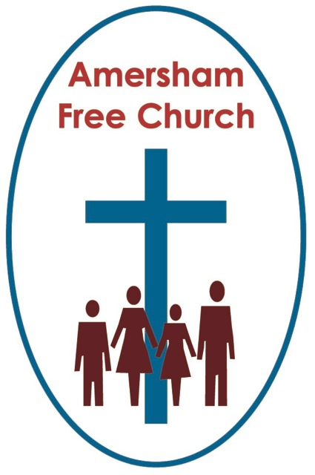
9th December 2018
Luke 3.1-6
Philippians 1.3-11

A Voice from the Margins
Gracious God – we open the bible and long to receive your word – open, we pray our minds and hearts to receive that word with all its comfort and in all its challenge. Amen
The name on his birth certificate is Edward Michael Grylls but we all know him as Bear Grylls. He’s currently the Chief Scout and, from the comfort of our arm chairs we love watching him cope with wilderness.
Ray Mears is another one. A lover of making it in the great outdoors – foraging for food and sleeping under the stars.
Personally I don’t really do Wilderness. Even when I go walking in the Lakes or down on Exmoor there usually has to be a pub in the middle and a tea shop at the end!
Yet, I sort of get it. The sense of being cut off, quiet, the rhythm of walking, away from routine. Wilderness – well at least Chorleywood Common – can be therapeutic.
On this second Sunday in Advent the lectionary takes us to Luke 3 and the story of John the Baptist whose natural context was the margin of society and whose spirituality was intimately connected to desert and wilderness.
I liked the description one bible commentator I read gives to the opening verses of Luke 3 – he said it was like a March Pass of important worldly rulers. He could maybe have alternatively called it a rogue’s gallery of corrupt tyrants.
This role call helps us date John’s ministry to between 28 and 29 AD – just before that of Jesus’ public preaching.
But it’s more than just a date handle. It’s as if Luke is saying – here are these powerful leaders – Tiberius in Rome, Pontius Pilate in Judea, Annas and Caiaphas in Jerusalem - many holding Israel in political servitude – even the high priests are mentioned because they have misdirected their priorities in the Temple.
I remember watching that TV series on the Borgias –the family that ruled Italy through the papacy in the late 1400’s. It makes for uncomfortable viewing – it’s the good people who run the taverns, the corrupt ones are standing at the altars of the Vatican blessing bread and wine. When we mix religion and power all too often history teaches us that we get a potent and ugly cocktail.

Now, says the evangelist, contrast these insecure icons of the establishment like Caesar and Herod with the person God is really speaking to and blessing – contrast them with John the Baptist, and notice that he lives in such an out of the way place that Luke describes his address simply as Wilderness. He’s the voice from the margins. He’s the ‘outsider’ who sees things as they really are and has the courage to speak truth unto power.

Just a few verses further on Luke invokes the words of Isaiah describing a day when a ‘voice will cry out in that wilderness’ calling people to faith.

For us the concept of wilderness often conjures up images of barren, non-fertile wastelands. Yet this isn’t necessarily the way our Jewish cousins thought of it.

In their culture ‘wilderness’ often became a place of hope because it came to be thought of as both a metaphor and a reality for change and transition.
The story told every Passover is that of leaving the servitude of Egypt under the Pharaohs and walking through the wilderness towards the Promised Land.

The story of Moses meeting God is that he is out in the desolate scrub – yet comes across a burning bush and receives a divine encounter.

It was in the wilderness that God seemed to reveal himself and so it became a longed for place of divine encounter. It was through the wilderness that God led his people into freedom.

Wilderness to Jewish people of faith – by the time John took it as his pulpit – was a place in which expectations were high – a place of visions, miracles and divine revelations.
To us, maybe, we talk of wilderness, metaphorically, as being those moments when we feel furthest away from God. In John’s day it was in fact the exact opposite. By preaching in the wilderness John was picking up on all the hopes and expectations that went with this location.

And so, it becomes in many ways the perfect image for Advent. For in this church season we move through the darkness towards the light and gift of Christmas – just as through the wilderness God’s ancient people walked from slavery to freedom.

In many spiritual traditions wilderness remains a metaphor not just for struggle but also positive transition.
Perhaps today we can all recall tough and difficult moments in our lives when we faced perhaps a bereavement, a family crisis or a personal tragedy. Walking through these wilderness moments demanded all our strength, determination and sticking power – yet the experience somehow reshaped us, changed us, re-visioned us – and slowly as we came out the other side we knew this had been a journey of transition in which God had travelled with us even if at times we seemed to be so very alone.
Here in the wilderness John preaches and calls people to a baptism of repentance.
In many ways the remarkable thing about the baptismal revival that seems to have broken out at this time around the Jordan isn’t the baptisms themselves – baptism was by then already a fairly well known and practiced tradition – converts to Judaism would be baptised and we know that in the Qumran community there was a daily ritual washing similar to baptism.
It’s not that baptism was new but rather who appropriated it.

This wasn’t a baptism called for and overseen by Annas and Caiaphas in the temple – it did not have the imprimata of the religious hierarchy on it. No, this was baptism as called for and overseen by a thundering wilderness preacher who ate wild locust for breakfast and wore a tunic of camel hair rather than richly embroidered liturgical robes of the temple.
Luke is undoubtedly being utterly subversive here. He is saying to us something like this – that God is at work in all sorts of places – perhaps we want to imprison him in the temple but he is to be found in wilderness too. Maybe we think he can only speak through priests but in today’s gospel his word is spoken by a riverside preacher.
Now John’s message focused on repentance and that sometimes gets a bad press among us.
It can all appear too negative or at times even too pious and individualistic.
Yet this wilderness tradition can surely help us here. The Jews walked through their desert and many times along the way made bad choices. In the wilderness they came to moments of repentance – moments that changed them, deepened their understanding of self and God – moments that that didn’t hinder but actually helped their journey enabling them to walk on. They walked towards all that God had promised – a deeper life, a liberation from fear and repression, a greater understanding of love and justice - they walked towards God’s promise of wholeness, healing, welcome and shalom.
Repentance changes us as individuals so that we too can long for such a society, for such a life together.
Beside my bed, at the moment is Dicken’s novel, Great Expectation. I’m enjoying it, yet maybe Dicken’s best loved work is his Christmas Carol, which is, in my humble opinion, one of the best parables outside the bible. It shows us repentance in action. Scrooge is taken on that Christmas Eve journey by the Spirits of the past, present and future. He walks through his own wilderness and in doing so his life gains a new and deeper perspective. He awakens on Christmas morning a changed man and that personal transformation brings about a way of life that blesses his community. He buys the biggest turkey in the shop for Bob Cratchit and his family and belatedly accepts the invitation to spend the day with his nephew. All of these actions are about living in community and finding a sense of meaning by sharing life positively with others.
However much you ‘disneyfy’ Charles Dicken’s Christmas Carol it is essentially a parable about how personal repentance can change the world – and change it for the better.
On this second Sunday of Advent the gospel reading prompts us to think again about ‘wilderness’ and this ‘voice from the margins’ – to see it as a place where God is mysteriously yet truly present – and to view repentance as a journey towards God’s wholeness.
An American bishop was asked by one of his parishioners how the man might help his wife who had been plagued by a sense of religious guilt all her life. He said to the bishop, ever since she was a child in Sunday School my wife has struggled with ideas like ‘repentance’ and its made her feel guilty at just about every turn in life. Christianity, said the Bishop, should not be a ‘dispenser of guilt and fear’ - but ‘a faith designed to expand consciousness, to increase love and to enhance life’
I love that – in fact I love it so much I’ll quote it again! ‘a faith designed to expand consciousness, to increase love and to enhance life’.
As we travel through Advent the challenge before us is to embrace ‘Wilderness’ and let repentance bring God’s healing and peace to both us and our world.
May it be so, in the name of Father, Son and Holy Spirit. Amen

