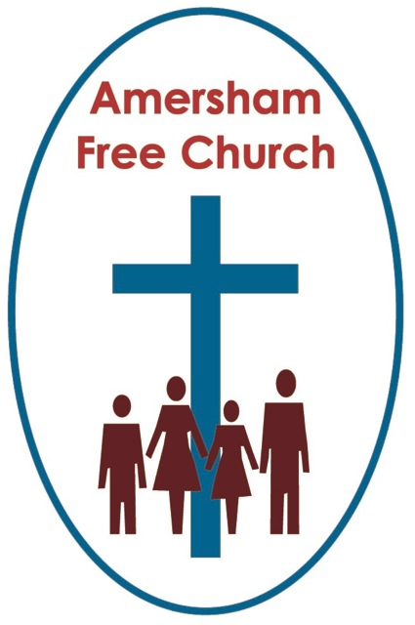
20th October 2013
Exodus 12.1-11
Luke 22.7-20

Communion – Past, Present and Future

Lord God – our prayer is that the written word will point us to Christ, the Living Word – so in his name we pray and for his voice we listen. Amen.
This morning we take a little time off from the Lectionary and make the theme of Communion our focus.
The Communion is one of two sacraments introduced by Jesus himself – baptism is the other one. We call them ‘dominical’ sacraments – that is Jesus said ‘do this in remembrance of me’, or ‘go and baptise in my name’. At its simplest, yet probably at its most profound, the reason why we celebrate communion and practice baptism is because the invitation to both comes from the Lord Jesus Christ.

The story is told of Napoleon’s generals talking one day to the Emperor and asking him for his most treasured memory – perhaps one of his great battles – they wondered if he might recall his triumph as a young general of 26 wresting Lombardy from the Austrians, or some of the shattering victories which had made him the master of Europe. But no, said Napoleon – the happiest day of his life was the day of his first communion – to which he added rather wistfully – I felt close to God then.

You could explore the theme of Communion by analysing its various names: Lord’s Supper, Eucharist or Mass. You could read a book or write an essay on who should preside at the table or what is really happening here. But this morning I simply want to offer a reflection about Communion in terms of the past, present and future.

What of Communion and The Past?
Well the New Testament offers us the idea that it’s a sacrament with a healing focus – it’s a sacrament which longs for the unity of the church that celebrates it.
Paul writes with deep sadness to the Corinthians about their lack of unity as they came to the Lord’s Supper. He urges them to think of each other, to put each other first – to be a loving community rather than a bunch of self-seeking individuals. Elsewhere we are instructed that whenever we worship God a pre-requisite is that we will have done everything in our power to be reconciled to each other.
Traditionally and liturgically churches have symbolised that longing for unity by sharing The Peace. Sometimes with a handshake, but here at AFC with a verbal greeting, before we take God’s gifts of bread and wine we offer to each other the gift of peace.

A decade ago, in May 2003 I led a Communion Service that even now lingers in my mind. For some time there had been divisions amongst the staff and churches of the regional association of which I was Moderator. It was all about forced redundancies and mismanaged appointments and although I came in on the back end of it all it was still sad to see Christians fall out. So it was the intention that sunlit spring evening to bring together the divided parties around the communion table at St Paul’s Church near the Jewellrey Quarter in Birmingham. I led the service and was thrilled by the change that came over the participants as we took bread and wine. You get one impression of a person through email and quite another when you sit next to them receiving bread and wine. We came together to meet the Lord and we all stood in need of his mercy and grace.

Bishop John Robinson was something of a controversial bishop with his book, Honest To God – but I think we could all understand one of the things he said about the Lord’s Supper – he wrote, There is no Holy Communion without Holy Community.

Our prayer is that the past can be addressed here with love, mercy and grace.

So what of Communion in the present?

An Iona hymn, often used at Communion starts, Jesus calls us here to meet him… Notice it’s in the present tense. Jesus is here.
Those early disciples like Peter and John actually remembered Jesus breaking bread – and I suspect that memory became an inspirational one.
Yet we, unlike the Andrews and Thomases of the gospels, have never been in the physical presence of Christ. How can we ‘remember’?
We do so, I believe, because of the mystery of Pentecost – that coming of the Holy Spirit as a liberal and generous gift for every age. So we dare to believe in Immanuel, God with us, this spark of the divine touching our daily walk and weekly routine. If God was in Christ, if God is made manifest through the Holy Spirit – then in the words of J B Philips, there is something of the ‘visited planet’ about us and Christianity does not bow down to a stoical and distant deity but worships a God who somehow both gives us this life and then desires to share this life with us.
And, I think, at no time is that more so than in the moment we remember God’s very essence of sacrificial giving flowing from a heart of loving grace.
I hope it’s not being sentimental to say that every time I take communion I deliberately open my heart and mind to the idea that makes, for me, this moment sacred – that Christ is here.

Jesus calls us here to meet him.

One of the stories I love best about the deep meaning of communion is about the father of a former Bishop of Liverpool. The bishop said of his old dad that he never failed to return to his pew after taking the bread and wine without tears in his eyes. What he had just done was so special – an encounter with the Lord Jesus Christ. It was a meeting in the present tense – there and then – in obedience to the words of Jesus, the bishop’s father had encountered his Lord. Nothing could be more precious, nothing felt more profound than receiving communion.

As a Call to Worship puts it: Here and now God waits to break into our experience.

So what of Communion and the future?

Well, Communion is a meal that in many ways developed from Passover. Jesus was eating Passover, bread and wine was used in that meal too. And originally Passover was a meal that the Israelites ate with an eye on the future. On their last night as slaves in Egypt they ate it. Exodus says they ate it with their cloaks tucked into their belts and their sandals on their feet. This was fast food. It was the night of their deliverance – soon Pharaoh would want to see the back of them. Passover signalled the start of a very different sort of tomorrow, one of freedom in place of bondage.

The Passover pointed to the future and in a way I think Communion points us to the future too– it points us to the sort of future we might expect if we follow the Lord who gave his body and blood for us in sacrificial service.

This year has marked the 60th Anniversary of the Coronation and one thing I discovered looking at some recordings of that wet June day is that the Coronation is set in what is basically the Communion Service of the Church of England. So straight after the crowning the Queen and Prince Philip’s first act was to take communion.

It’s as if, in those far off Medieval days, as the clerics of St Peter’s Church Westminster had to decide what would be the right sort of service to offer William The Conqueror for his coronation? They said the only thing worthy enough to mark a new reign was a Communion Service. Perhaps those wise monks of Westminster wanted to make a point to their new monarch – remember the kind of service offered us by The King of Kings, be inspired by the example of Christ and serve this country in a Christlike way.

All of us at times have a touch of the consumer Christian about us - eager for what we might ‘get’ from faith. That’s not what Communion is about. Instead as we take communion, and remember the sacrifice Christ made for the world – he beckons us all into the future and says: now will you give yourselves to me – it’s a call to service, to live with generosity and to practice grace. It’s the call of the kingdom and its tokens are bread and wine.
I’m struck by the routine of Mother Theresa’s Sisters of Charity who work in the streets of Calcutta. The day begins with communion – only then, inspired by bread and wine, do they go out to tend the poor and needy. Their inspiration, their strength, their partner is Jesus Christ.

Well it’s a Communion Sunday and what we are about to do can speak to us of a past put right, of a present encounter with the living Jesus, of a future in which we are all called to sacrificial and loving service.

You know some things in church life are seasonal – to sing a carol now might seem a little premature – but not communion – that has no season because it belongs to every season. Pray God, on snowy days, during the heat of summer or as the autumn leaves are now falling, we’ll be found gathered around the Lord’s Table – because Christ Jesus invites us – and says, Do this in remembrance of me.
May it be so in the name of the Father, Son and Holy Spirit. Amen
Ian Green Amersham 20th October 2013

