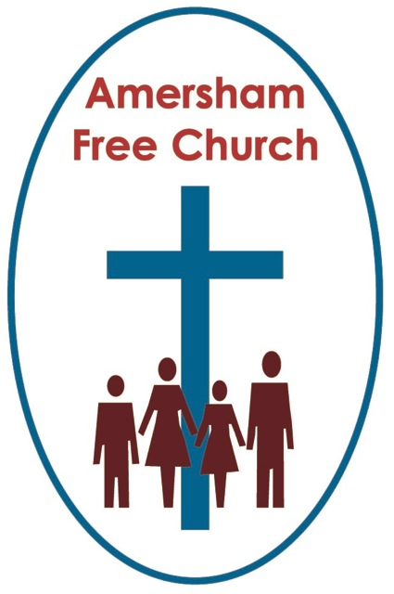
John 6.35, 41-51
12th August

Living Bread Monologue

Gracious God, we thank you for your word in scripture and made flesh in the Lord Jesus Christ. Help us now to catch your voice and speak, we pray, to our hearts and minds. In Jesus’ name. Amen.
My name is Benjamin. We live in Capernaum and I’ve just been remembering that day when Jesus fed over 5000. It was a day full of surprises. My family and I had other plans, but we got swept up by the enthusiasm going around town. It started early morning with the gossip that Jesus, who had made his base in our town, was going across the lake. He was getting quite a reputation as a preacher and by midday every boat was filled by our neighbours, so we hitched a ride too and sailed over to the other side of the lake to hear him.
We are not usually so impetuous. I guess we just got caught up in all the excitement. It’s out of character, but we packed hardly anything – really no food to speak of.
Yet ‘food’ seems to have been the theme for that day back then.
We shared a community picnic that seemed to come from nowhere and Jesus spoke to us so beautifully about ‘Living Bread’.
Food is important to us, because to be honest we hardly ever have enough. I think in your culture you would say the people in my village lived at the ‘subsidence’ level.
Look in our cupboards and most households in my street have three staples: Bread, wine and olive oil. Strange, really, how we also use those three everyday cupboard ingredients in our religious rituals. Bread and wine at Passover and oil for anointing, both kings and the sick.
We drink wine and, in the summer, and spring we’ll also drink goat and sheep milk. We’ll eat butter and cheese when we can, and figs and grapes are on our table almost every day. Dates and pomegranates are reserved for special meals, as is meat. We eat it on celebratory occasions and it’s usually mutton or goat.
But I know you’ve had a reading in church today all about Bread, I’ve also heard a whisper that you live near Chorleywood which in your age has become famous for a bread making process and that in your congregation you even have a master baker.
Well, perhaps bread in my day back in Capernaum was a little different to what you buy in the shops at Amersham.

And that’s the first point really – not many of us in Capernaum ever buy bread – that’s not how it works in my culture. We buy barley or wheat and we make bread. We don’t even buy flour, we mill the grains we buy. Every house has a storage place for grain and every house has either a jar or pit oven and we bake thin loaves. Oh, and another thing, all your bread knives would be redundant here because we never cut it, we always break it – we break bread together.
Bread – it’s just so important to our everyday routine, both making it and eating it. We eat bread at every single meal of the day, it gives us 50-70 percent of our calories. In fact, the very word bread, ‘Lemen’ in Hebrew is a word that we also use to talk about food in general, rather like your phrase all about ‘Daily Bread’.
So, you see, when Jesus spoke about bread he was speaking about something that is so vital to my society. I believe in your world you have lots of debates about carbohydrates and diets where bread is avoided. Well, as we live at the subsidence level nobody’s ever been on a diet in my village, but if they ever did it would never be the Atkin’s one because we hardly ever have meat and we’d never give up bread because what else would we eat in its place?
In fact bread is so important in our culture that the Jewish scriptures have no less than twelve different words for it!
So I’ve been thinking this week about the part played by food, and especially bread, in the faith stories shared by Jews and Christians and I’ve come up with five or six examples.
Here they are…
The first is all about that frost like daily provision God gave to the Israelites as they travelled those forty years through the desert – they called it Manna from heaven.
The story of the Exodus and march through the Wilderness isn’t so much one from history as a tale with a meaning and it forms a big part of my people’s identity. It’s our story of liberation and being set free. It’s our story of the way God led and guided us. It’s our story of how easy it is to get lost if you ever take your eyes off God.
I’d have loved to have tasted manna but I’m not sure I would have wanted it on the menu every day for forty years!
People say it could be collected daily and looked like the morning dew. Once harvested it was processed into something resembling honey biscuits or cakes made with oil.
I think the point of the story is that this was a ‘daily’ experience of relying on God’s provision. It’s not a story so much about food as about trust. Trusting in God. After all this was a journey proposed by him and this was his way of providing. And isn’t that a lesson we all need to learn – that whenever God calls us to do something he also equips us with what we need to see that task through.
Perhaps the quirkiest bit of the story about manna is that you could never keep it over for the next day. Every day’s supply was fresh because the previous days would go off.
I like that as a principle of trust. I think I’m called as a follower of God to trust him afresh each new day. To willingly place my trust in God every morning – just like my people collected fresh supplies of manna at dawn every day.
Of course, this is not the only story in the Jewish scriptures about God’s provision.
Elijah – next to Moses – is perhaps our greatest prophet and there is that famous incident in his life at a time of famine in the land. Elijah is sent by God, east of the Jordan, to the Kerith Ravin and there he can drink from the brook and twice a day, morning and evening the ravens bring him bread and meat. We usually feed the birds but in this story it’s the other way around!
Maybe it’s not a story about birds at all because there is an idea that the word for raven might also have meant Arab.
If that’s the case, it’s rather like the story of the Good Samaritan in the Christian scriptures – God’s care sometimes comes from unexpected quarters and even from people we think of as not being in our ‘clan’.
And then what about the story of Ruth. At a time of famine in her own land she goes back to her husband’s hometown of Bethlehem, a place that literally means ‘House of Bread’, and there her relative by marriage, Boaz lets her glean the harvest from the fields, so she can make bread. Eventually they marry. All part of the way God blessed Ruth and her mother in law Naomi.
And in so many ways God blesses us today. Love surprises us when it touches our lives and whatever its expression our existence is deepened and given fresh meaning and hope.
I think I started this reflection by telling you that my family and I were at the Feeding of the 5000.
Well, a lot has happened since then. Jesus and his inner circle moved down to Jerusalem and they seemed to cause quite a stir down there just like they did up here.
Even here there were people who just couldn’t seem to get over the fact Jesus came from Nazareth and had grown up as part of Mary and Joseph’s family. And whatever he said some people just took it all so literally and missed the real meaning behind the words. So, if he likened himself to a Good Shepherd or the Door to the sheepfold some people just looked befuddled and seemed to miss the deeper message.
We heard it got brutally dangerous in Jerusalem and ended up with Jesus being executed.
Afterwards some of his disciples came back to Capernaum and told us of the cross and empty tomb. My family was one of the first to believe that the ‘eternal life’ Jesus spoke of starts in the present and describes our relationship with God and neighbour in the here and now as well as when we die.
Every Sunday we join in with this new tradition based on the Last Supper the disciples told us about. Sunday is a work day here in town. I’m a potter and my shop is open every Sunday just like all the others. So, we remember Jesus and the Last Supper as soon as we rise on a Sunday around the breakfast table. Rebecka, my wife, provides fresh bread and wine, we break the bread and drink the wine remembering Jesus with our family and some neighbours. We remember the one we listened to on the hillside preaching – he touched our hearts and made the deepest impression on us. We remember the one who took those loaves and fishes and blessed them. We break bread, fresh bread, home cooked bread together every Sunday at dawn and remember the one who showed us, in his actions and words, what God is like.
We love the Lord’s Supper in our house. I believe in your culture it’s become surrounded by lots of ritual and rules but that’s not how we do it here. We take something that is so ordinary – our beloved bread – and in breaking it and sharing it we give thanks for Jesus and his life.
Now, I know I need to finish these reflections. Rebekka always tells me I run on a bit – something to do with making pots all day -you can’t have a conversation with earthenware!
Well, for me the most important thing is that Jesus said he himself was the Living Bread.
I think we all need nourishment in our lives, we all need strength and bread gives us that. So as I listened to Jesus preaching at the Feeding of the 5000 and heard him say that he was the Living Bread I started to understand that in him, through faith, that’s where I could find spiritual nourishment and strength.
Rebekka’s bread is good for my body, Jesus, the Living Bread is good for my soul.
And we need both everyday. Fresh supplies every day – just like the manna in the wilderness.
You know, unless there is famine, there is one phrase you’ll never hear in our homes in Capernaum and it’s this: There’s no bread in the house!
It’s that important to us. We just can’t do without it.
And, I think I’ve come to realise that too about Jesus – the Living Bread I just can’t do without either.
In the name of The Father, Son and Spirit. Amen.
Ian Green, Amersham, 11th August 2018

