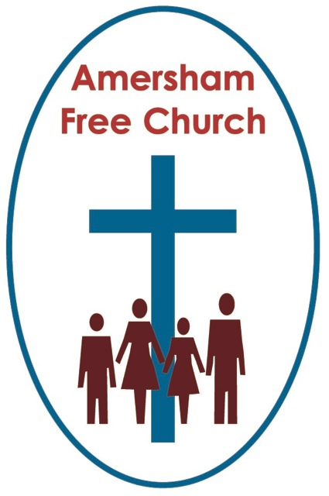
1st April 2018
Easter Day
Psalm 118.1-2, 14-24
John 20.1-18

Running Towards Resurrection
Gracious God, we thank you for your word in scripture and made flesh in the Lord Jesus Christ. Help us now to catch your voice and speak, we pray, to our hearts and minds. In Jesus’ name. Amen.
On this Easter Day I thought we might base our reflections on one of the paintings we’ve displayed in the art corridor this week – it’s also a piece of work that has featured in this month’s URC publication of Reform.
It’s by the Swiss painter, Eugene Burnand and shows the disciples Peter and John running to the Sepulchre on the Morning of Resurrection.
If you want to see the real thing you’ll need to take a trip to Paris and visit the wonderful Musee d’Orsay on the bank of the Seine.
Peter is graphically portrayed by Burnand. He’s the older disciple with furrowed brow and gnarled hands. He has the eyes of a man who thinks with emotion and who has spent a lifetime acting on impulse.
I suspect that Peter is a much-loved disciple amongst us. He’s all too human and we see ourselves in him.
Where does Peter find resurrection that first Easter?
Well, I’d like to think he encounters it in his mind and the way he thinks.
His journey thus far with Jesus hasn’t been the smoothest.
On the Mount of Transfiguration he misreads the sacredness of it all and wants to build tabernacles there to preserve the moment in aspic.
He once told Jesus he would not be a suffering Messiah and received the rebuke of his Lord in the severest tone with Jesus declaring: Get thee behind me Satan!

And, of course, in the early hours of Good Friday, around the fire in Pilate’s courtyard Peter denies Jesus three times before the cock crowed.
Yet this wizened and world weary character we see in our painting this morning got so much right.
He was the first to recognised Jesus as the Christ and he was the disciple who actually got out of the boat and joined Jesus on the water.
He, like so many of the male disciples, wasn’t at the cross. Yet here he is running towards resurrection. And if we could read his mind and hear his thoughts as he strains to arrive at the garden tomb, maybe we would hear a dialogue going on in his mind as he ponders that perhaps Good Friday wasn’t the end after all, and just maybe there is another chapter in the story of Jesus.
As the gospel unfolds Peter’s narrative develops too. For him the resurrection brings a new beginning as he is re-instated. He can begin afresh, he isn’t to be remembered solely as the disciple who denied his master, he will go down in history as a faithful servant of Christ, indeed one upon whom the church has been built.
Peter will still make mistakes. Indeed, quite soon he’ll retreat into a certain exclusivity, a sort of mindset that over-emphasises a particular religious tradition. Paul will come along and challenge him and once more he’ll change his mind and become more inclusive in his outlook.
But that, I suggest is the very essence of resurrection for Peter. The living presence of Jesus constantly challenges his thinking and taking him to new places.
This continuous revelation, these exciting ongoing discoveries about the breath of God’s love are Peter’s way of exploring faith and encountering the divine.
Perhaps they can be ours.
For it seems to me that one of the greatest experiences of resurrection for us today is the way that God is continually renewing our minds as we think through our questions, apply our faith to new situations, become eager to tease out more and more our understanding of the way spirituality touches the everyday – and in all this something of the life of God blossoms in us and in the church.
We too can meet resurrection in our thinking – just like Peter.
So what of Peter’s younger companion in Burnand’s painting. A painting that just breathes a sense of longing as these two men, who like their Lord have gone through the most taxing and traumatic of weeks, a week when they thought they had hit the buffers and this was the end – but now as dawn breaks they dare to believe in the possibility of a new future.
Well, our Swiss painter depicts John as Peter’s junior.
We know him as the disciple whom Jesus loved and characteristically this self-effacing evangelist often airbrushes himself, or at least his name, out of the story.
It’s to John that Jesus entrusted the care of his mother from the cross. An action which surely showed just how much Jesus trusted John. Mary would be safe in his care as she was brought into John’s family and honoured.
If Peter is the impetuous disciple John is the lovable follower of Rabbi Jesus. The one who writes to us of a God of love, indeed a God who can only be defined and named as love.
There is a certain sympathy and gentleness on the face of John as painted by Eugene Burnand. There is also a look of anxiety. This is the moment when certainties and alleluias are still some way off. This part of resurrection morning remains unresolved. No trumpets have greeted the dawn just unsubstantiated rumours.
So, they run. It might be true. Maybe it isn’t? But we must run. We must explore. We must go and find out. What else could we do than together run towards resurrection?
I’d like to think that John’s experience of that first Easter is that ‘love wins’. It doesn’t only survive it flourishes.
Peter might have experienced resurrection in his mind, John encounters it in his heart. In the love of Jesus that refused to die.
You might have seen Songs of Praise from St Alban’s Cathedral last Sunday on the telly. This Lent it was my privilege to lead a service there in the Lady Chapel one Wednesday morning and follow the tradition of pronouncing the blessing by the shrine of St Alban – Britain’s first recorded martyr.
His story is one of love.
He hides a Christian priest being pursued by the Romans at Verulamium. He is not yet a Christian yet he opens up his home as a place of refuge and safety. He is persuaded of Christianity by the priest and agrees to take his place, donning the priest’s clothes and giving himself up to the Romans in the priest’s stead, suffering martyrdom as a result – as a result of love, sacrificial, ultimate love.
It’s a love that reflected something of the life of Jesus. For as a commentator I read last week put it: The cross is a sacrament of divine love.
And John, the beloved disciple, meets the reality of that love, the continuing reality of the love of God in Jesus Christ, on Easter Sunday morning.
And we can too. Whenever we encounter love, however it touches our lives – something of the resurrection breaks in upon us – and Jesus lives again.
So that’s our painting! Well not quite. Because the last thing I notice is that faint glow of sunrise in the background. This is a new day and perhaps the best of the light is yet to come. This isn’t the dwindling dying light of dusk but the hope filled light of dawn.
Our world is being bathed in light.
We can look for resurrection all around us – we too can run to meet it in our families, our homes, work places – in the world at large.
For this is the resurrection of the cosmic Christ. The God who wants to bless our world with new beginnings.
The last book of the bible talks of a new heaven and a new earth.
Perhaps at the end of one of the longest winters of recent years we rejoice this Easter Sunday that we are seeing new life in the natural world.
On this Easter Sunday we pray for new life to break into the Rohingya crisis in Myanmar, the Israeli Palestinian conflict in the middle east and the Russian and British diplomatic struggle.
On this Easter Sunday we pray for new life to be nurtured through the partnership projects that will be supported by our Christian Aid Good Friday offering.
On this Easter Sunday you might be praying that the work you do as a volunteer at our Sycamore Club or the Chiltern Child Contact Centre will bring something of the compassion and blessing of God into the lives of others.
Because resurrection isn’t just a churchy word and an idea restricted to a pietistic minority – it’s the idea that God’s life can touch and transform every part of our world’s life. That whenever we sense new beginnings, works of reconciliation, justice for the marginalised, peace in place of conflict – then the dawn of resurrection is breaking once more and we are glad.
Today we can put ourselves in Burnand’s painting and join John and Peter – and like them we too can find resurrection – in our thinking, in our loving and in our world.
And whenever and wherever we find it we can join our song with the angels and proclaim once more: Christ is risen, he is risen indeed – Alleluia!
May it be so, in the name of the Father, Son and Holy Spirit. Amen.
Ian Green, Amersham, Holy Saturday, 31st March 2018

