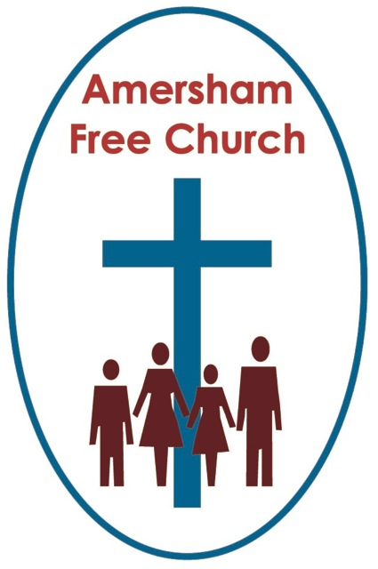
Exodus 3.1-12
1 Peter 5.1-7
26th February 2017

Called to serve

Gracious God, we thank you for your word in scripture and made flesh in the Lord Jesus Christ. Help us now to catch your voice and speak, we pray, to our hearts and minds. In Jesus’ name. Amen.
One morning this week a group of ministers gathered at The Manse for breakfast. You might have thought at 8am we’d have been blurry eyed and non-communicative. Not so! The conversation flowed and at one point a relative new comer amongst us was asked why he had become a minister? He’d been a hotelier, a job in which he thrived and at which he was successful, so going forward for ordination was quite a step change. ‘I just felt called’ he said.
I’ve no doubt that, just like all of us around the breakfast table, countless committees examined his sense of call and only after numerous conversations was he accepted for training.
But it was a good and necessary answer.
There is an idea running right through the Judea/Christian scriptures that God calls us. He doesn’t command us to follow him, he never cajoles us to be his servants. He beckons. He draws us on. He promises to accompany. He invites us to share with him in his work of love.
A sense of being called can describe our individual pilgrimage of faith. It can describe the service we do in church whether that’s stewarding at services or teaching in Junior Church. It can also describe the work we do on the Parent Teacher Association at our local school or the time we have spent in paid employment.
Being called can be a big deal. But it can also just be about normal life spent in a routine way recognising the things we are good at and using them for the good of our family, our church and our community. Being called has a spiritual element but also a down to earth understanding and application.
In our reading from the Jewish scriptures this morning Moses has that seminal encounter with God around the burning bush.
Moses was an adopted Prince of Egypt. Yet in one of the most bazaar ‘about turns’ in the story of Israel he was being called to be their advocate against the family who had taken him in and brought him up as one of their own.
This was a dramatic calling that was truly life changing.
He knew Pharaoh’s court because he had lived there and now he was being called to walk through these familiar corridors which had once been his playground to meet with Egypt’s ruler with the supplication from God: Let my people go.
No wonder he seems amazed and terrified at the commission that is now before him.
I think of John Newton, the author of Amazing Grace, and his call – to leave his well-paid station in life as a Slave Ship Captain and become a clergyman in the Church of England, and then the call to team up with William Wilberforce and work for the Abolition of Slavery.
A bit like the poacher becoming game keeper – and so it was with Moses. God was calling him to walk once more through Pharaoh’s palace but not this time as an adopted son of the king but as the representative of an enslaved people pleading for their freedom.
In the New Testament the calling of the disciples by Jesus is only partially described. We know that Andrew, Peter, James and John left their fishing nets to follow him and that Matthew took early retirement from his tax collector’s booth. Yet of the others in the group of twelve we have precious little biographical information. Their backstories, where they came from and what they did – even how they came to known by Jesus is a mystery. In some cases simply all we know of them is a name.
Yet Jesus called them all. ‘Come’, he said, ‘And follow me’.
Since then we’ve made them saints, pictured them in stained glass and named our Parish Churches and City Cathedrals after them.
Yet, apart from stand-alone characters like Peter and Judas the majority of that inner circle of twelve gave their best to being a team. They were team players. Even as Jesus sent them out on mission he commissions them to go not as sole preachers but in supportive groups of two.
So often we talk of ‘calling’ in individualistic terms. We seem to love mavericks and entrepreneurs.
My grandfather loved reading and right into his 90s went to the library every week to change his books. Yet he only ever read biography – the stories of individuals who had made a mark on life.
We are, of course, inspired by these narratives. Yet the story of the twelve is the story of a working community. These disciples travelled with Jesus, helped gather up a crowd, looked after their Rabbi’s needs, sat at his feet and learnt his ways. They might have gone out eventually as individual missionaries and church planters – but for that three years around their master they were a group, a community and a team.
God still calls us to team work. And in a team gifts are complimented, people learn from each other, the stronger become role models, each find their place – and as a result the collective whole becomes greater than the sum of its parts.
To talk like this is surly to talk of being Church. It’s to talk of being Family. Of being Community.
And into these teams God calls All Sorts.
I love one of the posters Patrick Carrol has made for our main board on the Woodside Road frontage of the church. With the Bassets sweets in the background it simply says: All Sorts welcome here!
And if we pushed further on into the New Testament that would become clear.
Paul becomes the dominant figure of the early church. In many ways he seems to us to be a larger than life disciple. Yet that doesn’t mean his character and his gifting are those to which we should all aspire.
Paul was helped by Barnabas – we might even suspect he was ‘balanced’ by him. If Paul was a motivator, even a stirrer, Barnabas, whose name we are told means ‘Son of Encouragement’ seems to be a warm hearted facilitator. A humble man who might have even been the leading apostle of his day until Paul comes along. Rather than become rivals he joins up with Paul and they work together as a complimentary team, each possessing different gifts.
I suspect that in most churches there are many more of us like Barnabas than Paul – and perhaps we should be grateful for that!

Never devalue the calling to be a team player and an encourager.
Let’s also this morning recognise that age is no barrier to offering service to God.
Timothy is named in the letters of the New Testament as a young minister. He has limited experience even though he seems to come from a very committed Christian family. Yet obviously he was gifted and eager – so Paul takes him on.
Last Sunday Matthew and I attended evening service at All Souls, Langham Place. To be truthful we went because we knew their orchestra was taking part in the service – one attended by over eight hundred people, many I suspect under the age of twenty-five. So all of that was immensely encouraging!
I was also encouraged that alongside all the ordained ministers taking part – the young lady leading the Prayers of Intercession was down on the Order of Service as the church’s Apprentice! Isn’t that a fascinating title for an Intern. A young person, rather like our Time for God volunteers, spending a year working in a church being called an Apprentice. I rather like that idea.
We are never too young to serve.
Now, of course, as I preach a sermon entitled: Called to Serve’ I’m very conscious that at our Annual Church Meeting next month we will be electing Elders to serve here at Amersham Free Church for three years.
We currently have twelve serving elders and they, along- side the two ministers, form the Eldership – sometimes called by the Presbyterians amongst us: The Session!
In the New Testament the terms Elders and Deacons were basically interchangeable. Churches with Jewish connections often called them Elders, whilst those with a Greek background used the term Deacon.
We are immensely grateful to everyone in our Church Family who has served as an Elder, is serving or is maybe contemplating serving.
I want to say from the pulpit that you don’t need a degree in theology to be an Elder. I don’t think disciples like Andrew or Barnabas were the leading theologians of their day. We are all disciples on the way, fellow seekers after truth.
Sometimes Elders lead Vestry Prayers with the ministers before the service or take opening devotions at Elders Meetings – if that’s not something you’d feel confident doing we have books of prayers and meditations that can be used by you in those situations.
Sometimes folk turn down being nominated because they don’t feel they have the pastoral gifts needed to look after the list of people allocated to the Elders. This too isn’t an insurmountable barrier. We are so blessed that some of our non-serving Elders keep their lists. If you really feel this side isn’t part of your tool set all you need to do is have a word with our Church Secretary and a pastoral list will not be allocated to you.
We need all sorts of people on the Eldership, with all sorts of gifts.
And if the task of being an Elder just looks too big to you then I hope you’ll be encouraged by a new scheme we are introducing whereby new elders will be allocated an ‘Elder Buddy’ – an established Elder who walk alongside the new member of our team showing him or her the rope as we all learn on the job.
It seems to me that God is in the habit of calling us to all sorts of tasks, assignments and ways of living.
These are never one off moments set in stone. As our life context changes so does the calling of God upon our lives.
Mother Theresa felt called to be a Nun – a teaching Nun with geography as her subject. She might have spent the rest of her life in education had it not been for a bout of TB.
As she was sent to recuperate in the foothills of the Himalayas she felt as she sat in the train she received, how did she put it: The Call within The Call.
A new phase of her life stretched out before her – to leave her order and her role and move to central Calcutta, set up a new order and work amongst the poor. ‘The Call within The Call’.
Whatever God is calling you to – listen out for his prompting, his invitation and his beckoning, how does that hymn from Iona put it?: Will you come and follow me…if I but call you name.

May it be so in the name of the Father, Son and Holy Spirit. Amen
Ian Green, Amersham, 24th February 2017

