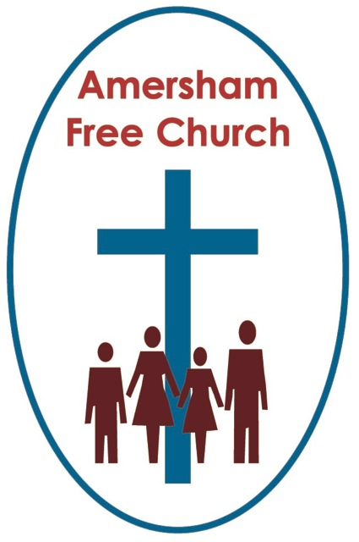
Psalm 37.1-9
Luke 17.5-10
2nd October 2016

Faith Matters

Lord God – our prayer is that the written word will point us to Christ, the Living Word – so in his name we pray and for his voice we listen. Amen.
Today’s gospel reading says: Faith, as small as a grain of mustard seed, can instruct a mulberry tree – go, be planted in the sea and it would obey you.
It’s a sister saying to the more popular maxim: Faith can move mountains.
To take the bible literally is always to misunderstand the style in which it was written – and a popular rabbinic way of talking in Jesus’ day was to use hyperbole – provocative word painting guaranteed to catch the attention of the listener.
Faith cannot move mountains nor make mulberry trees tolerant to salt water – but it can transform anyone’s life giving it a deep sense of meaning, peace and purpose.
So I suppose it was understandable in today’s lectionary reading that the disciples make this opening plea: Lord, increase our faith.
Maybe we have prayed the same words or felt a similar inadequacy deep within our souls.
Whilst on the one hand that may be admirable – wanting more faith – Jesus’ answer that even a small amount can achieve so much surely indicates that he is never in the business of judging us on the basis of the quantity of our faith.
I wonder why we human beings so often concentrate more on what we haven’t got instead of being grateful for what we have.
That’s how it comes across from these disciples – it’s as if they were bemoaning their lack of faith and so asked for an increase.
Well, if that meant more faith would spur them on to a greater sense of devotion and commitment – that is surely a good thing.
But if this negative concentration on their small amount of faith brings an uneasy guilt into a pilgrimage with the idea that we are not as holy or faith filled as the saintly Mrs Jones sitting three rows in front of us this morning – then perhaps we are judging ourselves too severely with a yardstick that Jesus would never have used.
It seems to me that he loved meeting people with faith – and valued even the smallest amount of it in anyone’s pilgrimage.

I find it interesting who it is making this comment, The Apostles said to the Lord: Increase our faith…
Because the truth is that these were the people who had in many ways taken a huge risk in following Jesus already. Fishermen like the brothers Peter and Andrew, James and John had thrown away not only their nets but a family business to follow a radical rabbi. Matthew had given up a lucrative career in the Roman Inland Revenue – no doubt with a guaranteed non-contributory pension scheme thrown in.
And here they were, at this point in Luke’s gospel, on the road to Jerusalem, slowly realising that a cross not a crown lay in front of Jesus.
Even Thomas who we all too quickly label the ‘Doubter’ said to Jesus on hearing of the illness of Lazarus: ‘Let’s go to Bethany’ – Thomas knew that this village, so close to Jerusalem, was an unsafe place for Jesus to visit – yet still he urges Jesus to take a risk in the name of love and go to his friend.
In other words, these were the very people who had already shown a not insignificant amount of faith in their lives.
Faith rarely has a linear progression. It has ups and downs. It wobbles. It moves in unpredictable and sometimes erratic phases as it responds to life’s challenges.
We sometimes say, perhaps rather patronisingly, a person has ‘come to faith’ – yet that is never a one off experience describing a finalised and stable state. Instead we have to repeatedly apply and re-apply faith as our years unfold. And often, because these will be demanding contexts like bereavement or struggle, the amount of faith we bring to these challenges will indeed at times be very small.
And I dare to believe that Jesus says to us this morning – that’s fine – and that’s how it has always been – because, in the language of poetry, if you have faith as small as a mustard seed you can indeed plant a mulberry tree in the English Channel or move Snowden up to Scotland!
This week the AFC Book group will be discussing The Name of God is Mercy by Pope Francis. This book has been written during, what is for our Roman Catholic friends, one of their Jubilee years – the 27th in their history. These are special years with a special emphasis – and this one was dreamt up at the speed of light by the current Pope. Normally a Roman Catholic Jubilee year will have been in the diary for a decade or two before it happens. This Year of Mercy was announced by the Pope just the year before it started, on December 8th 2015 it began and it runs through until the feast of Christ the King, the Sunday before Advent, in November 2016.
It’s as if Francis wants Mercy to be the theme of his papacy – that compassionate generosity of spirit which has seemed to characterise his time as Pope so far - indeed he has more than once said ‘God forgives not with a decree but with a caress’
Well in this little book the Pope talks about us coming to faith and says: The medicine is there, the healing is there – if only we take a small step towards God.
But this is the bit I liked – as the Pope re-read those words – his words - when sent the draft of this book, he phoned his publisher and asked for a phrase to be added – so it now reads: The medicine is there, the healing is there – if only we take a small step towards God – or even just the desire to take that step.
It’s as if the Pope too is saying – your faith may not even be strong enough for you to take a step – it may be as small as a mustard seed - but God sees the sincerity of your heart and recognises your ‘desire’ to move towards him – that’s the mercy of God, that’s the love of God, that’s the welcome of God – the God who rejoices in our ‘desire’ for a deeper life.
When it comes to faith I’m not only grateful for the mercy of God, I also rejoice in the companionship of others.
Just like any church, mosque or synagogue – we are called to be a community of faith.
In our Christian tradition we seek to worship God by the help of The Spirit in the name of Jesus.
And we are not called to this life of faith alone – it is not a solitary endeavour – we are called to join fellow pilgrims so that we can share the journey together.
The picture I have this morning is of our collective faith – melting all our individual expressions into one so that it forms our corporate morning worship, gathering up every crumb of faith here in our community so that together we raise £5,000 for Street Kids Direct, together we staff LunchBreak for over 50 Tuesdays a year, together we help with Open The Book bringing bible stories to school assemblies. No one person can sustain this sort of witness and service entirely alone – but together – when we combined all the small amounts of faith we have as individuals – we can often do something truly significant for God and neighbour.
As we close this morning perhaps we can try to tie up our two readings.
From the New Testament we have this theme of faith and the value of even the smallest amount. And in part that value is surely explained by the essence of our reading from the Jewish Scriptures and Psalm 37.
That’s because this Psalm points to whom we seek to place our faith in – to God. This isn’t faith in a new system or an ancient philosophy – although both may have a part to play in our lives – it’s faith in God who can become the foundation of our lives.
Psalm 37 is an acrostic poem – one of nine in the Jewish psalter. That is – every other line begins with a successive letter of the Hebrew twenty-two letter alphabet.
And this is a poem about trust and faith in God.
So we have phrases like verse 1: Do not be vexed, verse 3: Trust in the Lord, and verse 4: Delight in God.
Psalm 37 is a great song for any of us to pray whenever we feel that maybe our faith really is too small because it reminds us, verse after verse, that our small faith is placed in a great, compassionate and loving God. And that really is the key to our texts this morning - our faith is in God!
Go to a place like Westminster Abbey and stand, say at the West Door and look up at those 20th Century saints like Bonhoeffer and Luther King now cast in statues and we might almost be overawed by the faith and trust they showed in God.
But surely just as much inspiration could be gleaned from looking around our congregation this morning – because worshipping alongside us today are fellow pilgrims who, like us, are trying to live out this life of faith in the every day.
Friends who hold on to faith even though a loved one is suffering or has died.
Friends who hold on to faith even though they have bad health or a difficult past.
Friends who hold on to faith even though prayer is tough and the questions persist.
Yet – in the words of Psalm 37 instead of being vexed we seek to trust in the Lord and delight in God.
Live this week rejoicing in the faith you have – move those mountains and plant those mulberry trees – because it’s faith in a great God, full of love, compassion and mercy.
May it be so in the name of the Father, Son and Holy Spirit. Amen
Ian Green, Amersham, 29th September 2016

