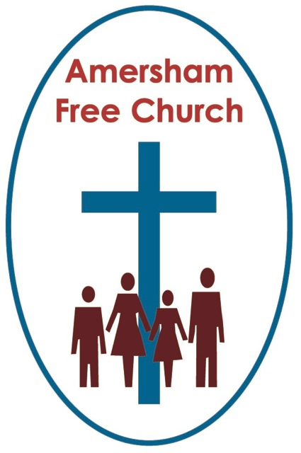
7th August 2016
Hebrews 11.1-3, 8-16
Luke 12.32-40

You gotta have faith

Gracious God – we open the bible and long to receive your word – open, we pray, our minds and hearts to receive that word with all its comfort and in all its challenge. Amen.
How many times have you been converted?
I grew up in a church where people often attached a date to their conversion. The day when they came to faith.
The theologian Marcus Borg says in his biographical work Convictions that he has three major conversions in his life – seminal moments when the shape of his faith changed, grew, developed and evolved.
Today we still talk of people ‘coming to faith’, and sometimes those who profess to have none call us Christians and those in other religious traditions ‘People of faith’.
In thousands of Anglican churches today the response to the sermon will be marked by reciting The Creed and this will be introduced by the priest using the phrase: Let us affirm our faith..’
Well, if you haven’t already guessed - our text this morning is from Hebrews 11: Faith gives substance to our hopes and convinces us of realities we do not see.
I think a Life and Faith group could easily spend a whole evening discussing that one verse!
The unknown writer of Hebrews is acutely aware that living a life of faith in that first century world wasn’t straightforward.
Rome tolerated many indigenous religions throughout the Empire but stipulated that alongside these its citizens and subjects must respect the cult of the Emperor – and on high days even burn incense in his honour. To mono-theistic traditions that felt a lot like idolatry and refusal to kneel at the Emperor’s shrine meant persecution – and much of the New Testament comes out of those threatening and uncertain times. Times when expressing faith was potentially very costly.
For that reason the author of Hebrews wants to encourage his readers to keep their faith in God.
Even today we talk of people losing faith. It may well have happened to you – periods of dryness when we felt detached from ideals and longings we once held dear.
Today’s passage uses the language of ‘yearning’ – that stirring within us that won’t go away. And it’s that God given yearning that can drive us on through the bleakest of days and darkest of times.
It would, perhaps, be easy to read Hebrews 11 as a negative criticism of the world as we know it. At one level it seems to be very anti this world with its thought that we are just strangers passing through whilst longing for a different future. Sometimes the bible seems to come across like that – heaven is our ultimate goal which rather relegates our life here as no more than the obligatory warm up act.
Yet some commentators recommend that we don’t view this chapter in quite so negative a light – that we should hang on to the idea that this world, even with its imperfections, still represents something of God’s creative love and beauty.
Instead they ask us to read this chapter with a ‘deeper grammar’ – that’s their phrase – ‘a deeper grammar’. To see that these verses describe faith as a yearning within us that we belong to something deeper than just the material – that life has a meaning that can be slowly and joyfully discovered with each passing season of our years.
I’m beginning to see the value of this word ‘yearning’ when it comes to faith. I think it’s a wonderfully ambiguous word that simply refuses to be too specific – tie it down and it will snap the ropes.
You can’t really make faith into an equation. It doesn’t fit a constitution and it probably even defies a precise definition. Yet somehow experiencing it as a yearning seems, to me at least, to be appropriate. And I suspect that loving and praying could also be described in that way too. A yearning deep within us that motivates and drives us on and which gives energy to our journey and purpose to our pilgrimage.
Hebrews 11 puts Abraham – the Father of the Israelite nation in the spotlight, holding him up as an example of faith-filled living.
In essence Abraham is an example of someone who yearned for something greater in his life. So he sets out on a journey – verse 8 says: By faith Abraham obeyed the call to leave his home and by faith he settled as an alien in the land which had been promised to him. For he was looking forward to a city whose architect and builder is God.
The ‘deeper grammar’ of these verses hints at the idea that these servants of God were looking for something greater in life and more meaningful than just the material.
The future goal of some of these explorations is described poetically as a new temple, a new land or a new city. The idea behind each one is the same - it’s the search for a future with God at the centre.
Perhaps this ties in with the New Testament reading today which spoke to us of God giving us his kingdom. Of us, as it were, living as blessed subjects in his kingdom of love and light with God at the centre.
Or how about that other phrase from Luke that tells us: where our treasure is, there will our heart be also.
It’s all about what really motivates us.
Faith can transform our view on life – it can become one of the most important treasures of our lives changing the way we think about God, ourselves and the world around us.
Isn’t that the essence of the opening verse of Hebrews 11: Faith gives substance to our hopes and convinces us of realities we do not see.
William Loader, the Australian bible teacher puts it like this: Faith is about believing there really is something greater and permanent towards which we are heading and that gives us the confidence to go on.
I believe one of the greatest treasures of life is faith. It lifts our horizons and deepens our sense of identity – and when it is shared among us it brings about a solidarity of purpose that can unite a church or energise a mission project.
This year we are supporting Street Kids Direct in Guatamala and Honduras and the founder of that organisation Duncan Dyson is currently walking the equivalent of 30 marathons in 30 days through South America to raise money for these street children.
What’s driving him on? What will sustain him on days 28,29 and 30?
Well many of us have met this wonderful Christian maverick and I think we sense it’s Duncan’s faith that drives him on.

Perhaps as we contemplate all the lives that have been blessed and enhanced by the ministry of Street Kids the words of Jesus ring true that with faith just the size of a mustard seed mountains can be indeed be moved.
Now as I bring this little talk to a close I just want to go back to that New Testament theologian, Marcus Borg, who died last year aged just 72.
He was one of the key leaders of Progressive Christianity and in his book, Speaking Christian, which our book group discussed last year, he says that faith is essentially about trust.
We sometimes think of belief and faith as meaning the same. Yet could it be argued that belief is primarily about our mind and the way we think where as faith is not only about the mind and the intellect – it also has to do with the deeper movement of the heart.
We can all hold bad beliefs as well as good beliefs. The good ones will shape us into people of compassion, justice and peace. Trusting faith shapes us into faithful disciples and persistent pray-ers.
Marcus Borg makes the point that the Latin word for faith – fiducia – means trust.

For all that – the life of faith can be a lonely one if we try to live it by ourselves.

Here in church on Sundays and at a variety of gatherings and sharing moments throughout the week – we seek to build each other up in The Faith.
As we pray and worship together – in our fellowshipping and discussing – these are moments when our faith can be built up. Being alongside others who are also striving to live with a sense of trust in God can be wonderfully inspirational and re-assuring.
That’s why – if ever we feel we are losing our faith – staying away from church might well be the very worst thing we could do.
Individual faith is often sustained best in the context of corporate faith.
In all of this Christians are not asked to exhibit ‘Blind Faith’.

That ‘belief’ part of our framework is all about searching, questioning and often this is painful, even confusing.
Yet alongside belief – when we cannot think of a further question that will sharpen our understanding of God and life – alongside belief we seek to place faith.

The sort of faith that trusts in the providence and generosity of God. The sort of faith that willingly leaves some of the big questions not totally answered – but is content.
Such an understanding of what it means to have faith – that it is essentially a purposeful act of trust led Julian of Norwich, that 14th Century nun, to write’ All shall be well, and all manner of things shall be well.’
It takes a great deal to say those words if you live in Syria, if your relative was injured in Russell Square last Wednesday, if your savings are hardly growing because of last week’s interest rate cut – yet this is what faith helps us say – and it helps us say it with conviction.
To my head held belief I can add my heart –felt faith and say – with deep trust: All shall be well.
Because as George Michael once sang: You gotta have faith!
In thee name of the Father, Son and Holy Spirit. Amen.
Ian Green Amersham 4t August 2016.

