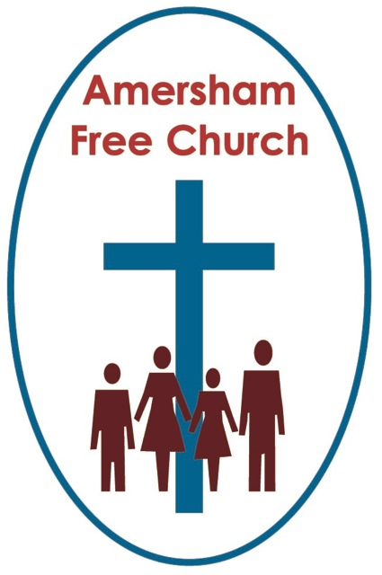
19th June 2016
Galatians 3.23-end
Luke 8.26-39

The Possibility of Love

Gracious God – we open the bible and long to receive your word – open, we pray, our minds and hearts to receive that word with all its comfort and in all its challenge. Amen.
On our recent Christian Aid walk, Circle The City, we sauntered alongside part of the old London Wall just south of Moorgate. Fascinating to realise that in former times this was where London stopped – just a couple of miles north of St Paul’s. Hence the name of one of the churches we visited that afternoon, St Botolphs Without! Without what? Well ‘without’ is, of course, just a medieval way of saying ‘outside the city wall’.
I guess in those far off times your whole life was affected by whether you were in or outside of the wall.
And that’s a similar theme taken up by Paul in today’s reading from the letter to the Galatian churches – congregations in what today we’d call Turkey.
He was concerned that some, when it came to faith, felt they were well and truly part of the ‘in’ crowd, whilst others sensed they didn’t quite come up to scratch and so remained outsiders.
In fact in today’s passage he talks of a legalistic faith mind-set that made people feel they are prisoners – as if they have ‘failed’ when it comes to religion and could only look forward to the condemnation of an angry God.

Strikes me it’s always a great tragedy when religion makes people feel guilty or excluded– and in part that’s what Paul is so worried about when he writes Galatians.
He’s concerned by all the rules and regulations that some of his fellow Christians are still putting on people – and, in short, he finds that oppressive.
That’s also a feature of the gospel story we had this morning – the one set in today’s lectionary. It’s a complicated narrative that doesn’t quite hang together in the re-telling – for a start the field where the pigs were grazing is forty miles from Lake Galilee so they would have had quite a long suicidal trot to the lakeside cliff edge!
But maybe one of the points the evangelist Luke is making by putting this story in is that Jesus comes to set us free from oppression. So the man in the narrative has the demon cast out – he is set free – because liberty, a fresh start and a life with broad horizons – rather than restrictive boundaries - these are the themes of the kingdom.
Paul, especially in his early days before the church became too institutionalised, was keen on flexible boundaries and freedom – he had a word for it and called it ‘grace’.
On Tuesday at our Elders’ Meeting we had a good discussion about Church Membership – which to some might be seen as an odd boundary in our life together. You’ll know if you’ve been coming to AFC for some time that we value people becoming Church Members – it’s part of both our Baptist and URC traditions – to encourage folk to deliberately and prayerfully opt in to membership. Yet some very faithful friends here haven’t taken that decision yet play their part and others haven’t got round to it and I dare say there might even be some who are not sure about the necessity to sign on any dotted line. And the Elders wanted to say this as we drew the discussion to a close – that we value everyone who worships here. That there are no first and second class citizens. If you worship with us once a week, once a month or once a year we hope you feel a sense of belonging and acceptance.
I have a bit of a routine on a Monday morning in that I often tune in to the recording on the internet of the service held the previous day at Washington Cathedral – I almost view it as the ‘other’ church I belong to! And at Washington the previous Dean always invited people to communion with these words – ‘Wherever you are on the journey of faith – you are welcome to receive the bread and wine.’ I love that understanding of pilgrimage and sometimes use the phrase myself.
We must be careful that the boundaries we create don’t misfire on us and actually end up pushing people away from faith rather than encouraging them to take the next step. We need, I believe, to view our churches as having flexible boundaries – ones that affirm everyone’s journey and pilgrimage takes place at different speeds. As a clergy friend of mine often says as he gives out the notices on a Sunday – ‘the most important word you will hear in our service this morning is ‘welcome’’.
Paul, I think wasn’t keen on boundaries.
So what is he keen on in Galatians 3? Well he seems to be saying something about the Essence of the Gospel when he talks of you and me being the sons and daughters of God.
He paints a picture of a God who is always reaching out to us in compassion. This is the God who gives us Jesus. This is the God who gifts us a world of beauty and potential. This is the God of welcome, renewal and forgiveness.
For a long time Paul was something of a religious zealot and he was keen to have a dogma and a ritual for everything –he wanted faith codified and strictly adhered to. Yet he seems to have had a visionary encounter with Jesus that turned his spirituality on its head.
Post Damascus Road Paul preaches with conviction not of a God of exclusivity and boundaries but of expansive love, generous compassion and unlimited grace.
So in today’s passage he describes us as God’s sons and daughters. It’s the picture of a household and that of belonging to a family and it is ultimately the idea that God is to us a Good and Loving Father. Not a bad day to remember that!
Now some might argue, with a certain justification, that giving God human characteristics always comes a cropper in the end, and that we are definitely on controversial ground with the idea of Fatherhood – yet many have been delighted, and encourage us to delight, in the concept of God as a Good Father.
He can, of course, be viewed as a divine parent – a sustaining and nourishing presence that reflects the qualities of a Good Father and Loving Mother at one and the same time.
So here in this circular letter to diverse and young churches Paul talks of us as being sons and daughters of God united in Jesus Christ – and I’m intrigued by that because the apostle seems to put so much store by the unifying nature of Jesus – verse 28: you are all one person in Jesus Christ.
Might another way of putting that be to say that our common humanity - the most important things that unite us and transform us from individuals into community – these ideals and aspirations can be seen and encountered in the life and message of Jesus?
We believe in a Jesus that shows us the compassion of God, a Jesus who lived and died showing us that the struggle to forgive is immensely worthwhile, a Jesus who affirms community with the weak being supported by the strong.
Earlier this month many of us from AFC spent an evening at the Chesham Mosque. Like all ‘Beyond Difference’ gatherings it was an evening to listen to each other’s stories and as on so many occasions we ended up rejoicing not in our differences but similarities – that so much of Islam is about a forgiving and compassionate God – one who is often kinder and gentler than the followers in both our traditions who sometimes mis-speak in his name.
So much of the message Jesus taught and the life Jesus lived resonates with the core values proclaimed by other faiths – and rather than find that worrying I personally sense that such a realisation enhances the idea that there is a common spirituality amongst the world faiths that is actually good and positive for humankind.
The essence of the Gospel, says Paul, is not a God who imposes restrictive and exclusive boundaries but a God of compassion and grace – a God whose nature and message is revealed to us, in our particular tradition, through Jesus Christ.
Now lastly this morning I think all of this means that Paul is giving us here in Galatians something pretty close to a definition of faith.
In a way he’s doing that negatively and pulling no punches saying to the leaders of the Galatian churches ‘stop making your congregations feel guilty’ – ‘stop setting them unnecessary boundaries so that they end up with the idea that faith is a rule keeping , box ticking exercise they will probably never achieve.
Instead of law Paul advocates grace. He wants the readers of this first century letter to make an open and positive welcoming response to the possibility of love. The wonderful possibility that can define us – that God is love, that each human life is precious and worthwhile in his sight, that whenever we encounter compassion, kindness, faithfulness and forgiveness something of the divine is touching and blessing our lives.
Faith is not about crossing over a boundary winning line because we have achieved a pious holiness or kept every commandment for a lifetime – faith is about welcoming that possibility that God loves us and holds us and blesses our life with meaning and purpose.

Isn’t that idea of faith something that was so clearly at the centre of the story of the Prodigal Son – another New Testament narrative with pigs!
Perhaps the most telling moment in that parable is when the runaway, tear away, irresponsible and selfish son wakes up to the idea that he is actually loved by a good father – that just maybe he could take the first step and go home assured of a welcome. When he comes to that mind blowing conclusion – when he wakes up to that possibility of love – his life regains perspective and is renewed in meaning and restored in hope.
It’s a eureka moment that can transform any life. Faith is essentially naming, appreciating and valuing the love that is already and everywhere around us – this God breathed love that brings dignity to life and hope in death – God’s love and God’s welcome. And once we have woken up to that possibility of love – once we walk towards it, embrace and accept it as a wonderful gift - we will spend a life time pondering, exploring and being challenged by it.
Paul isn’t keen on legalistic boundaries when it comes to faith – he much prefers to talk of a Good Father who welcomes us as his children – because love, not achievement, is the essence of the gospel.
May it be so in the name of the Father, Son and Holy Spirit. Amen...
Ian Green Amersham 16th June 2016

