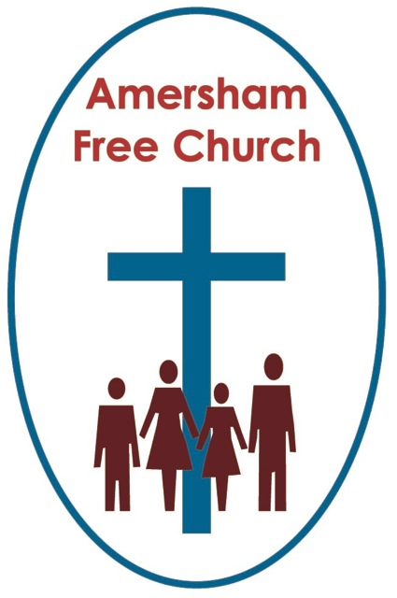
17th April 2016
Acts 9.36-43

Cross and Resurrection

Lord God – our prayer is that the written word will point us to Christ, the Living Word – so in his name we pray and for his voice we listen. Amen.
The day our first son came into the world was the day after the official cease fire by the IRA in Northern Ireland.
We spent that late summer day in September 1994 at The Lister Hospital in Stevenage awaiting Matthew’s arrival and I remember looking down at the newspapers in the Waiting Room so full of hope that after so much pain and so much struggle just maybe a new sort of life for Northern Ireland was within the grasp of our generation.
I read of those hopes even as Rachel and I were on the cusp of welcoming a new beginning, a new life into our own world.
One of the joys of this Easter Season is that congregations in this country and overseas use these weeks up to Pentecost to make a conscious effort to celebrate life.
And that’s what today’s lectionary reading from Acts beings before us.
Tabitha, sometimes known as Dorcas, and both names able to be translated Gazelle, has died and she was such a beloved member of the community at Joppa.
So Peter, who we are told was going about ‘here and there’ – in other words he was very busy continuing the work of Jesus was called in.
Luke, I believe, then gives us a symbolic narrative all about life. He tells a story about Peter raising Tabitha.
Well in the Judeo/Christian tradition isn’t that what Jesus did, isn’t that what Elijah did. So there is a recurring theme here. God’s gift to us is life. Life not just to be longed for in heaven but life – as the famous Christian Aid motto helpfully puts it – there is life to be longed for and made a reality before death.
And this is the season to celebrate that. To rejoice wherever and whenever (and that is surely every day) we encounter the wonder, the beauty, the profound preciousness of life.
And of course there is a great beauty about today’s passage.
It’s so good to read of Tabitha as a named disciple of Jesus Christ. For she lived in a male dominated age but she seemed to have broken through this cultural glass ceiling and we have her here in Joppa named as a beloved member, maybe even leader of the church there.
We have just ordained and commissioned Elders and what a great reading to have on a day like this. Be a leader like Dorcas known for your encouragement, valued in this church because you have seen the good at the centre of this faith community and your role here is to build on that so something of the life and love of God can be experienced among us in this place and at this time.
There are big themes in today’s passage because they prompt us to reflect on death and life, struggle and resolution. And we want to do that honestly rather than in a triumphalistic mindset that can so often beset religious thinking in that it is easy to read of resurrection in these biblical stories, even if we choose to see them as symbolic narrative, and jump to the conclusion that God is so much more present in Easter Day than Good Friday – and basically I just want to challenge that understanding this morning.
Even in this season of life, perhaps especially in this post-Easter season, I believe it’s essential we don’t unwittingly devalue all we were so eager to proclaim during Lent and Good Friday.
In those days we affirmed a belief that God’s love, light and comfort is not absent from us on days when we struggle or moments when we encounter pain.
In the Jewish scriptures this is perhaps nowhere more eloquently portrayed than in the story of Shadrach, Meshach and Abednego being thrown into a fiery furnish by Nebuchadnezzar because they would not go against their monotheistic principles and practices. They were not speared that terror yet, we are told, a God like figure seemed to be walking alongside them in the furnace, sharing their fears and sustaining them in their nightmare.
Isn’t it also the truth in one of the most significant moments of Holy Week when Jesus prays in Gethsemane’s Garden? The essence of that experience is that he didn’t go round the pain of the cross but through it and it was as he prayed, as he struggled, as he endured an endless night of blood, sweat and tears – at that moment of intense personal turmoil and desolation – he comes to a moment of consolation and equilibrium – a prayer filled moment when he senses the strength he needs to walk into tomorrow with confidence and calmness.
It is I would suggest a natural but misguided question to always be asking why God seems to be absent in a natural disaster or a personal tragedy.

We have painted a false picture of God if we have made him so supreme that we expect him to intervene and save us from the harsh realities of life. And that false expectation doesn’t ring true to life as we experience it. We will probably all live with terminal illness in our families at one time or another; we are part of a world where earthquakes and terrorism regularly rob people of a full and long life. And if the Holocaust taught us anything it surely dispelled any notion that God intervenes and divinely frustrates ‘man’s inhumanity to man’.
Instead, I believe, a more honest understanding is that God shares our pain and gives us strength, hope and a renewed sense of life to overcome these trials with dignity and hope.
Rachel and I watched the Selma film this week about Martin Luther King’s struggle to bring about voter registration for Black Americans in the 1960’s.
There was a very upsetting scene of white state troopers killing a young black man simply because he was requesting the right to vote. I confess I found it really hard to watch.
Dr King then visits this young man’s 82 year old Granddad to pay his respects that his grandson had been so pointlessly murdered. As they talk Martin Luther King said no words could describe the pain or explain away the suffering, but he believed that when the young man was so brutally murdered God was the first person to weep. On hearing that the young man’s grandfather takes of his glasses, nods and embraces this Nobel Peace Prize Pastor.
Sometimes our greatest theology is expressed in the simplest language – God was the first one to cry.
I rather like Celtic crosses – like the one on today’s service sheet. A cross with a nimbus or ring round its intersection.
The truth is we’re not absolutely a hundred percent sure why the Celts made High Crosses like this – but today we often think of the cross as representing Good Friday and the circle Easter Day.
Can we ever have one without the other? All Easter and we are in danger of denying the struggles which are a natural part of living. All Good Friday and we fail to see the hope and present-ness of God in the pain.
We need to be aware of God in both – and that’s the message I take away from a Celtic cross.
So what does that mean for us in 2016?
I heard a lovely story this week as I was visiting a member of our congregation. Of an Old Folks Club a number of years ago just about to close. A club that brought companionship to many on the brink of calling it a day because of lack of helpers. It needed new life – you see. So this couple put an advertisement in the local paper asking for folk to volunteer and they did. What was dying came back to life. And today that club still opens its doors bringing a sense of God’s wholeness to those who attend.
We don’t have to look far for signs of resurrection all around us. And when we see them I believe it’s as if God is whispering to us – Behold I am alive for ever more. I’m with you in your struggles and I shed the first tear. I’m with you in your joys and I smile alongside you.
Bill Loader, the Australian Bible teacher comments on Tabitha’s resurrection by saying this: These stories symbolise hope. The greater wonder today is when we can see people standing on their feet; communities make their way out of poverty, enemies move towards reconciliation. These are realities which take up the direction or flow of what would otherwise be legends left to the past. They invite us to take such stories as symbols of what is an abiding value and through them to find the hand of God in new beginnings today.

In this season of resurrection may we – you and I, disciples of the risen Christ – may we be warm-hearted people with a faith that celebrates and values life and sees God a work in both Good Friday and Easter Day.
In the name of the Father, the Son and the Holy Spirit. Amen.
Ian Green Amersham 15th April 2016

