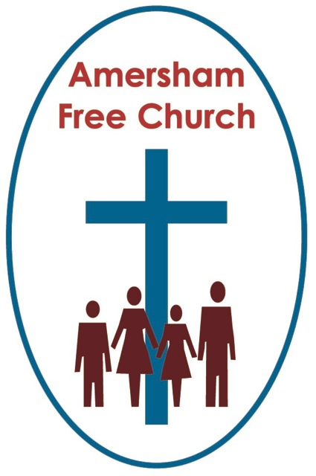
3rd January 2016
Jeremiah 31.7-14
John 1.10-18

The Word made Flesh...

Gracious God – we open the bible and long to receive your word – open, we pray, our minds and hearts to receive that word with all its comfort and in all its challenge. Amen.
My name is John and depending on which tradition you subscribe to I’m an apostle, brother to James, a son of Thunder and the author of both the fourth gospel that bears my name and the final book of the bible Revelation. On the other hand, some say John the Apostle might have dictated the words and I’m John the Elder who simply wrote them down. Or on a third imaginary hand – impossible I know! – others believe I’m neither and in fact the words were written by a group of people I taught and spent time with - a sort of school of John, if you get my drift!
Anyway, let’s make it simple this morning and say I’m John the Apostle – a follower of Jesus who once was a fisherman in my father Zebedee’s business by lake Galilee – in truth I once had a bit of a temper, hence the nickname I was sometimes proud of but at other times hated, a ‘Son of Thunder’ – just glad they said it too of my brother James.

Of course all of that was a long time ago now. It’s about seventy years since Jesus left us and I’m an old man now in my 90’s yet it all seems like yesterday. The time we spent up in the north – with towns like Nazareth rejecting his message, the journey we made south to Jerusalem – all those teachings and acts of compassion. His death and our confusion – I even looked after his wonderful mother for a while.
And perhaps to our surprise it’s all continued. It didn’t dry up after he left us but somehow the message of love and light Jesus preached has travelled down the path of so many Roman roads and two generations later his followers meet on Sundays before work in countless towns across the Mediterranean.
Well, you may ask – if these groups of, what do we call ourselves – Members of The Way or Christians – if we already had a record of Jesus in Mark’s writings – that was the first collection on the scene if I remember rightly, then why, after Matthew and Luke had tweaked Mark and added their own bits did I decide to add a fourth collection that now seems to be doing the rounds?

Well, the truth is my writing is not quite like theirs. Don’t get me wrong – it’s not so much better than Matthew, Mark and Luke – just different.
Perhaps it’s just my personality – or maybe it’s the mystical tradition I’m part of – but I’m not really overly concerned about the right order of events, who said what and where. You see I love stories with a purpose. I think narrative can teach us much more than just when an event happened but why. It’s the ‘why’ that intrigues me.
Let me explain.

You’ve just had Christmas haven’t you! Survived it did you! I see – some better than others – well my friends Matthew and Luke get very worked up about all the events of Christmas but you won’t find a single shepherd or manger in my gospel. You see I wasn’t even around when it all happened and although I love the story I’m more interested in why we think it’s an important story.
That’s why I slipped in that bit about the Logos before I really got started on my gospel.

I was old by the time I wrote that fourth book of your New Testament and in my long life I realised that whereas loads of religious people around me believed in a God – to them God was always remote, far away and up there. People in those days sometimes used to think of God’s essence using a sort of shorthand – they called it Logos, or Word – it described the wisdom and presence of the divine. Wasn’t just us, lots of religions had a Logos – two a penny actually in Greek thought. But then it struck me that the faith that grew out of the teaching and example of Jesus was actually saying this – God isn’t remote and unapproachable – he is with us – he came among us. You see that’s what I think the story of Jesus points to – it points us – and here, if I may say so I came up with a rather lovely poetic phrase – it points us to the Word, the Logos, made flesh. Good eh?! And that, I think, is quite a distinctive belief – a God who shares life with his creation.
Of course not everyone is actually happy with that idea of God. Sometimes, it seems to me, we fail to see God all around us – almost preferring him to be an absentee landlord.
I was brought up on the Jewish scriptures and that bit in Isaiah that talks about a people walking in darkness just about summed up my neighbourhood – it was a rather common understanding that we in Galilee – us northerners – walked in the darkness. Ironic then, don’t you think, that Jesus shone his light up there in his home region so that us Galileans, the people who walked in darkness saw a great light!
But we didn’t always see this decisive disclosure of God in Jesus. Even we disciples got the values of his Kingdom the wrong way round. I’m ashamed to say me and my brother once had quite a spat with the other disciples as to whether or not we’d end up on heaven’s top table. Perhaps there was a time when I thought of God’s salvation in terms of power – the power to be free and make the most of my position. Now I realise God gives us the freedom to love and to serve. And the Logos, the Word made flesh showed us how God intended things to be – gave us, if you like, the real meaning of life and the principles that hold our universe together
I love the reading you had in church from the Jewish Scriptures this morning as Jeremiah talks of the Lord saving his people from the northern lands, preserving a remnant and gathering his flock like a shepherd watching over his sheep.
It’s the picture of a Lord who shares the pain of his people and travels with them. And this is the bit I really like; Jeremiah says when we see life like this – through God’s perspective and consciously aware of his presence then: Girls will dance for joy and men, young and old will rejoice. Strikes me that God is always for us and that’s what rang true with Jesus as he made parties flow with wine, welcomed children, spoke of being the bread of life and light for the way. This Word made Flesh came to hallow our lives and teach us to be ever more aware of the blessings of life all around us.
I’m a passionate believer that God isn’t remote – it doesn’t mean he ceases to be tantalisingly yet comfortingly mysterious – but it does mean he is that wonderfully creative force in the universe that brings meaning, life, dignity, love and hope to our lives – and that this phrase I’ve slipped in to the opening preamble of my attempt at a Gospel, ‘Word made Flesh’ is one way of saying that.
I’m signing off soon – I come from a warm climate so I really don’t know how you can listen to sermons in such a cold church!
But I would say this in closing – my world in 100AD wasn’t so different to yours in 2016.
Everyone wants answers – especially my Greek friends – they have a love of logic that can make faith a bit mechanical.
What I sense about faith is this. The Word made Flesh isn’t about having every problem and question wrapped up with a water tight and logical answer. Rather it’s about the deep belief that whatever this New Year throws at us, whatever cards we are dealt, whatever successes come our way or tragedies arise – God travels with us. That’s his nature. Not detached but alongside us. Not stoically stiff upper lip but shedding a tear with us, dancing with joy around us, holding us secure when we are afraid, pushing us forward when we are anxious.
The Word made Flesh is about the love which is at the centre of the universe – about the God who is love at the centre of our faith. Love in action, love that honours folk at the boundary, love that gives the crestfallen a second chance, love that delights in goodness, kindness and just plodding on in faithfulness.
My world was in so many ways just like yours and everyone’s can be transformed with the notion that God shares the journey with us.

Come to think of it the name Immanuel – how many times I wonder have you heard it since last November – says much the same thing – God is with us, has been, is now and always will be.
Faith isn’t perhaps about answering questions but being conscious of a presence – the presence of love in our lives – the power of love in our actions and the preciousness of love in our relationships.
Time for me to go and let you get home to the warmth of your courtyard fires or whatever else you have these days.
The Word became Flesh – even though I say it myself – I think that’s such an encouraging thing to say and believe about God – might even be worth mentioning it at the end of a carol service or two!
May it be so, in the name of the Father, Son and Holy Spirit. Amen
Ian Green Amersham 1st January 2016

