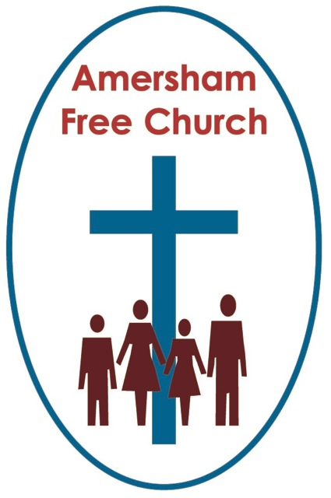
27th December 2015
Micah 5.2-5a
Luke 2.15-20

O Little Town...

Gracious God – we open the bible and long to receive your word – open, we pray, our minds and hearts to receive that word with all its comfort and in all its challenge. Amen.
A shortened sermon this morning – I’m sure you won’t mind that!

We’re focusing on a place most of us have never visited but we’ve all sung about – and it’s as much a part of our Christmases as turkey and tinsel – Bethlehem.

I love Bishop Philip Brooke’s carol, O Little Town of Bethlehem – he wrote it after visiting the town – he wrote it for his Sunday School back in Macetuchetts. The first line says: How still we see thee lie.
Well perhaps it was quiet at night, but it would surely be the calm after a bustling, crowded and busy day. This was census time – every bed in town taken – the place was not its normal self – here was pressure and chaos. A small town, 7 km south of Jerusalem – coping with an invasion of people. In this place – amid this turmoil - Jesus is born.

It strikes me that just about nothing of Jesus’ birth was really ordinary. Mary and Joseph lived in Northern Galilee, in a township called Nazareth – that would have been the obvious place for Christ’s birth. But a census called them south. 80 miles south – not an easy journey for a lady at the end of her pregnancy.

The Romans took a census about every 14 years – we have the detailed records of one they carried out in Egypt. Normally they did this to count the number of men available to them for military service – but Jewish men were not required to serve in the army of their occupying force – even the Romans thought that too demeaning. So a census in Israel was primarily for taxation purposes.

Each male, we are told, had to register in his hometown. Well Bethlehem is where David the shepherd boy, son of Jessie, grew up. The shepherd boy who eventually became Israel’s greatest king. I’m sure that Joseph must have been proud of his ancestry – because his family belonged to the line and the lineage of David. In a Jewish society family means everything – and to belong to this royal line, however distant, would surely have meant a great deal. Joseph was going home to Bethlehem – and taking Mary with him.

In his prophesy Micah gives Bethlehem its old name as well as its new one. There were two Bethlehems in Israel so this was a way of distinguishing it – he calls it Bethlehem Ephratha – Ephratha (the Hebrew name for Bethlehem used in the book of Ruth) literally means Fruitful – and the word Bethlehem itself literally means House of Bread.

But this fruitful town was small – it was one of the smallest of the 1000 family towns of Israel – it wasn’t like Jerusalem with its palaces for Herod and Pilate, its grand official residences for the High Priest and garrison for the Roman Army, it didn’t have a temple or a court for the Sanhedrin. But Bethlehem – O Little Town – was the birthplace of kings. Perhaps as Windsor is to London, Bethlehem was to Jerusalem.

Yet we really don’t know the exact birthplace of Jesus. The Emperor Hadrian totally destroyed Bethlehem and it lay desolate for 200 years. When it was rebuilt the place of the nativity was something that could only be guessed at.

The bible simply says in Luke 2 – While they were there the time came for the baby to be born, and she gave birth to her firstborn, a son. She wrapped him in cloths and placed him in a manger, because there was no room for them in the inn.

Later on Luke says the angels told the shepherds they would find the Christchild in a manger – it was – for the shepherds at least – the sign they were looking for, they knew they had found the right house, the right family, the right baby – because he was in a manger – and animals feeding trough. No where in the bible are we told the animals were also there – that’s really the invention of St Frances of Assisi – but whose quibbling and it was great to see the floppy donkey in church last Sunday!

The impression Luke leaves us with is that Jesus was born in the most basic of circumstances. Maybe it was the outhouse, stable of an inn, maybe it was the downstairs of a Jewish home, upstairs is where the family slept, downstairs was reserved for the animals, hence the manger.

But at this busy, congested time the Holy Family were grateful for a manger.

From the start there was something of a refugee about Jesus.

In an ideal world – perhaps – Christmas would be idealic. Everything would be ready without pressure. Families would meet up without division. We’d celebrate this time of year not worrying about what the New Year would bring.

But – that’s not the way it is. In varying degrees we all have pressures, hurts, problems and worries to deal with at Christmas.

Remember it was like that too the first Christmas. Remember the long, fraught journey from Nazareth to Bethlehem. Recall the worry of Joseph that in his home town he couldn’t really provide what was necessary for his new wife – how did that make him feel – to have their firstborn laid in a manger.

God came to our world in Jesus – and Jesus was born in difficult and chaotic circumstances. This is the way in which the light of God entered and still enters our world – often in difficult times and despite chaotic circumstances.

A generation later St Paul ponders his own physical difficulties. He’s a great missionary but he knows he has no special favours – and he’s in some pain, some distress – he calls it his Thorn in The Flesh. And as he ponders this troublesome, worrying time in his life he writes in 2 Corinthians 12.9 – God’s power is made perfect in our weakness.

God is with us in the chaos – in the pressure – in the worries. When
we are feeling weak – God offers us his strength. Through prayer
and worship, in fellowship with each other and by recalling his
promises to us in scripture many of us find that strength from God.

Bethlehem must always have been a special place to Mary – maybe
one of the things she pondered in her heart – for in her husband’s
hometown her firstborn was born.

And now – just as then – in the chaos and confusion of Bethlehem
of Christmas - God comes among us.
May it be so, in the name of the Father, Son and Holy Spirit. Amen
Ian Green Amersham 23rd December 2015

