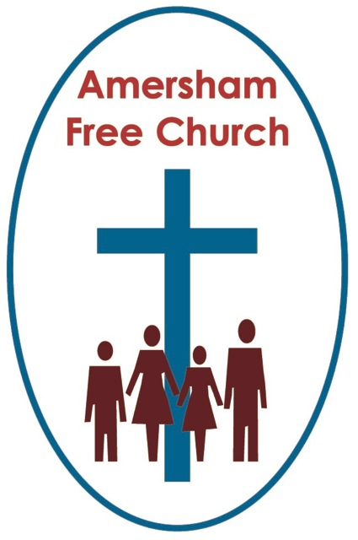
29th November 2015
Jeremiah 33.14-16
Luke 21.25-36

Signs of the Kingdom
Gracious God – may your Living Word come to us afresh this morning – so touch, we pray our minds and hearts with your grace and truth – through Christ our Lord and in the power of your Spirit. Amen
On Tuesday twenty seven children from Curzon Junior School stood on the steps down there and sang Christmas carols to a captivated LunchBreak audience. By the time they got to Away in a Manger they had just about melted every heart in the Sanctuary!
So I confess that as I thanked them at the end I was a bit of a Scrooge and perhaps rained on their parade by reminding them it was still thirty days till Christmas. Last Tuesday we hadn’t even reached Advent so there was still some waiting to be done.
Waiting is something of a popular theme for Advent – why wouldn’t it be? The Old Testament prophets looked forward to a time of liberation for a crushed people – but there was some waiting to be done.
Mary and Joseph – like all parents – anticipated the birth of their first born – but there was some waiting to be done.
Theologians sometimes talk of God’s rule of love and justice in terms of a kingdom now and a kingdom yet to be – and it can feel as if there is some waiting to be done.
This morning’s reading from Jeremiah in the Jewish Scriptures speaks of a nation in exile after the fall of Jerusalem to the Babylonians in 587 BC. God, so the prophet says, is promising a time when a leader will emerge as a branch springing from David’s line – this leader will, says Jeremiah, restore and maintain law and justice in the land. But you get the feel – some waiting has to be done.
So we act out this anticipation in the liturgies of Advent. We light the candles, but not all at once – come back next week and we’ll light one more. We are waiting.
We’ll sing O Come all Ye Faithful but leave the final verse, Yea Lord we greet thee born this happy morning, exclusively for Christmas Day. We are waiting.
But, can I just become a little impatient with this theme today! Is it just possible that we are missing the point by re-living the narrative too closely or reading the apocalyptic literature that is such a feature of this season too literally?
For on the one hand the exiled people of the Old Testament sat down by the waters of Babylon and wept for a different kind of future – but on the other they actually prayed for the land they were in and even gifted leaders such as Joseph and Daniel to these adopted nations to work for their prosperity right now.
Therefore I rather agree with that Iona hymn that begins somewhat provocatively ‘Heaven cannot wait’.

So, in a season of waiting how do we live with our eyes on the present not just the future?
Well today is the first Sunday of a new Church Year in which the majority of our Gospel readings will be from Luke. Now Luke begins with two songs of liberation. We call one the Magnificat – attributed to Mary the mother of Jesus and the other the Benedictus, attributed to Zachariah the father of John the Baptist. Both songs long for liberation and justice. Both songs dream of a future but hint that it starts now.
William Loader, the Australian Bible Commentator says: True and faithful Jews and true and faithful followers of Jesus made such liberation hope the centre of their faith.
I suspect that ever since St Francis of Assisi promoted the idea of Nativity scenes with real animals we have all somewhat fallen in love with the narrative of Christmas. We might even be in danger of over sentimentalising it.
For some in our community it is the one time of year to come to church – it feels as if it’s the most important festival.

Last Christmas Eve here at AFC a lovely chap greeted me at the door, I didn’t know him but he’d obviously appreciated the service and said with a glint in his eye – ‘See you same time next year’ – so I’ve put him down as a regular!
Yet isn’t it fascinating that neither in Mark nor John’s gospel is Christmas mentioned. In Matthew it sometimes seems more the story of Joseph than Jesus. So it’s really up to Luke to be the chief story teller of the Nativity.
Indeed this is what Borg and Crossan say in their book, The First Christmas: stories of Jesus’ birth were not of major importance to earliest Christianity. Sounds heretical doesn’t it?! So I’ll say it again! Stories of Jesus’ birth were not of major importance to earliest Christianity.
Sometimes I wonder if in living out this narrative too closely – in emphasising the ‘waiting’ theme of Advent – we might be in danger of missing the much bigger point of it all.
Perhaps it depends in part in the way we read scripture.
Take today’s gospel reading with phrases like: People will faint with terror at the thought of all that is coming to the world. It’s pretty stern stuff. Take it literally and this is about waiting for the end of the world and that climax will be in the form of a great Apocalypse.
Or what about the reading from Jeremiah? Take that literally and you’ll be able to construct a case for Zionism.
Yet neither of these really deserves such a simplistic interpretation. Indeed Luke even takes Mark’s earlier apocalyptic passages and because he now writes after the fall of Jerusalem in AD70 he amends them. If Luke doesn’t take a fellow biblical author literally just decades after Mark wrote those words – why would we take it all in the literal genre centuries later?
The language used in both Old and New Testament readings today is that of dreaming dreams and catching visions. It’s the language of longing. Its genre is closer to poetry than prose.
This is the kind of language that Martin Luther King used as he stood on the Lincoln Memorial and gave what I think might have been the speech of the 20th Century – the Dream Speech.
A speech longing for justice and equality. A speech lyrical with a picture of a possible future. A speech confidently waiting for a better tomorrow.
Yet nothing about this waiting was passive. Nothing this Baptist Pastor said that day suggested to the thousands who listened to him around the Reflecting Pool that they should simply go back home accepting their present day discrimination because perhaps one day it might all change.
Mary, Zachariah, Luther King all sang about today. The Christian message – actually I think the Christmas message – says that our hopes for the future inspire our actions for today.
A ringing phrase from today’s gospel reading calls us to ‘Lift up our heads’ and see the signs of the Kingdom all around us.
I love that thought. I love the thought that instead of seeing how much of the fig tree is still to bud we rather rejoice in the blossom that has already arrived.
This Advent rather than direct our thoughts predominantly on the theme of waiting why not Lift up your head and rejoice in God’s daily presence with us.
Of course the Fig Tree isn’t in full blossom. As individuals we are a work in progress, as a church we know that often our light barely shines and as a society it would be foolish to think that many of our ideals about a fairer world are anything other than aspirational.
Perhaps that’s why Anne Stewart, who teaches at the Princeton Theological Seminary in New Jersey, says this: Advent invites us to name the places in our lives and society that are at odds with the divine vision of justice and righteousness.
We can lift up our heads this Advent in both rejoicing and longing. Already there is blossom on the fig tree but still there is room for more.
In my home church in Southampton my minister used to tell us of the Sunday teas he had with his great aunt. She was a great believer in the Second Coming – no doubt she would have loved today’s verses about portents appearing and no one knowing which way to turn from the roar and surge of the sea.
Well – the Return of Christ is a traditional Advent theme.

But I wonder what that means for us in 2015?
Believers at the time of Luke thought it was imminent – but it didn’t seem to happen in the way they expected. Perhaps it will never happen in the way we expect.
Maybe this breaking in of God’s Kingdom isn’t so much the appearance of Christ in the clouds, more a rising of the Spirit of Christ in renewal and transformation.
So as we ‘Life up our heads’ what ‘Signs of the Kingdom’ might we see this Advent?
I think I saw a sign at last Sunday’s Church Meeting as we embraced the challenge of supporting the Mentoring Scheme for Street Kids in Guatemala and making it our focus for 2016.
I think I see a sign every time the Chiltern Child Contact Centre meets on our premises two Saturdays in the month – enabling children from broken families to reunite with their non resident parent.
I think I see a sign in the Interfaith gatherings we’ve held in the Owen Room a couple of times this year as we’ve welcomed friends from the Chesham Mosque and listened to both Islamic and Christian perspectives on life and faith.
I believe I saw it as I called in to both the Sycamore Club and Women’s Own recently and felt that sense of belonging experienced by the members there and the wonderful Pastoral Care offered by faithful leaders and helpers.
I hope I see it as I work at my marriage, love my family, care for my friends and worship my God.
On this first Sunday of Advent let us Lift up our Heads and rejoice in all that God is doing among us and through us – and in rejoicing at the blossom already on the Fig Tree we both long and strive for more.
In the name of Father, Son and Holy Spirit. Amen
Ian Green Amersham 27th November 2015

