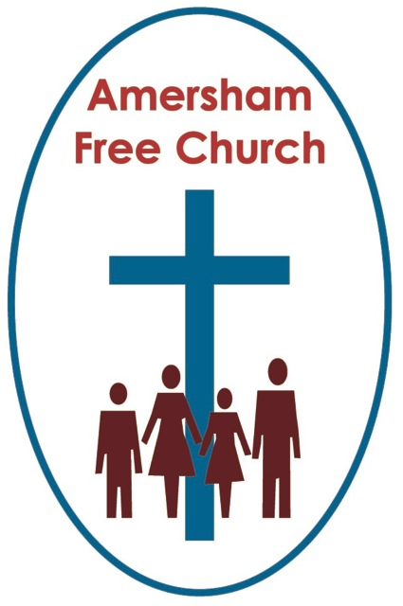
1 Thess 5.12-28
November 8th 2015 Remembrance Sunday

BLESSED ARE THE PEACEMAKERS

Gracious God – we open the bible and long to receive your word – open, we pray, our minds and hearts to receive that word with all its comfort and in all its challenge. Amen.
It was May and we were standing in the Mall. We’d decided to spend my day off that week visiting London and in the morning to stand with the crowds outside the palace watching the comings and goings of a State Visit.

But this was a controversial visit. The Emperor of Japan was on his way. And as he rode passed, in an enclosed rather than open carriage that day, some protesters right in front of us turned their backs on him and jeered. Emotions ran high that day. We saw people crying. A confusing blend of pomp and pageantry mixed with anger and accusation.

I’m not sure that I could ever fully understand the intensity of feelings expressed by the former POW’s and their families who were protesting that day. After all I have never felt their pain or experienced the depth of anguish they must have felt. I do recognise, however, their right to feel anger. I also recognise that for many reasons our government wanted to move on and build bridges with countries we once viewed as enemies.

That day reminded me just how difficult it is to build peace, to come to a point of reconciliation – to move on. Watching the news reports and reading all the arguments surrounding the Emperor’s visit was a confusing experience. Each side had reasonable arguments for their position – how do you move on in that stalemate situation – how do we cope with that sort of confusion.

Well this morning we are going to try. That’s because we’ve looking at the 7th beatitude that Jesus taught us – the one that goes, Blessed are the Peacemakers.

On this Remembrance Sunday our theme is Peacemaking.
Time and again the bible encourages us to pursue peace. How about a verse from this morning’s reading: 1 Thessalonians 5.13, Live in peace with each other.

Peace is a most ethereal word, yet pursuing it, making it, forming it, and even praying for it can be the most demanding struggle.

Because it can be all so confusing, this morning I want to try to be very simple. And simply say two things – to split the word peacemaker in two parts.

Peace – in Hebrew of course the well known word Shalom.

The thing about Shalom, the Jewish word for peace, is that it means far more than just the absence of war. You know when a world or regional conflict ends they often say that peace has broken out. And of course by that people mean that the bombing, the killing, the fighting has stopped. All those horrible and negative things have come to an end. There’s peace. Yet it’s also true that building peace takes more than a ceasefire, or an armistice. Building the peace is essentially about filling that new void with something positive. And if we asked those striving to do just that in Northern Ireland or Afghanistan or in Syria we’d hear how you need courage, patience and determination to build a peace.

So Shalom – biblical peace is always something positive.

In a recent Christian Aid newsletter I read we were told this real life story from Ethiopia – a country where two thirds of the people live in constant hunger. In Ethiopia Christian Aid works alongside the Orthodox Church funding projects to help Street Kids, especially families struggling to survive because they’ve had twins.

Christian Aid told us about a young boy called Joon living in Addis Ababa, the capital. He lives in the shantytown district with his family of 3 brothers and one sister – the twin sister of one of his brothers has just died.

Joon’s family live in one half of a house, to get to their half they have to walk through the living quarters of the other family who live there. Joon is 13 and each day he fetches water, that’s a fifteen-minute walk and each day he has to empty the latrines, that’s a 20-minute walk.

His mum, Rawda received help from Christian Aid sponsored Gemini Trust when her twins were born. That meant at least one of them survived instead of starved. But she was worried about Joon. He was withdrawn, didn’t go to school because he felt he must stay at home and help his family. She was worried that he would chew a drug called chat, or sniff petrol like the other boys.

All of that was before he joined the dance troop, run by the Gemini trust, sponsored by Christian Aid.

Is that what we give our money for? In part yes. And this Dance Group has transformed Joon’s life. Psychologically, emotionally he’s changed. He’s grown, before he was thin. He walks, before he used to drag his feet. He laughs, before he was sullen. This is not a made up story it’s real.

A few months ago Joon performed with the Adunga dance troop in one of Addis Ababa’s biggest squares. I was very happy, he said, I never imagined all these people would come and watch me. all the clapping made me feel good.

That’s shalom. It’s peace. Something positive and wholesome in place of despair and failure. In Christian Aid’s view Shalom has something to do with Life before Death.

You and I could quote other stories.
And the work you’re doing in your family, at your school, in the community – it’s Shalom work. The work of Peace. Sharing the wholeness of the Lord Jesus Christ, body, mind and spirit wholeness.

Blessed are the Peacemakers, said Jesus.

Now secondly don’t you think it’s significant that he didn’t say, Blessed are those who love peace – those who value it – instead he said, Blessed are those who make it, who actually strive after it and actively work for it.

This then ought never be a passive desire, without a practical outworking.

That’s why it’s probably such a difficult beatitude.

Our inspiration comes from Christ himself. He came to bring us peace when he died upon the cross. That’s what communion is all about. Reconciliation, God restoring us lovingly to himself through Christ’s work of peace.
I once went with the Elgar Society to the Birmingham Oratory. Once there we looked at the original score of his Dream of Gerontius and the library and room of Cardinal Newman. Prior to all that we were given the grand tour of this grand Roman Catholic Church. Passed by one or two Confessional Boxes. As a Baptist I was quite keen to try them out, just for curiosity value you understand, but I behaved myself. One of them caught my eye – this confessional had a carving of the cross on one door, and a carving of the prodigal son on the other. Well, I know you might have views about the theology of the Confessional box – but I thought that carving of the prodigal son was so appriate. Confession – essential confession before God – perhaps rather than before a priest, confession is about coming home to God. It’s about being received into the forgiving arms of a loving father. It’s about a welcome. It’s about making peace. The way God actively makes peace with us, through Jesus.

We have a peace making God. That’s why we are called to be peacemaker. Christ is our peace. Christ is our inspiration. Christ is our guide. Christ is our role model.

To live in any other way – is to dishonour Christ.

Have you read the Railway Man by Eric Lomax or seen the film starring Colin Firth? For years Lomax hated his Japanese tortures. For he too was a POW like the ones we saw that day in London. After a long struggle with his conscience, through agonising arguments with himself and with others. He finally met the very man who put a tube down his nose and poured water down it whilst integigating him. His integeator was contrite and had given the rest of his life to striving for reconciliation and had built a House of Peace. Eric Lomax met him and embraced him. Such a brief summary does no justice to all that lead up to that moment. It was a long and difficult and heroic journey.

And that journey may be difficult for you and for me. Difficult not to give up making the peace, keeping the peace, searching for the peace. Yet Spirit filled disciples are given strength to do difficult things.

It was said of Abraham Lincoln that he once remarked, Die when I may, I would like it to be said of me, that I always pulled up a weed and planted a flower where I thought a flower should go.

That’s what a peacemaker does too. In place of the weed of strife, with God’s help we can plant the flowers of peace.
May it be so in the name of the Father, Son and Holy Spirit. Amen
Ian Green Amersham 3rd November 2015

