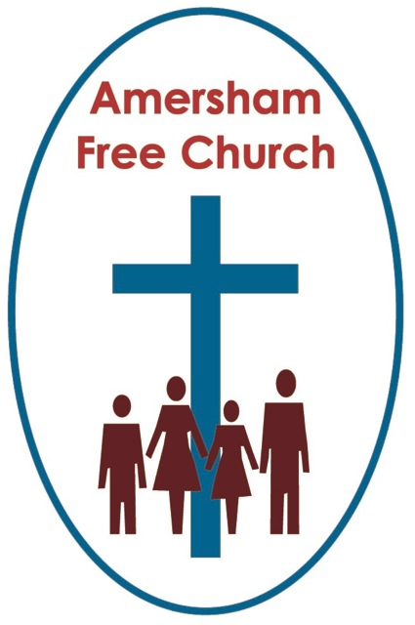
John 11.32-44
1st November 2015
All Saints’ Day

The Death of Lazarus

Gracious God, we thank you for your word in scripture and made flesh in the Lord Jesus Christ. Help us now to catch your voice and speak, we pray, to our hearts and minds. In Jesus’ name. Amen.
On this All Saints’ Sunday the lectionary gospel takes us to a story about a death and resurrection. Lazarus – a name that literally means God is my help, was a friend of Jesus – a good friend – he was also a good brother to Mary and Martha of Bethany.

In John 11 Lazarus dies:

We often talk of death with humour – perhaps it can be our way of coping. Winston Churchill said of his own demise: I’m ready to meet my maker. Whether he is prepared for the ordeal of meeting me is another matter.

In our society where we talk about almost anything – death is still the final taboo. Understandably we push it to the back of our minds. And when it comes – although it may be a release to some, to most of us it feels like an intruder. And that interruption takes some getting used to.

In today’s narrative Lazarus becomes ill, those around him worry as they care for him. They send word to Jesus – Lord the one you love is sick.

But it’s too late and to no avail so Lazarus dies.

The Hospice Movement has given people a great deal of dignity as they approach death. Many feel that hospices are places of hope as well as of help. I’ve been in a few hospices visiting folk – and I’ve always been touched by the sense of peace. Patients are surrounded by people who have a depth of cumulated knowledge – over the years and having dealt with many people these folk have witnessed death many times and are there – often quite literally to hold the hand – of those who are now dying.

Lazarus dies.

This how one writer puts it, - he writes from a Christian point of view – Death comes as to one who has finished a long journey, stills the motor, turns off the lights, steps from the car, and walks up the path to the home that awaits him.

Now as we look at this story from John 11 we notice secondly That Jesus delays.

John 11.6 – Yet when he heard that Lazarus was sick, he stayed where he was two more days.

Eventually Jesus would travel back down to the south of the country, back to Judea – but it would be at a time of his own choosing. People were trying to influence him, to coax him – but Jesus stays put. That must have been frustrating to those who would have hurried off to Bethany. To them it was a mystery that Jesus stayed where he was, up north, in Galilee.

God’s timing can so often seem to be on a different calibration to ours. We see things one way – maybe God observes with all round vision. And that frustrates us because there are things about God, about faith, about life and death that remain a mystery to us – and one of the greatest mysteries is the timing of it all.

Yet in today’s gospel it is only a delay – Jesus goes to Bethany in the end.
This was one of the least hospitable places for Jesus to be in Israel. His disciples were sceptical about his safety – that’s the reason they had come north – vs. 8, But Rabbi, they said, a short while ago the Jews tried to stone you, and yet you are going back there?

The answer that Christ gave to that was that he must go back south for God’s glory. Vs 5: This sickness will not end in death.
In the raising of Lazarus at Bethany and the death of Jesus just weeks later outside Jerusalem something of God’s glory was shown – the glory of his love, compassion, forgiveness and peace.ll be wonderful, but even more wonderful – back to Jerusalem to Good Friday and Easter Day.

And did you notice something very helpful. That the disciple we often malign as Doubting Thomas – the one we paint in such a bad light – it’s him, Thomas who is the first to agree to this dangerous journey. So whatever we say about Thomas at the end of the gospel – and to be truthful many of us identify with him rather than criticise him – here in the middle of the gospel he comes across as a person full of faith and trust.

Lazarus dies, Jesus delays.

Thirdly this morning: The Village Mourns…

Well it was the Jewish custom.
In fact a death was very much a village thing. In Britain we may want a bit of space following bereavement – a little time alone with our thoughts. In ancient Israel the first 7 days of mourning were set aside for deep wailing. We would be joined by most of the women in our street or village and we would cry together. The whole village would turn our for the funeral procession with the women walking in front. Then for 30 more days after the first week we, as a family, would enter the second stage of lighter mourning.

Emotions were still raw when Jesus comes to Bethany. Martha and Mary were crying – not just gentle tears but passionate wailing for the brother they had lost – and many friends who were also weeping joined them.

This passage has that shortest verse in scripture: Jesus wept.

I’ve always read this verse picturing our Lord shedding a tear – but maybe it was more than that – he cared deeply for his friend – as a Jew - on day four after the death – it’s probable that Jesus entered that grief with deep wailing.

Well, however he cried, surely John 11.35 is one of the most precious verses for any of us in the bible. Whenever we go through our grief – we trust in a Lord who knows the pain of bereavement. Who knows the hollow feeling that’s left when someone we love dies.

A certain group of Jewish religious thinkers had every reason to cry at a funeral. They were the Sadducees who didn’t believe in the resurrection. They were rather like Bertram Russell who once described death simply as a full stop. The end. No new sentence or paragraph to be written.

But Martha isn’t a Sadducee. We know that because when she meets Jesus she says in verse 24: I know he will rise again in the resurrection at the last day.

Well, this is a four-point sermon and because ultimately the Christian message about death is one of hope I hope you think it’s appropriate on this All Saints’ Sunday that we should end this talk on a positive note.

Lazarus dies, Jesus delays, the village mourns, and finally LAZARUS IS RAISED.

God was glorified through Lazarus’ resurrection – Jesus does a wonderful thing and gives Lazarus new life. And somehow through the mystery of the cross and resurrection he offers that new life to us as well.
So those words he first spoke to Martha are now proclaimed at practically every funeral service that’s held – Jesus said to her, I am the resurrection and the life. He who believes in me will live, even though he dies…

I remember Paul Beasley Murray who for one year was my principal at Spurgeon’s College in London. He’d just returned form a funeral service and was cross. In fact he was on the brink of being very cross. Because the officiating minister had taken the whole service without reading this verse, John 11.25, and without talking about the resurrection.

Well it’s central to our faith as Christian people. That death isn’t a full stop – it’s not the end but the beginning.

In recent years Rwanda has been one of those African countries racked with civil war and massacres. In 1963 it was much the same story. Yona was a young pastor in Rwanda when the inter- tribal fighting broke out. He got caught up in the fighting somehow, refusing to leave his village and escape with the rest, he stayed to look after the sick. The invading army took him to a bridge where he was shot. But here’s how we know that Pastor Yona held that Christian belief that death is not the end. His last wish was that he might make a final entry into his diary – he wrote, ‘We are going to heaven’. It was latter reported that his composure in the face of death had made his executers feel deeply ashamed of themselves. As he faced death Yona was able to write, We are going to heaven.

What does Paul say in Romans 8: I am convinced that there is nothing in death or life, nothing in all creation that can ever separate us from the love of God.

The Christian response to death isn’t to ignore it, or glibly say it doesn’t matter. Jesus wept – and in so doing sanctifies all grief. He knows how hard bereavement is. We have a God in heaven who understands.

The Christian response to death is to point to Jesus Christ – to trust in his promise that he is the resurrection and the life.

These are the last words of Edward the Confessor – the King of England who founded Westminster Abbey and died in January 1066 – As I leave the land of the dying I trust to see the blessings of the Lord in the land of the living.

Clever that, wasn’t it – earth is the land of the dying, heaven is the land of the living.

You see we are all of us on a journey – a journey not to sunset, but sunrise.
May that be our hope in our living and in our dying, in the name of the Father, Son and Holy Spirit. Amen.
Ian Green Amersham 23rd October 2015

