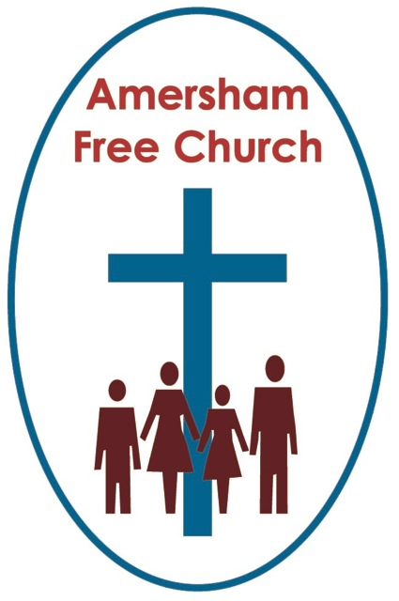
Joshua 2
18th October 2015

The God of the Unexpected

Lord God – our prayer is that the written word will point us to Christ, the Living Word – so in his name we pray and for his voice we listen. Amen.
I guess if you asked the question – Where can you meet God? – a lot of people might come up with religious places like churches or cathedrals. Others, I’m sure, would say they encounter God in natural places like the garden or countryside. And although it probably wouldn’t be our first answer, in thinking about it wouldn’t it be true to say that you can also meet God in a crisis or a difficult situation.

That was to be Joshua’s experience. As he takes over from Moses he seems to be on a roller coaster ride – one crisis after another will come his way – and in each one Joshua learns more of God – he meets God in unusual places and people.

This morning I want us to think about Rahab – she’s part of the story of Joshua chapter 2. She ran what was really a brothel in Jericho – so I think she was fairly well known. She belonged to the oldest profession in the world – Rahab was a prostitute.
In his book, When God Surprises, Richard Bewes says this of our encounter with Rahab – She is in the hall of fame to shock us out of our smug complacency. She is there to encourage us that the weakest, the most notorious in the city, can enter the service of the Lord God.

So here’s a first thought about FINDING GOD IN UNEXPECTED PLACES

In Joshua 2 a couple of Israelite spies are sent into Jericho on a recognisance trip. Verse 1 Go; look over the land, Joshua said, especially Jericho. Jericho was a walled city – the Israelites needed to capture it if they were to make any headway at all in taking the Promised Land.

Where did these two spies stay in Jericho? Who gave them help? Well verse 1 tells us: So they went and entered the house of a prostitute named Rahab and stayed there. This was God’s leading, God’s way. In a brothel these spies meet up with God.

When Rachel and I started dating – many moons ago, I would drop her home and walk back to my flat in Kettering, passed the local pub called the Cherry Tree. Almost every night I did this I’d look through the windows and see the Methodist minister there. Now I’ve no doubt that Clive, my Methodist minister friend had lots of other meetings during the evenings just like me. But it seemed he always finished off his evenings with a quick visit to the Cherry Tree. I guess to some Methodists and Baptists that idea took some getting used to.

Clive used to say to me that for him those visits to the pub were his deliberate way of making friends outside of his congregation. It was his way of listening in to the gossip of the town, the issues of the day about which people felt deeply. He enjoyed those times – and two things were happening there – he could share something of God from his own experience with others as they chatted together – and during the evening, he said, he would invariably experience something from God in that context. You see Clive meet God in church – yes of course he did and he was glad he did. But he also meets God in the pub.

Now don’t get me wrong I’m not advocated this morning that you should abandon this autumn’s Life and Faith Groups’ programme for the Dog and Duck – but what I am saying is that we can all meet God in unexpected places. God is bigger than our church buildings.

One of the healthy things about our church life here is that so many of you are involved in community organisations in Amersham. We have church members involved in Help the Aged, Hospice Work, local politics,WorkAid and much else beside. This is great – it’s where we need to be. And in these places we can serve God and learn from God.

In the story of Joshua the spies found God in unexpected places – in the Jericho brothel.

Secondly they heard God THROUGH UNEXPECTED PEOPLE. Through Rahab.

I mean she wasn’t a priest or preacher – or anything like that. She wasn’t even a Jew. Yet listen to what she says in Joshua 2.11: …for the Lord your God is God in heaven above and on the earth below…

These were words of faith. Perhaps for her it was a new discovery – a moment of conversion. But there’s no doubting her sincerity – as she speaks to Joshua’s spies it’s evident that she too trusts in their God – she describes him as the God of heaven above and the earth below.

Nationally we expect to hear God speaking to us through people like the Archbishop of Canterbury. But isn’t it also great when non- professional Christians also speak up.

On those occasions it’s as if God is speaking to us through unexpected voices – people who make more impact because they are not religious professionals.
I remember Chris Akubusi the athlete being interviewed on Breakfast TV a few years ago. The interviewer was really pumping him for gossip from the Olympic Village – something a bit nasty or scintillating. Instead Chris Akubusi turned the questions round and talked about his Christian faith. Hearing God, you see through unexpected people.

On another occasion I tuned into Desert Island Discs and heard Sue Lawley interview the Director of Kew Gardens in London. One of his choices was Amazing Grace – and quite naturally and unashamedly he just slipped in that he chosen that hymn because of his Christian faith.

Well, I don’t know, but if you are a teacher I suspect your colleagues would expect to hear about God if I came and took an assembly – and maybe it would pass them by. But if you talked about your faith over coffee break in the staff room – I suspect that would make a greater impact. Hearing God, you see, not from a religious professional – but unexpectedly through the voice of a friend, neighbour or colleague can make a better impact.

Finding God in unexpected Places – a brothel
Hearing God through unexpected people – Rahab

And finally this morning how about SEEING GOD IN UNEXPECTED WAYS

Quite simply Rahab was a brave woman. She had made it clear that she believed in the spies’ God. Now she would do all she could to help the spies. She allowed them to stay at her house, identifying with their cause she even suggested a safe place for hiding, on the roof under the flax. When soldiers knocked on the door searching for the spies, she covered for them. In all of this she laid her life on the line. She turned her beliefs into actions.

An old Bishop of Liverpool – JC Ryle once said: A religion that cost nothing is worth nothing.

We are called to walk the talk. That means we put our beliefs into actions in a family through love, in our work life through integrity and in our community life through example.
I was at a ministers’ meeting the other day and an Anglican colleague came out with an interesting phrase. She was talking about the various activities of her country parishes – it was hard to keep all these churches open for business but she had a great desire to do so – so that in her words – they could keep the rumour of God alive.

Keeping the rumour of God alive. That happens in all sorts of unexpected ways.
I know it was fifteen years ago now but do you remember how it happened at the turn of the millennium? Perhaps many Christians hoped it would be through the prayer said at the Dome on New Year’s Eve – but that didn’t really work. Instead by far the bigger impact seems to have been through the Seeing Salvation exhibition put on by the National Gallery – under the directorship of Neil Macgregor – its Christian curator. That exhibition in central London of religious art focussing on the story of Jesus broke all records, more people went to see it than have gone to see any other exhibition at The National Gallery. It was a great success and it was a wonderful surprise.

Seeing God at Work – in unexpected ways.

Well, we’ll leave Joshua, Jericho, Rahab and The Spies there this morning.

Finding God in unexpected places – like a brothel
Hearing God through unexpected people – like a prostitute.
Seeing God at work in unexpected ways – like Rahab’s courage and practical help.
May we all get many unexpected glimpses of the Divine this week, so that the ‘rumour of God’ is kept alive though us and around us, in the name of the Father, Son and Holy Spirit. Amen

Ian Green Amersham 12th October 2015

