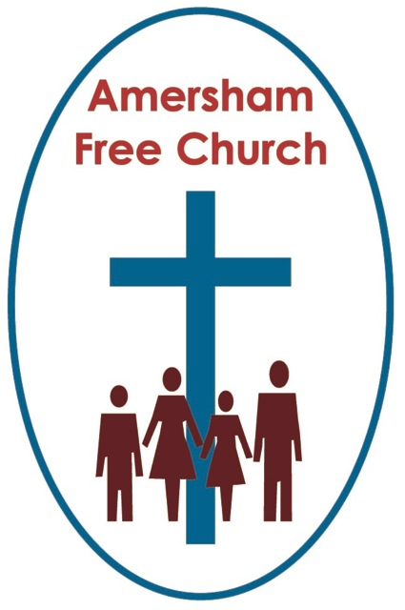
4th October 2015
Mark 10.2-16

Divorce – is this the last word?
Gracious God – we open the bible and long to receive your word – open, we pray, our minds and hearts to receive that word with all its comfort and in all its challenge. Amen.
There is often a tension between the ideals we strive to hold and the reality of life we experience.
No where is that encountered more, I think, than in matters of faith.
We believe in prayer but so often feel ours are not answered.
We believe in the Church yet find the one we belong to is often divided.
We believe the Bible but get confused by the apparent contradictions we find within it.
We believe in God – however we find we need to redefine what we mean by that almost every week.
Why, we sometimes pine, could it all not be simpler and more straightforward.
In a world where money seems to be king, euthanasia is becoming more accepted and same sex relationships are part of the everyday wouldn’t it be better if the bible gave simple answers to these complex issues?
There is a tension between the ideals we strive to hold and the reality of the life we experience.
The tragedy is when we fail to acknowledge that reality or accommodate it within our faith. When that happens a dis-connect occurs between what we supposedly believe and how we experience life.
It can be a tragedy when someone with faith opposes divorce but carries on living in an abusive domestic relationship.
We need to make the connections and ground our faith in reality.
This morning’s lectionary reading is tricky and I’ve been very tempted to avoid it and select the alternative readings instead of the gospel – but that would be my vain attempt to avoid grounding my sermons in the reality of life as it must be lived
Divorce was a controversial subject in Jesus’ day.
But perhaps it’s also worth saying that life was very different in his time too. Women, for example, had far fewer rights and when it came to marriage were considered the property of their husbands.
Deuteronomy 24 gave the green light for divorce in Jewish culture. The process was relatively straightforward – a man could divorce his wife simply by writing a note and giving it to her, releasing her from her marriage vows so she could remarry.
The ease of that process meant women could easily be abused – for they had few rights and were at the mercy of the whims and passing fancies of their husbands.
Two Rabbis are often quoted in this area.
Rabbi Hillel ruled that a man could divorce his wife for almost any minor reason – even for being a bad cook!
Rabbi Shammai, on the other hand, ruled that divorce was only permitted when adultery had been committed.
It was against this background of endless debate that the Pharisees, says Mark, try to trick Jesus into making a public statement about divorce.

Never a good thing to use an ethical dilemma to score points. Never a good thing to discuss human tragedy and frailty in this hypothetical and emotionally detached way simply to win an argument.
Yet that is what is happening here.
In this morning’s narrative Jesus continues his journey southwards towards Jerusalem and the events of Holy Week. He’s questioned about divorce and responds in three ways.
Firstly he draws their attention to Deuteronomy and the Jewish Law that permitted divorce – but he says, in effect, this isn’t God’s ideal but was permitted because people’s hearts are stubborn.
Secondly, and perhaps most importantly, he goes back to Genesis and reaffirms that marriage is a wonderful gift that should be cherished.
Thirdly, once indoors, he says – or at least appears to say, that those who divorce commit adultery.
Now if you want to read the bible like a constitution and take every verse literally you’d end up saying slaves should obey their masters, women should cover their heads when worshipping and stay silent in church and divorce is wrong.
But that, I suggest, is a mistaken way of reading scripture. These words have a context and culture and being made in the image of God means we must read them with our minds and come to reasonable judgements about what these verses meant then and how they should, or should not be applied now.
Even Jesus did this in his day – in fact every Rabbi did.

It was the custom to say ‘you have heard it said....but I say to you.’ In other words there is often something provisional in the laws of the Old Testament and, say, the teachings of Paul in the New. In others words some biblical teaching is time and culture specific, descriptive rather than prescriptive. That means, despite verses in the Bible that might appear to support the contrary, modern era Christians advocated the abolition of slavery and women are now bishops in The Church of England.
So how do we understand Jesus’ statement about divorce which seems, at first reading, simply to say that it is wrong.
I think we have to understand why he might have said that.
In his day a women had few rights, a man held all the cards and could divorce for very minor reasons which nearly always disadvantaged the woman.
Might it not just have been the case that Jesus was actually speaking against this particular type of unfair divorce – in essence he was standing up for those women who had been so crushed and abused by their husbands.
To underline this he spends a lot of time quoting Genesis and that poetic description of marriage as something mutually supportive and encouraging – a real partnership blessed by God.

That was Jesus’ ideal and that’s what he wants the Pharisees to focus on. Jesus responds to their negative question with a positive – marriage is good, he says, - it should be valued, honoured and worked at.
Divorce is bad, he seems to be saying, because in our culture women are treated as things to be thrown away by unloving and cruel husbands.
But what of today?
Lord Carey, a former Archbishop of Canterbury, has talked openly of the pain he felt as a parent seeing his children’s marriages fail and end in divorce.
I think it was during his time at Lambeth Palace that the Anglican Church started talking about ‘irretrievable breakdown’ in a marriage being understandable and acceptable grounds for divorce.
I have generally felt it right to accept invitations to officiate at second weddings – believing that God in his mercy constantly offers us the chance of new beginnings which can bring about healing and wholeness.

I’ve sometimes been humbled by the sincerity of those who have sought remarriage after a divorce when they have requested a quiet service of confession prior to their marriage. A service when just a few of us have gathered and used the silence to bring to God the pain and failings of the past, to lay them down before him in his love and grace and seek his blessing for the new union about to take place.
Our ideal is that a marriage will grow and be sustaining. Yet when that doesn’t happen – and after many prayers have been said and much effort made – there is a moment when a couple probably know they have come to ‘irretrievable breakdown’ – and at that moment the response of the Church should reflect the love and welcome of a God who believes in new beginnings.
Jesus, I believe, was not giving us the last word on divorce in Mark 10 but speaking into a specific context in which women were all too often discriminated against in easy divorce.
Last month we had a marriage service here at AFC. It was an occasion of great joy. The couple choose our church because the bride’s parents had been married here.
At the rehearsal a nervous bridegroom said to me that for him as he thought of everything that was going to happen that Saturday – the most important part was the service in church.
Our ideal as a Christian community is to promote and support marriage as a wonderful gift given to us by God – a creation ordinance.
Our reality both within and outside of the Christian community is that not all marriages make it – and at that point we are called to reflect God’s love as we respond with compassion, understanding, wisdom and support.
There need be no disconnect in our ideals and reality – because God shares our joys and holds us in our sorrows.
May that be our experience in the name of the Father, Son and Holy Spirit. Amen

Ian Green, Amersham, Thursday 1st October 2015

