Bearing our cross
Mark 8:27-38, 1 Cor 1:18-24

13 September 2015
A few weeks ago four of us from this congregation drove down to Kent to visit a small church at Tudley, a village just outside Tonbridge. From the outside the building didn’t look particularly interesting, but as we entered our conception changed dramatically. This traditional, ancient building houses the most amazing collection of modern stained glass widows designed by Marc Chagall, the world famous 20th Century Russian-French artist. Later on we’ll hear a bit more of the story of these windows, here I just wanted to say how the quiet contemplation of one of those windows influenced the way we are going to approach our text today: “Anyone who wants to be a follower of mine… must take up his cross and follow me”. What does this well-known summary, almost a manifesto of Jesus’ might mean for us today? We have some visual representations to look at in the hope that through them we might arrive at some helpful insights.

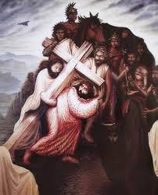
From a distance our first picture looks like a rather traditional showing of the suffering head of Jesus on the Cross, or perhaps on the way to the Cross. In fact, it is more than that: it is one of those ‘optical illusion’ type pictures which require closer inspection. Once you re-adjust your eyes, you will see that the forehead and the nose are made up of a cross, which is surrounded by people, characters of the crucifixion story. The eyes are heads of two men holding up the cross, and they also make up the chins. Presumably one is Jesus the other is Simon of Cyrene, who helped Jesus to carry his cross. The crown of thorns is also made up of other figures. Taking the picture as a whole tells me something about how Jesus himself might have ‘taken up’ his own cross. The closed eyes create the impression that here we are given a rare insight into Jesus’ internal, mental state. The cross he is carrying is not just the crude instrument of torture imposed upon him by his mortal enemies from the outside, it is a reality that dominates his whole being in the inside too. In spite of the obvious suffering there is a kind of mental assent being expressed here. Could it be that, the first step in taking up our own cross is a kind of internal acceptance? The way our common wisdom has it: “We all have our cross to bear.” In one way or another suffering is a part of the human condition, so the question is not so much whether we do take up our cross, more like how we do it.

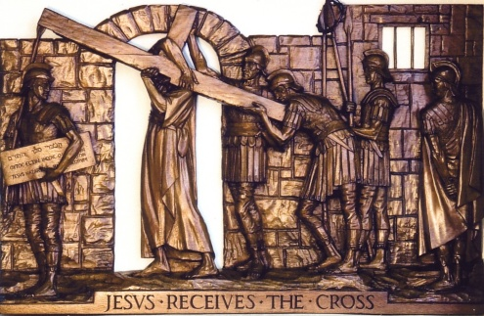
The next picture is a wood carving and it is part of the Stations of the Cross in the Chapel of the Community of St Mary the Virgin at Vantage. It was lovingly and painstakingly carved by Mother Maribel of that Community. It depicts Jesus in the physical act of ‘taking up his cross’, which, according to tradition meant carrying the cross-beam of the cross to the place of execution. If we home in on the beam we realise that it is that part of the vicious instrument, which will actually support the whole body of its victim. Taking it metaphorically, it might mean that before anything else our first cross we have to bear is ourselves. The kind of people we are, made up of ‘nature and nurture’, hostage to our upbringing, education, life experiences, capable of instinctive words and actions often regretted afterwards. How do we relate to ourselves? Jesus actually says, ‘deny yourself’. Does this mean we are asked to negate our God-given humanity? I don’t think so. From everything else we know of Jesus we can safely say that he was not talking of rejecting our true selves as we have been created and held in the mind and heart of God. Yes, he castigated those who put on a show of themselves for others’ benefit, but he was always generous and affirming with those, who were put-upon, who were not allowed to believe in themselves, who needed liberating as much from external shackels, as from internal, self-imposed bondages. Taking up the cross of ourselves may be the realisation that we can be a burden to ourselves as well as to others, but if we accept it as part of the burden of following Jesus, we are heading in the same direction as he did, towards the loving gaze of God, who ‘receives us exactly as we are, without judgement or distortion, subtraction or addition. – as Richard Rohr says (Falling Upward 2011). ‘Such perfect receiving is what transforms us’.

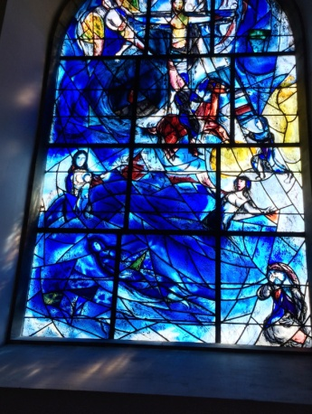
And so we come to the Chagall window. It is also about taking up the cross. This time it is the cross of tragedy and bereavement, which is borne with the hope and faith that it does not have the last word. This window was commissioned by a well-to-do family of the Tudley Church to commemorate their 21 year old daughter, Sarah, who died tragically at sea in 1963. Having visited the Church to see where his window would be placed, Chagall was so taken with the ambiance, the light, and the position of the other windows that he was moved to the most surprising statement: “I will do them all!” And so he did. There are now 12 Chagall windows in this little Church, which makes it a centre for modern day pilgrims, art-lovers, tourists, ad-hoc visitors from all over the world. The grieving family who had the financial wherewithal has found a means of bearing their own cross in a way that is and will be inspirational for countless others for generations to come. This is the largest of the windows, the East window. What is striking about it is its internal dynamics. There is a clear juxtaposition between two kinds of crosses. The bottom half, the bigger half is dominated by the sea, the place of tragedy. We see Sarah’s dead body in the sea and her desolate mother on the left. This is a huge cross to bear. There is no minimising here of human suffering, the kind, which sometimes prompts us humans to turn on God. “God, you don’t know, what it’s like! You don’t understand; how could you? I am hurting so much!” And then there is the other cross in the centre through which comes the whisper of God: “Me too!”
There are other features pointing to the hope of Sarah being taken up to the cross and finding new life in the Resurrection of Christ, but for me the message of the picture is that Jesus on the Cross stands for all human suffering, for yours and mine for the emaciated bodies of starving children in Africa, for the thousands of refugees bombed out of their homes, for the desperate migrants flooding Europe, for people with crippling physical conditions and terminal illnesses. God does not take away our crosses, but in solidarity puts alongside them the Cross of Jesus, where the divine suffering matches the human suffering.

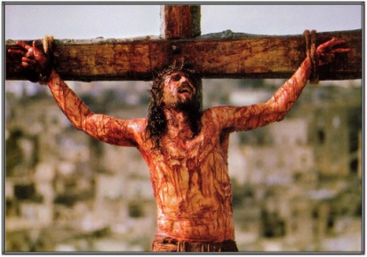
This is a still picture taken from Mel Gibson’s film “The Passion of the Christ”. Those of you who have seen the film will know that the director does not pull his punches in showing Jesus’ suffering in all its gory details. You could argue with the merits or otherwise of this way of portraying the Cross, one thing is certain though, for those of us, who tend to over-spiritualise the significance of the Cross, it is a sobering reminder of, what the Apostle Paul calls ‘the offence of the cross.’ The cross represents cruelty and barbarism. The Crucifixion was the most absurd, shocking thing that could have happened to any Jewish person, let alone to someone, whose followers hailed him as the promised Messiah, God’s own Annointed. Anyone, who hung on a tree, the OT asserts (Deut 21:23), is irrevocably cursed by God. The Messiah could not be cursed, he would be forever blessed. For the Greeks, the other component of the early church, the very idea that the Divine Creator would need the torture of an innocent man to atone for the sins of others, was immoral and preposterous. But that was then, what about now? Can we follow Jesus and bear our crosses without giving offence? I am not sure. Just think, if we dared to truly follow him, if we were able to turn the other cheek, if we loved our enemies, if we took care of all those in need – wouldn’t that be an offence to everyone else around us?
This brings us to our next picture, a painting by Hyeronymus Bosch, the 16th C Dutch artist

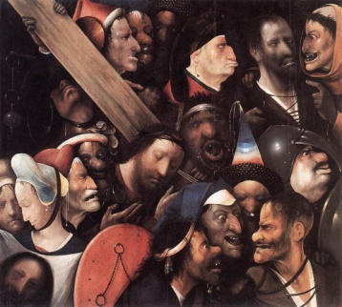
and to some words from the 20th c German martyr theologian, Dietriech Bonhoeffer. Jesus carries his cross among his enemies, evildoers, deserted by his friends. Bonhoeffer’s words come out of his own flesh-biting sufferings as he warns: “If we merely want to be among friends, to sit among roses and lilies, only with devout people, not with bad people, we are betrayers of Christ’s Cross”. It would worth pondering on how this might affect us.

After the challenge of Bonhoeffer’s words we now come to a lovely children’s cartoon, which highlights another aspect of the Cross.
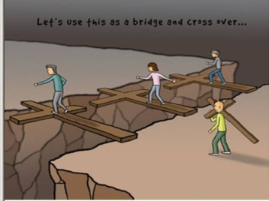
In a playful way this picture says something really important about the most positive meaning of carrying our cross. It illustrates the mysterious truth that the cross can, in some way, help us to bridge un-bridgeable gaps. There are multiple understandings of this: it might mean bridging the gap between the innocent and the guilty, as it happened to the thief crucified with Jesus. It might mean bridging the gap between the powerless and the powerful, as it happened to the centurion who witnessed Jesus’ death. For us it might mean bridging the gap between fellow-sufferers, bridging the gap between different cultures, bridging the gaps that society erects between people and groups of people, bridging the gap between colours and creeds, between the haves and the have not-s. The Cross is the place where Christ draws all to himself and as his followers we are called to do the same. The Cross maybe an offence, but it is not there to divide us, it is there to unite us even over the deepest human schisms.

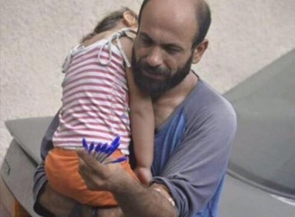
And finally a picture to bring us right up-to-date, a picture that doesn’t even show a cross, but it is about a way in which taking up the cross is understood the ‘Simon-way’. That is, Simon of Cyrene, the person bearing some one else’s cross. The photograph shows Abdul Italim Attar, a desperate Syrian refugee holding his little daughter selling pens in the Lebanese capital Beirut for his and his family’s survival. A couple of weeks ago the photograph went viral on social media after an Icelander, Gissur Simonarson posted the original tweet. This moved its viewers to a global fundraising campaign, which, at the point I’ve found the picture on the internet, has already raised $200,000. In our age of instant communications it becomes possible for us to take up the crosses of others from the other side of the world. When Attar was told about the money, he was overjoyed and said that it would be used to set up an educational fund for Syrian children and for him to return to Syria as soon as it became possible.
My prayer is that, as we reflect on these images further we may be helped to understand more deeply how to take up our cross and each others’ crosses and that we may gladly, courageously and joyfully follow after our Lord Jesus Christ as we do so.

