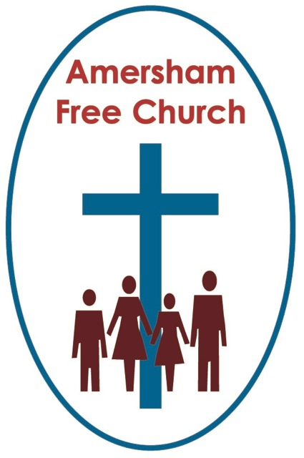
2nd August 2015
John 6.24-35

Bread of Life

Lord God – our prayer is that the written word will point us to Christ, the Living Word – so in his name we pray and for his voice we listen. Amen.
A friend of ours down in Somerset works as a Life Coach. She is a thoroughly charming lady and regularly asked us over to her cottage for dinner. Occasions we really enjoyed. But the thing was this – because of her background in nursing and counselling she seemed to ask the most innocent of questions that would open up a conversation that went to the profoundest of places. One of her most poignant to me – at a time when I was putting on a few pounds and just before we tucked into the delicious meal she had prepared was – and Ian, what would you say is your relationship with food? It flustered me a little and I sort of knew that any answer I gave just wouldn’t cut the mustard!
Well in today’s gospel Jesus talks with the crowd about their relationship to bread – not that baked everyday in the family oven but their relationship with him, God and faith – all wrapped up in the image of bread – the Bread of Life.
After the Feeding of the Five Thousand Jesus retreats to the opposite side of Lake Galilee, to Capernaum but he is not left alone for long. Word gets out about his whereabouts and the crowd catches up with him
Read their encounter and it doesn’t sound as if Jesus is all that pleased to see them. He actually chides them about their motives accusing them of treating faith as a side show.

This is what he says: In very truth I tell you, it is not because you saw signs that you came looking for me, but because you ate the bread and your hunger was satisfied. You should work, not for this perishable food, but for the food that lasts, the food of eternal life.
Now in a Life and Faith group that may prompt a discussion question about whether or not Jesus was therefore interested in poverty, physical hunger and the marginalisation of the poor. Is this verse proof that the gospel is exclusively spiritual?
Well put the whole story together and surely we see in the Feeding of the 5000 and the healing of the lepers a Jesus, who in the words of an Iona hymn, ‘feed their mouths as well as preaching’ – so putting it bluntly I don’t think today’s lectionary reading puts Christian Aid out of business.
So why does Jesus get so exasperated with crowds like this one?
Isn’t it because he was actually disappointed they didn’t want more. Their questions seemed to focus on the temporary and immediate yet he wanted them to go deeper and search not just for a lunchtime sandwich but for the sort of bread that would sustain a lifetime of faith.
They kept asking for a sign yet missing that Jesus was himself the sign.
So he says: I am the Bread of Life and in doing so answers their question at a far deeper level than they ask.
Instead of going for the immediate and superficial Jesus wants them to ‘work’ at this faith – what were his words: You should work for the food that lasts.
Last summer we spent a day in Geneva en route home. Before making our way to the airport we stopped off at the city park and looked at the Reformers Wall. Huge statues of Church reformers like Calvin, Knox and Zwingli whose message was basically faith cannot be earned or worked for but is a real gift from God to be received with open hands.
So what could Jesus be meaning here about ‘working’ for this eternal life?
I don’t think this is, actually, about earning a place in heaven but rather a way of using the idea of working hard as that which you’ve set your heart on, the goals you are striving for, the effort we might put in to a spiritual quest.
It really begs the question – how important is the spiritual in our lives?
Well I guess our presence here this morning indicates a sort of answer!
The truth is faith isn’t easy. There are questions and conflicts – at times it can take a lot of work and effort to nurture faith.
Sometimes I’ve been on weekend retreats and the leader has reminded us of that. Because it’s perhaps easy to caricature Quiet Days, Retreat Weekends, Church Services and even just being a Christian as something that’s a bit of a soft option, ethereal in nature and a bit of a breeze in practice.
Yet the reality is if you want faith with integrity you have to ask difficult questions and if you want faith in action you have to put real effort into an ethical and compassionate lifestyle.
Work at it, says Jesus – it won’t just fall into your lap.
All of this means that church must always be more than a club and faith must spill out into Monday as well as Sunday. We need a spirituality that fits the modern world and makes a connection between faith and work life, faith and family, faith and church, faith and ethics – even exploring the connection between faith and religion.

When Jesus asks us to work at this faith isn’t he just urging us to put faith at the centre of our lives so that it forms us into the person we are and motivates our goals and ambitions.
To help us in this quest for a deeper, more focused spirituality Jesus talks of himself as the Bread of Life.
Bread – a food staple then as now. Something so basic that we take it for granted in the everyday but run out and we soon miss it.
Commentators – fluent in biblical language and metaphor tell us that the image here is very elastic – sounds like bread made using the Chorley Wood method – that Jesus is himself The Bread of Life yet he also offers this bread to the world.
The last twenty years has seen global communication develop faster than ever before – primarily through the internet. Before then every generation seems to have tried to communicate faster than the one before. At one time we lit a beacon, then we sent a letter, telegraphed a message, spoke on the telephone and now we type an email or send a text.
In the time of the gospels you sent a messenger. If a king, a ruler or a leader wanted to communicate they sent an emissary, a messenger – someone who would personally communicate their words.
And so Jesus says in today’s passage: This food – he’s talking of the Bread of Life – the Son of Man will give you, for on him God the Father has set the seal of his authority.
Jesus is both God’s messenger and God’s message to us. He is The Bread of Life and yet he also wants to give us the Bread of Life.
Perhaps we can begin to understand that conundrum with an appreciation that Christianity isn’t so much a rule book but a relationship.
This quest for a deeper faith and a sustaining spirituality isn’t nourished by a constitutional approach. We can’t look at Clause 4 subsection b to find out how to forgive or face life with an illness. There are no set answers to learn by rote that will ensure our prayer life is vibrant or the relationship with our family compassionate.
Religious legalism is actually an easy option but we should never confuse it with the Bread of Life.
If Jesus was the Bread of Life and wants to give us the Bread of Life then doesn’t that mean something of the life, character and message of the Lord Jesus Christ would do well to live in our hearts and inform our minds.
An old gospel hall hymn puts it this way: Let the beauty of Jesus be seen in me.
So perhaps it’s worth ending where we began and asking ourselves my friend’s question: What is our relationship with food – in this context with bread – The Bread of Life.
What is our relationship with God?
What sustains us?
What can nourish us?
What motivates and inspires us’
Jesus longed for the crowds to ask these sorts of questions because he knew that a sustaining spirituality needed to be worked at.

I am the Bread of Life, he said, whoever comes to me will never be hungry, and whoever believes in me will never be thirsty.

May it be so, in the name of the Father, Son and Holy Spirit. Amen
Amersham 1st August 2015

