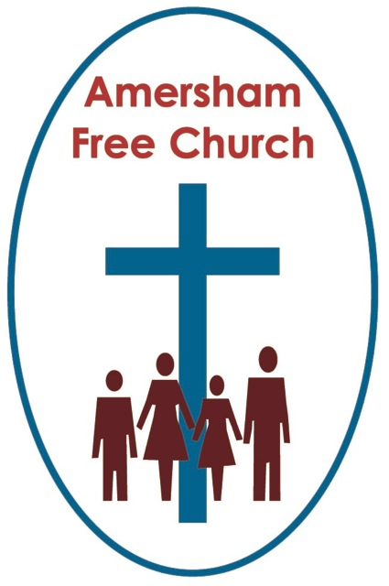
19th July 2015
Jeremiah 1.1-10
Luke 3.1-20

Jeremiah – a Reluctant Prophet

Gracious God – we open the bible and long to receive your word – open, we pray, our minds and hearts to receive that word with all its comfort and in all its challenge. Amen.
In any walk of life there are usually characters that swim against the tide – loose canons. They are a committee chairman’s nightmare – but for all that they often offer a valuable alternative viewpoint that we need to hear.

I’ve no doubt that Baptists and Congregationalists were viewed as the awkward squad by 17th and 18th Century Anglicans.

In the world of faith Dietrich Bonhoeffer certainly swam against the tide of Nazi propaganda – a Lutheran minister who dared to speak out against the Reich. He could have stayed in America – and many of his friends urged him to do just that – but he returned to his homeland with the express intention of opposing what he saw as a national evil.

Jeremiah – our subject this morning was also a man of faith who dared to criticise the state. He was a prophet who spoke up for God. He was an unpopular prophet with an unpopular message.

Let’s Set the Scene.

Here’s Jeremiah’s C.V. He was the son of Hilkiah and his family lived at Anathoth – about 3 miles north of Jerusalem. Being a prophet was a long term calling for him and he served in that ancient Jewish office for 40 years. He started in the 13th year of King Josiah – that was 627BC and he went on speaking out until the destruction of Jerusalem and the beginning of the Exile.

Jeremiah has something of a reputation as a Prophet of Doom. His were more sermons that disturbed the comfortable rather than comforted the disturbed.
So his message in today’s reading is – God says, I will pronounce my judgements on my people because of their wickedness in forsaking me, in burning incense to other gods and in worshipping what their hands have made.

Obviously Jeremiah wasn’t interested in popularity ratings – number one of his list of priorities for prophets was this – tell it like God wants you to.

Now some in his profession took another view and urged the leaders of Judah to avert national humiliation by forming an alliance with Egypt.
Others looked for superficial solutions – they wanted to paper over the cracks – treat the symptoms but ignore the problem. Jeremiah isn’t one of them. He declares that Judah deserves invasion even exile – the people have sinned and turned their backs on God – they have broken the Covenant they made with God – what was coming to them was just and fair.

The old Baptist Preacher from Manchester, FB Meyer describes how whole families got involved in the idolatry of Jeremiah’s day – he writes, In the streets of Jerusalem the children were taught to gather wood, whilst the father’s kindled the fire, and the women kneaded the dough to make cakes for Astarte.

Astarte and Baal were idols worshipped by Jeremiah’s fellow countrymen and women.

You see if there was one thing that marked Judah out in those distant days it was their monotheism – a belief in One God. That’s part of the Ten Commandments. It’s part of God’s revelation of himself. He is One God. He alone is to be worshipped. No idols.

As a nation they had not only forgotten that but they had quite deliberately gone against it – and Jeremiah told them so.

But his message wasn’t a hopeless one – not at least in the long term. For although he believed and preached that Jerusalem would fall to the Babylonians – modern day Iraq actually – he also believed that in the decades that followed the people would return – it was the concept of a remnant – starting over, but this time with a smaller group who had learnt the lessons of history.

Short-term destruction. Long-term restoration – that was the message from Jeremiah.

So we’ve Set The Scene.

Now how did he Hear His Call?

Well Jeremiah 1 verse 5 has that very memorable and deeply significant word from God: Before I formed you in the womb I knew you, before you were born I set you apart; I appointed you as a prophet to the nations.

Isn’t that a strong verse of scripture – I appointed you to the nations. Something for Jeremiah to cling to when he read his opinion poll ratings in the Jerusalem morning Post.

When I applied for the Baptist Ministry I went through six interviews before being accepted. I remember the last one was a bit like going on Mastermind. I was marched into the Pastoral Studies room at Spurgeon’s College and had to sit on a solitary chair – actually it wasn’t black or leather – on a stage whilst sixty members of the College Council fired questions at me. I’m told they do things differently these days!

I don’t resent any of these interviews – they were all designed to answer the question – did I feel Called to be a minister. Called by God.

And that sense of calling, of course, isn’t limited to ministers. I suspect, quite rightly, that many of you would want to say to me that the reason you are a elder, or that you’re involved with Traidcraft, or you lead a Life adn Faith Group, or you have taught Junior Church – or that you faithfully work behind the scenes quietly getting on with the tasks that need doing – is that you are fulfilling your calling too. God has given you certain gifts and along has come opportunities to use them for him – so you’ve step into that gap or been elected to that office. Each of us has a calling.

Well, yes we do, but in verse 6 Jeremiah objected to his - he says, Ah, Sovereign Lord I do not know how to speak, I am only a child.

Here Jeremiah pleads his age – I’m too young, he says.

Verse 7: But the Lord said to me, Do not say I am only a child, You must go to everyone I send you to and say whatever I command you.

Jeremiah felt inadequate, he wasn’t from the Jerusalem metropolis, he lived in a village out in the sticks. And he was young. But God still chose him.

Interesting to note that Calvin was 24 when he wrote his Institutes, which helped bring about the Continental reformation of the church. And John Wesley, just 25 years of age when he inaugurated a system that eventually led to the creation of the Methodist Church.

Jeremiah was chosen and commissioned by God, and so are we – as I used to sing – you might have done too, in Sunday School There’s a work for Jesus none but you can do. Whether we are old or young, God still calls.

Setting The Scene
Hearing The Call, and thirdly this morning:
Preaching the Message

Jeremiah was anxious about this – what he should say and how he should say it. In verse 6 he had already complained ‘I do not know how to speak’.

Verse 9 gives us this assurance in response: Then the Lord reached out his hand and touched my mouth and said to me, Now I have put my words in your mouth….

A modern day prophet, preacher and Christian isn’t called upon simply to give a personal opinion – I mean that is obviously what we partly do – but essentially Christianity isn’t about my opinion but about God’s revelation. God has put his words into our mouths – through scripture. This is God’s word to us; it’s the way he’s revealed himself to us – through the life of Christ and the message of the bible.

I can’t go around saying envy is fine because the bible says it isn’t. I can’t go around saying holding a grudge is OK because that’s not the way Jesus lived.

This way of thinking doesn’t fit well with our postmodern age – where religion, faith and belief are often thought of as being purely a matter of personal choice.

Then the Lord reached out his hand and touched my mouth and said to me, Now I have put my words into your mouth.

Those words are not always in tune with our culture. Putting God first, listening to his word and speaking his word often means that we are called to be counter cultural. Just like Jeremiah we sometimes have to speak from the margins of our society – almost as outsiders.

What should I say Lord – that was Jeremiah’s question – God’s answer was – speak my words – however they offend and run counter to the trends of the day – speak my words.

Well there we must end this sermon about a reluctant prophet – he preached a message from God, because he heard God’s call and shared God’s word.
May that courage and conviction be ours this week as we seek to live out our faith in prophetic words and actions – in the name of the Father, Son and Holy Spirit. Amen
Ian Green Amersham 16th July 2015

