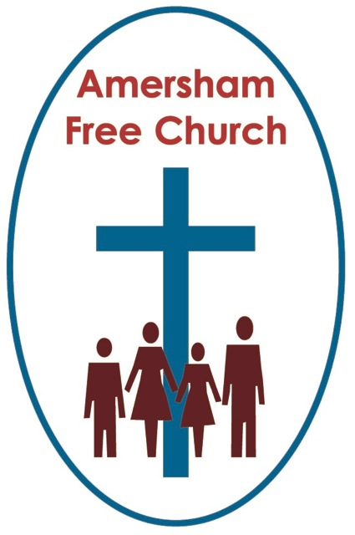
Psalm 24
Luke 24.36-53
17th May 2015

Reflecting on Ascension

Gracious God – we open the bible and long to receive your word – open, we pray our minds and hearts to receive that word with all its comfort and in all its challenge. Amen
Erna and I were busy on Thursday. Forty days after Easter comes Ascension Day and St Michael’s, now in vacancy, invited us to pop over the road and preach at their morning and evening services.
Ascension hymns explore themes of endings, new beginnings and kingship. Luke is so taken with the idea of Ascension that he ends his gospel with it and starts Acts by retelling it. For him it seems to have been a seminal moment that looked, like the Roman god Janus, in both directions, both back to the past and on to the future in that it Ascension signals an ending and a beginning.
There is, I think, an inevitable sense that the Ascension is a letting go. These forty days since the resurrection seem to have been precious. Broken relationships between Jesus and some of his disciples were healed during that time. Slowly the narrative of the cross was beginning to be grasped as Jesus talked it through with confused disciples.
Yet, don’t you get the impression that this gap between resurrection and ascension was viewed by everyone as a bonus time – days to be cherished because they were so unexpected. But they had to come to an end and at the centre of Ascension there is that inevitable letting go.
I rather like the story of the Baptist Minister at Hebdon Bridge in Yorkshire, Revd Dr John Fawcett. He’d been pastor of that church for seven years and then a call came from London. Carters Lane invited him to be their minister. So he preached a farewell sermon in 1772 and next day his goods and chattels were loaded onto a wagon for the long journey down south. His congregation was so upset as they started to wave him off, so much crying – so the story goes, that Fawcett just couldn’t bear to say goodbye! Everything was offloaded and put back into the manse, and five years later, in 1777, a bigger church was built for him and his growing congregation. With that experience behind him it’s not surprising that Fawcett penned the hymn: Blessed be the tie that binds our hearts in Christian love.
Yet saying goodbye cannot always be avoided.
Some goodbyes remain painful to us forever as in a death in the family or a breakdown of a relationship.
Other goodbyes, although painful at the time, act as gateways into new opportunities. Parents and teachers know their job is done when the child or student is confident enough to walk away and take the next step of the journey independently.
Part of the Ascension story is about saying goodbye.
Now, as I’ve reflected on the story this week it’s struck me once more just how brief was the life of Jesus. Like Kennedy, Luther King or the Princess of Wales his was a life cut short. We sometimes talk of him being around thirty three at his Ascension. In many ways it verges on the incredible that after such a short public ministry of just three years he left enough of a foundation upon which Christianity has been being built over these last two thousand years.
Perhaps as we read of his saying goodbye we ask the question; couldn’t he have done so much more if he had lived just a little bit longer?!
And that, in part, may prompt us to question an idea I grew up with – that Jesus, in his humanity, has experienced all of life – and that whatever we are going through Jesus has gone through it before us.
Well, that simply cannot be true. Jesus didn’t grow old. We don’t think he ever got married – despite what Dan Brown wrote in the DeVinci Code! And maybe most frustratingly of all – Jesus didn’t live long enough to experience the institutionalised church, he never voted in a Church Meeting or was included on a coffee rota!
What Jesus gave us was rarely the specifics of a religion but the broad brush strokes of faith. Read the Sermon on the Mount and the themes are huge and take a lifetime to work through. Be touched by the stories of his encounters with people on the margins and that inspiration can go deep into our hearts and guide us in our own relationships and aspirations.
One of the most influential books I’ve ever read is called Confessions of a Liberal Conservative by John Hapgood, a former Archbishop of York. In it he talks of what it might mean to be made in the ‘image of God’. He says that for him it means being a thinking person, a questioning person, a growing person. Someone who doesn’t look for neat, water tight answers in the bible.
So many of the issues of our day were never on the table in Jesus’ time. We might struggle with macro-economics and what it means to live this side of the 2008 crash; we might want some moral guidance on euthanasia or having a nuclear deterrent.
Hapgood, rather provocatively says, it’s actually blasphemous to think of the bible as a closed book containing all the answers. To think like that is to deny the image of God in us – an image that prompts us to continue this evolutionary process of thinking, exploring and developing – for ours has to be a living faith made relevant for a modern age.
So the challenge, it seems to me, is to take these broad brushstrokes of faith – those mainstays of the gospel such as the command to love God and serve neighbour – and work hard at applying what that means for us in 2015, living in Amersham, in my street, part of my community, family and church.
So as I’ve pondered Ascension this week I’ve been drawn to three ideas. It was a letting go – and that can be a positive experience. Secondly it highlights just how young Jesus was when he died so we who might live longer than him and in a different age need to work hard at applying his teaching to our pilgrimage of faith.
And thirdly, reflecting on the words of Luke I just love the idea that it was whilst he was blessing them that he was taken from them. It was the last act they witnessed – his blessing.
I recall two blessings that have been given to me – and they couldn’t have been more different.
On the final morning at Theological College the faculty lined up outside chapel to say farewell to us individually. I got to the end of the line and a tutor – not known for his pastoral sensitivity said: Ian, you’re going to be an Assistant Minister is that right? Yes I said, hoping for some pearly words. Well, just remember, he continued that half of all assistantships fail. Goodbye!
Well it certainly made an impact! Actually I had five wonderful years as an Assistant Minister.
A much more precious blessing came to me as I visited my grandmother for the last time. We had always been tremendously close and even though she could hardly speak as she held my hand the very last words she ever said to me were ‘thank you’. One of the most precious moments of grace I’ve ever encountered.
Our words of support and our faithful encouragement of each other can be a rich blessing and one of the most important gifts we can ever give one another.
For these disciples it meant they went back into Jerusalem – a city in which they had experienced so much pain and disillusionment – yet we sense they went back hope-filled because they had received Jesus’ blessing.
Go this week back to you homes, your work, your family – go back to the challenges and tough assignments that might have come your way – go back to the joys that you are looking forward to – and go back knowing that God offers us his blessing – his blessing of peace, strength and hope for another week.
May that be our experience of the Ascended Jesus, in the name of the Father, Son and Holy Spirit. Amen
Ian Green, Amersham, Ascension Day 14th May 2015

