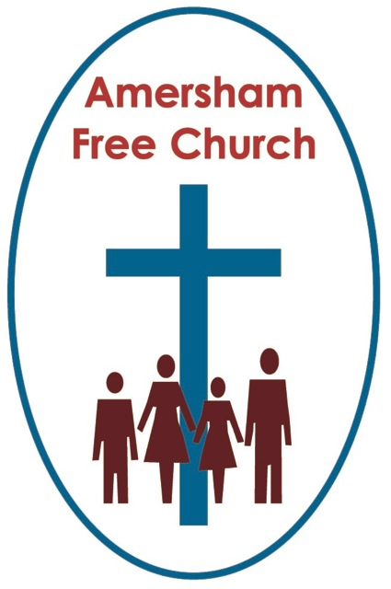
Acts 5.1-19
Luke 21.1-4
3rd May 2015

First to the Lord

Gracious God – may your Living Word come to us afresh this morning – so touch, we pray our minds and hearts with your grace and truth – through Christ our Lord and in the power of your Spirit. Amen
We’ve called today ‘Commitment Sunday’ because the Ministers and Elders thought it would be appropriate for us to emphasise this aspect of our pilgrimage together once a year here in church.
Such a focus isn’t exactly new. Methodists hold what they call their annual Covenant Service on the first Sunday of the year and the famous prayer often used on that occasion is printed on the back of our notice sheets today. It begins with these challenging words:
Lord God, I am no longer mine, but yours, put me to what you will... I think we could have spent a whole sermon or housegroup thinking through the implications of praying such life changing words.
And such a focus will probably have come our way in times past too. If married we will have made vows of commitment on our Wedding Day. In our baptism a commitment to follow Christ will have been uttered either by our Godparents on our behalf or from ourselves before we went under the water. The day we became a Church Member we will have promised to serve Jesus in both this congregation and the wider community. And every time we take bread and wine do we not recommit ourselves to God with gratitude for his commitment to us.
During his ministry Jesus invited fishermen and tax collectors to become his disciples with the words: Come and follow me. For Peter and Andrew, James and John leaving their nets and taking this new path was a sign of great commitment.
And such a focus is inevitably part of today’s service because we have just re-commissioned our Elders. Twelve members of the Amersham Free Church congregation who have been elected to serve – usually for a period of three years. Eldership demands commitment. Attending meetings and talking through the joys and challenges of church life, keeping a watching eye on folk from your Pastoral List, turning up for practical duties such as opening the church for Sunday worship, welcoming folk and supporting the life of the fellowship in any way you can.
So in a way it’s really encouraging that three of our newly elected elders have all served before – survived that experience and are willing to give it another go. We are deeply grateful to all our Free Church Elders this morning.
We had two scripture readings on the theme of giving just now.
The first – charting the rise and fall of Ananias and Sapphira certainly has shock value. It reads as if ‘keeping up with Jones’ meant this couple wanted to appear more generous to the early church than was actually the case. They deceived everyone into thinking they had given up everything whilst in reality they had kept a portion back. It’s not that prudence is being criticized here simply their double crossing of the church. As to dropping down dead – that’s probably not in the list of possible persuasion techniques open to modern day treasurers.
I suspect like you I’m more inspired by Jesus commending the widow for giving her mite – one of the smallest denominations of coinage, but given her circumstances this represented a really big offering. It’s from this story that we find the themes of quiet generosity and self- effacing sacrificial giving.
I meet those themes – lived out – here at Amersham Free Church all the time.
As a church community you have been so generous in your support of the Water Aid project, the Christian Aid Mother and Baby Kenyan Appeal and the funding of Vision4thefuture.
I’m sure too that individually you are already considering how to support Nepal after the earthquake via organisations like Christian Aid, Samaritan’s Purse or Rotary.
What inspires me at AFC is there is no sense of compassion fatigue. Part of loving neighbour means practical compassion expressed in generous giving.
On this Commitment Sunday we wanted to flag up to the whole congregation what we said at the recent Church AGM – that our church faces a shortfall of some £20,000 on the General Fund unless our giving increases by some 20%. So today Elders will be giving to folk on their pastoral list a letter from the church treasurer and me outlining the financial challenge before us in 2015. After so many years when we have asked you to support extra projects we think there needs to be an emphasis this year on trying to balance the general income and expenditure of our church.
But, of course, a Commitment Sunday is about so much more than money. Part of our discipleship is to offer our whole selves to God. Up front service – like being part of a Worship Team where there are current vacancies. Behind the scenes service like serving at LunchBreak or Tea at Three. And as we get older and cannot be so actively involved – then our commitment might well be expressed in prayerful support, attending when we can and giving encouragement to those who have stepped up to the mark and followed us in running a project or group that we still hold dear. And of course service outside the church community is also an expression of faith whether that’s sitting on a School Governors Board, working in a Charity shop or serving on the District Council. All of it a response to the grace and love shown to us by God in Jesus – someone we sometimes call ‘The Man for Others’.
One of my favourite pieces of Christian writing is attributed to the 16th century Spanish nun, Teressa of Avila – the choir sometimes sing it in a beautiful setting by David Ogden:
Christ has no body but yours,
No hands, no feet on earth but yours,
Yours are the eyes with which he looks
Compassion on this world,
Yours are the feet with which he walks to do good,
Yours are the hands, with which he blesses all the world.
Yours are the hands, yours are the feet,
Yours are the eyes, you are his body.
Christ has no body now but yours,
Christ has no body now on earth but yours.
That, it seems to me, is the essence of commitment. So that ours becomes not guilt ridden duty but inspired service – offered because of our belief in God; a God whose character is generosity and love.
So when we think of how much to give, how much time to offer, what to get involved with – the question for a disciple of Jesus Christ is never – what’s the minimum.

Instead the examples we follow are those of a widow giving her smallest coin and in doing so gave her all – and of Jesus Christ who on the cross showed us the true meaning of generosity and sacrifice.

We must close.
Some of you are kind enough to give me church magazines from the churches in whose parish you live. I like reading these publications and seeing what the opposition – I mean our friends are up to. And I noticed once that a local diocese was having a stewardship campaign amongst all their churches – they were doing it thoughtfully and prayerfully – seeking to encourage their members to think again about their giving. And the thing that struck me about it was the title of this project – they called it ‘First to the Lord’ - I think it’s a great title – when we think about our list of priorities – God deserves our best.
May it be so, in the name of the Father, Son and Holy Spirit. Amen
Ian Green, Amersham, 2nd May 2015

