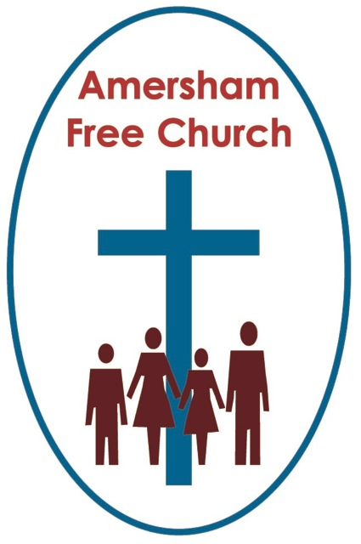
Luke 24.26-48
Acts 3.12-19
19th April 2015

We are witnesses

Gracious God – we open the bible and long to receive your word – open, we pray our minds and hearts to receive that word with all its comfort and in all its challenge. Amen.
It’s been a week full of promises. Promises made to us by politicians and written up in the manifestos each party has launched on successive days since Monday. All part of the unfolding ritual of a British General Election.
The cynic in me has been reluctant to invest too much time into reading these promises. For although I value the democratic process I also recognise that any party ‘campaigns in poetry but governs in prose’. Yet in the end some sort of belief and some sort of trust will surely influence whose name I put a cross against on May 7th.
Today we are still in the church season of Easter. There may not be so many alleluias in our hymns but the Resurrection remains the theme of our lectionary readings and we too are left with questions of trust and belief. What do we believe about Easter and how does trusting in this idea of a risen Christ affect my day to day living?
Well on this third Sunday of Easter we have yet another gospel set as our reading. Over these last three weeks we’ve heard from Mark, John and now Luke.
And we’ve encountered a mass of emotions from the disciples as they struggle to come to terms with Jesus’ death and rising. Just looking through today’s gospel we hear of them being: startled and terrified, incredulous even and men and women who had doubts.
Strikes me the Resurrection was a complicated process. We greet Easter morning with some of the boldest and most triumphant hymns in the book. Yet for the Marys and Peters of the gospels this was an episode just as much about tears, confusion, misunderstanding and fear.
Of course the actual gospels were written decades after that first Easter Day. By the time the evangelists described these events they had come to a settled mind that in some wonderfully mysterious way the living presence of Jesus Christ was still with them – inspiring their service and motivating their lives.
This morning’s set reading has Luke writing with a sense of boldness and certainty which is palpable.
Jesus is back with the disciples at one of those post resurrection appearances. He stands before them, not as a ghost says Luke but a real person and so invites his followers to actually touch him. ‘I’m flesh and blood’ says Jesus and even eats a piece of fish as if to prove his physicality.
All of this is very different to Luke’s account of the walk to Emmaus when the disciples then didn’t even recognise the risen Christ. It also has a different emphasis to other gospel accounts which has Jesus not walking up the stairs and coming into a room through the door but just appearing – ghost like.
In today’s passage, just like the Emmaus narrative, Jesus says that in a way nothing that happened should have surprised his followers. If they had remembered the prophesies they had grown up with from the Jewish Scriptures and if they had remembered his teaching whilst he was with them over that three year period, then his death and rising was surely something they knew was part of God’s plan.
To this, say Jesus ‘you are witnesses’. This is the story, the truth, the reality he asks them to pass on. To pass it on as faithful witnesses to the Resurrection.
It’s something Peter says too in the sermon we heard in Acts 3 this morning. In defence of Jesus – whom we killed but God raised, Peter says ‘we are witnesses of these things’.
Now, of course you can take a number of views about Resurrection.
Taking a hint from today’s gospel one tradition is to think of it as a physical reality. Jesus rose in bodily form and asked his disciples to touch and feel him.
On the Thursday after Easter we were in London at an Orchid Show in the Royal Horticultural Halls. Now truth to tell there are only so many different types of orchid I can look at whilst still remaining interested. So after an hour or so I bunked off and toddled around the corner and popped into Westminster Cathedral – the centre of Roman Catholic worship in England. I caught just the first quarter of an hour of a lunchtime mass and this reading from Luke was the basis of the priest’s homily. He told us he was in no doubt whatsoever that Jesus rose in bodily form on Easter Day.
Another tradition, which hasn’t up to now really been part of my tradition – says Jesus’ resurrection was more spiritual. That it doesn’t matter whether the body came back to life or not – what really matters, and is the very essence of Easter, is that something of the spirit of Jesus Christ lived on in the lives of the disciples.
When I was at college we sometimes had a visiting professor by the name of David Jenkins. He eventually became the Bishop of Durham and in the early nineties he was regularly on TV around Easter saying, in his rather charmingly eccentric way, that this was his belief. He didn’t care whether or not there was a bodily resurrection – what matters is that the spirit of Jesus lived on.
And then, there is the reality that the idea of a young man preaching a message, dying for it and then rising again isn’t a concept unique to Christianity at all but actually one that can be found in many ancient faiths.
This was something of a stumbling block to C.S.Lewis in his agnostic days in Oxford. It troubled him until one September he was out walking with his friend J.R.Tolkien who convinced him that although there were many such stories the one in the gospels was the most complete and truest of them all.
But it seems to me that in a sense the point is not ultimately do I believe in a physical or a spiritual resurrection. Either answer would ultimately be a matter of personal faith and interpretation.
The fact is that unlike the first disciples none of us have actually met with, or claimed we have met with the risen Jesus in a physical and temporal way. That option or possibility just isn’t open to us.
So to what or to who are we called to be witnesses today? What does the resurrection mean and say to us in 2015?
One commentator I’ve read this week has, I think, a really helpful phrase – she says we all need ‘Reminders of Resurrection’.
So as we are reminded of it we become witnesses to it. We become convinced that the living presence of Jesus Christ is active in our world today – so convinced that we put our faith in this Jesus Christ and seek in some small way to be his witnesses.
How can we experience resurrection and the living presence of Jesus? A Jesus we have never seen, heard or touched.
I am reminded of resurrection when I see pastoral care being exercised both within and outside of the church. In the way loving concern and support is freely offered – and so the compassion of Jesus lives on.
I am reminded of resurrection when I see folk campaign for justice and raise funds generously for humanitarian cause – in our own community the Water Aid project along with our fundraising for the Kenyan Mother and Baby appeal means that something of the integrity and generosity of Jesus lives on.
I am reminded of resurrection when I experience worship. People coming together for prayer and praise, for quiet reflection or gathered around a table to take bread and wine. And in the midst there is the sense of a divine presence. At that moment something of the adoration uttered by Thomas when he said ‘My Lord and My God’ lives on.
I am reminded of resurrection when I see service done in Jesus name. When at LunchBreak just a fortnight ago someone came up to me and said these Tuesday lunches, eaten alongside others in friendly companionship just transform his week. In such quiet, dedicated service something of the welcome and hospitality of Jesus lives on.
And I am reminded of resurrection when I am with other disciples and seekers after truth. In the conversation we have, the yearnings and ideals we hold in common and sometimes just in the smile or whisper of a fellow traveller something of the voice of Jesus lives on and speaks to me afresh.
So if you ask me do I believe in the resurrection – I would say yes. And am I a witness to it – well the answer would be yes again. For everyday in so many different ways something of the living presence of Jesus touches my life and makes this world a better place to be.
In the name of the Father, Son and Holy Spirit. Amen
Ian Green, Amersham, 16th April 2015

