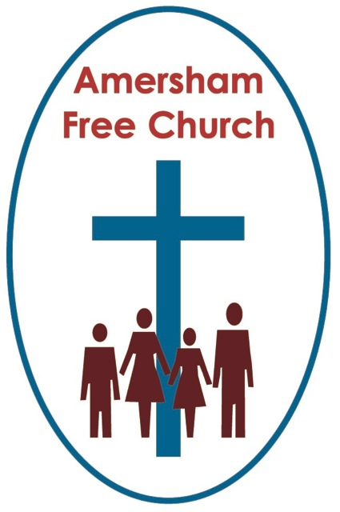
Mark 16.1-8
5th April 2015 Easter Day

Life is Stronger than Death

Gracious God – we open the bible and long to receive your word – open, we pray, our minds and hearts to receive that word with all its comfort and in all its challenge. Amen.
This year the Archbishop of Canterbury’s recommended book for Lent was one written by the former Bishop of Cape Town, Desmond Tutu.
One of Tutu’s most famous sayings goes like this:
Goodness is stronger than evil
Love is stronger than hate
Light is stronger than darkness
Life is stronger than death
I love those words and that hope – they seem almost creedal and I think they also help us on Easter Sunday to define what it is we are actually celebrating today.
Resurrection says to us that Goodness is stronger than Evil.
Of course it takes a certain amount of faith and courage to believe that at times. Events simply pile up on the daily news bulletins, whether it’s the tragedy of the Alps plane crash or the on- going civil war in Syria. It takes conviction and a certain trust in both God and humanity to believe in goodness.
Last Tuesday at LunchBreak we looked at some of the stories behind the statues of 20th Century Martyrs that stand above the Great West Door of Westminster Abbey. Men and women of faith who also believed that goodness is stronger than evil. Maximilian Kolbe – the Polish Franciscan who took another man’s place in Auschwitz’s starvation chamber, Uganda’s Archbishop, Janani Luwum who lost his life because he spoke out against Idi Amin. Lucian Tapeidi, a priest in Papua New Guinea who stayed at his post during the Japanese invasion and lost his life through beheading, and Dietrich Bonheoffer who walked to his execution expressing a hope deeply rooted in Easter by saying: For me this isn’t the end but the beginning.
As his guards placed a crown of thorns upon his head and purple robe around his shoulders it might have seemed to Jesus on that first Good Friday that evil was indeed holding the upper hand over goodness. I suspect it will often feel like that. Yet how small and temporary the misplaced arrogance of those mocking Roman soldiers now looks today.
And yet it is a matter of the will – to keep on believing in goodness. To look for it, nurture it and celebrate it whenever and wherever we find it.
In the Wilderness temptations Jesus had to make a choice between a goodness based on God’s character of love and a sort of evil that pandered only to self interest and the gratification of instant popularity at any cost.
In the wilderness experience we remember at Lent’s beginning, and upon the cross we recall at Lent’s end, Jesus chose to believe that goodness is indeed stronger than evil and on his resurrection day we affirm it once more.
Tutu goes on to say that: Love is stronger than hate. Both, of course, are dynamic and intense emotions but is it really possible that love can win through in the end?
The words of Jesus upon the cross are full of love in the face of hate. He bears the pain yet prays: Father forgive. He endures the ridiculed taunts of a hate-fill crowd yet uses whatever energy he has left not to respond in anger but to entrust the mother he cares for to the disciple he loves.
And then as darkness falls and the body is taken down Joseph of Arimathea – in a gesture of love made at the end of a day of hate, offers his own burial chamber for the body of the crucified Jesus.
Three days later the women make their way to the garden tomb to anoint that body with herbs and spices – an act of loving homage interrupted by news of resurrection.
Easter has love at its core.
Last week the choir reminded us through the music of Stainer and the words of St John that: God so loved the world, that he gave his only begotten son.
Goodness is stronger than evil
Love is stronger than hate ....
The third line we consider on this Easter Sunday morning runs:
Light is stronger than darkness.
In the northern hemisphere the light we celebrate at Christmas is one that pierces the darkness and the gloom – as dusk gets ever earlier we fill our churches with candles and sing carols that make our hearts glad even at the bleakest time of year.
Easter is different. The clocks have sprung forward and the days continue to lengthen. Spring and summer are before us and there is a sense that in the natural world ruled by light – life is returning. April and May are months of hope.
And the gospel accounts of Easter have a sense of light about them too. ‘At dawn’ the women come to the tomb.

If crucifixion was about the earth being shaded in darkness, resurrection is all about daybreak.
One of my most vivid memories as a teenager was travelling up to Scotland with my church youth group in two mini buses convoy style. We drove through the night and reached Edinburgh in the early hours. The dawn came almost imperceptibly. It was never night and then day – the shift was more subtle. Not an explosion of light but a growing sense if it.
I sometimes think we expect too many fanfares when it comes to Easter and Resurrection. In reality our experience of emerging from deep bereavement, say, into a more settled place can be slow and gradual. Problems and challenges rarely disappear in a puff of smoke because hope and resolution often needs to go through phases and work itself out in a process.
But when the dawn begins to break, when the light replaces the dark then maybe something of the resurrection is touching our lives and giving us hope, new perspective and fresh strength.
To live as Easter Morning Children is to live in the light of the resurrection, to be people of hope – pray even, yes even in the night time of our despair.
And that last line in Tutu’s verse that I believe fits so well with Easter Sunday worship:
Life is stronger than death.
J.P.Phillips called earth ‘The Visited Planet’ – encapsulating the idea that God isn’t just the creator but the active participator in our lives and that in Jesus, this Son of Man, there is a mysterious fusion of the divine and human walking the road from Bethlehem to Jerusalem.
And at every turn this Jesus seems to embrace, celebrate and enhance life in the here and now. Even his resurrection appearances bless events in real time: a meal at Emmaus, a BBQ breakfast at Galilee with the reinstatement of a fallen disciple and comforting Mary in the garden with words of reassurance.
The resurrection simply shouts out that the God we seek to both worship and serve is surly a God who is for us. He is the God who offers abundant life so that this side of the grave we might be people of love and justice, travelling together in companionship because loving God is never a different thing from loving neighbour. And he is also the God who offers us the promise of everlasting life – who spoke in Jesus of going ahead and preparing a place for us, who promised a penitent thief that today you will be with me in paradise.
So in the words of a much loved hymn at the centre of the Easter gospel there is the promise of ‘strength for today and bright hope for tomorrow’.
This is the Church’s resurrection day – a day to celebrate life – the inspirational life of The Lord Jesus Christ who spoke in parables, whose Sermon on The Mount will take a lifetime to explore, who gave so many people society misjudged a second chance.
The death of Jesus reveals to us an ocean of love and forgiveness.
The resurrection of Jesus offers us a hope-filled way of living for both this life and the next.
Today we blend our hallelujahs with all those who have gone before us and sing God’s praise in a greater light and with Church throughout the world. We sing hallelujah because in the life, death and resurrection of Jesus we see that:
Goodness is stronger than evil
Love is stronger than hate
Light is stronger than darkness and
Life is stronger than death.
May it be so in the name of The Father, Son and Holy Spirit - for:
Christ is Risen – He is risen indeed – Hallelujah!
Ian Green, Amersham, 1st April 2015

