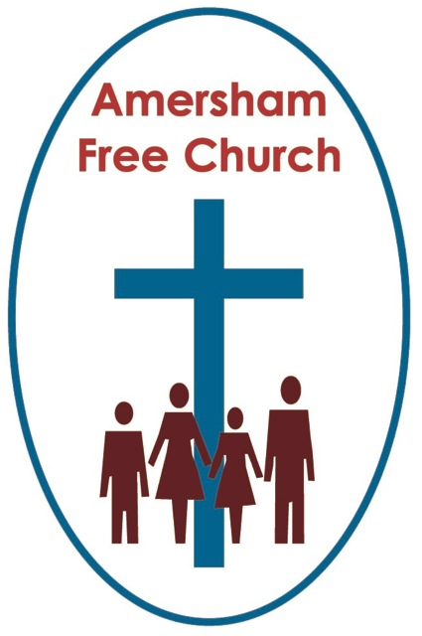
Mark 1.21.28
February 1st 2015

He Spoke with Authority
Gracious God, we thank you for your word in scripture and made flesh in the Lord Jesus Christ. Help us now to catch your voice and speak, we pray, to our hearts and minds. In Jesus’ name. Amen.
As I caught one of the headlines on the BBC News website this week I wondered how it might be received. It proclaimed we had reached that pivotal moment of just 100 days until the General Election! Already there’s been much talk of what kind of TV debates might be coming our way.
I remember writing an essay at school debating the merits of Churchill’s one liner: Democracy is a bad form of government until you consider the alternatives.
So we have 100 days in front of us full of debate and controversy – and that is a bit like Mark’s gospel – set for this lectionary year.
The issue Mark particularly wants to explore with us is; The Authority of Jesus. He is presented by the evangelist as someone who spoke truth and he did it in a way that made his audience sit up, listen and come away thinking this is a new kind of preacher who seems to simply cut through the red tape and pedantic interpretations of the traditional scribes – and let’s face it, everyone loves something different from the routine.
But the point Mark is making is that Jesus doesn’t seem to be a very comfortable preacher. His ‘authority’ will be contested – put simply many within his own tradition didn’t like what he was doing to their well thought through interpretations of the Torah. So Mark’s gospel is full of contests and controversies between Jesus and the religious hierarchy ranging from how to view the Sabbath to what the Temple was really for. And Mark writes it down and ends up presenting us with a picture not of a passive Jesus effortlessly preaching a well received gospel – but of Jesus who challenges the system and is up for a fight with his words and yet the way he taught and the content of his teaching seemed by many to have that ring of truth.
I wonder if you are a person who loves a good argument? Or do you shy away from them because the actual process of debating something with passion troubles you?
We were split on this in my family when I was growing up. My father and us three boys could go a full two hours around the table after Sunday lunch discussing and debating a wide range of topics. I sometimes wonder if my Dad played Devil’s Advocate just to get us going. But my Mum chose not to join in – she simply wasn’t that personality type. So, after a few minutes she’d guess the way it was going and get up, clear the plates and say ‘Well it’s not worth arguing about’ and then retreat to the kitchen.
It’s hard to get the balance right but truth is rarely arrived at passively and isn’t inevitably delivered in a soft and gentle reasoned voice. Many of the principles and practices we hold dearest have been the result of robust debate and challenging controversy.
That was evident on Monday at York Minister as Libby Lane became the Church of England’s first women bishop. It looked as if she might be totally squashed as practically all the other bishops in the country so enthusiastically gathered round her to share in her consecration. Yet even after decades of debate and controversy one loan voice still found it necessary to raise an objection at the service.

This summer the United Reformed Church is recalling last year’s General Assembly to re-consider once again the issue of same sex marriage and whether or not it merits a place in churches like ours. A subject that brings out a vast spectrum of viewpoints held by deeply sincere and committed people.
Jesus, says Mark, was no stranger to controversy and a good fight with words was often his way.
In today’s reading Jesus is deep in the centre of controversy as he exorcises an evil spirit from a man attending synagogue.
In Matthew the first episode in Jesus’ public ministry is his Sermon on the Mount, in Luke it’s his sermon at Nazareth, in John it’s the Wedding Feast at Cana – but here in Mark the first thing the evangelist records him doing is bringing healing and wholeness to a man who had been possessed by an evil spirit.
Sometimes what we do first sets the scene for what follows.

Not many of us will forget, I think, that upon being elected Pope Francis’s first action was to ask the crowds in St Peter’s Square to pray for him. It demonstrated the sort of humility that seems to have now become his hallmark.
Now, if you read Mark’s gospel in one go you might be struck by just how many exorcisms he includes – one bible commentator says this gospel is simply ‘awash with the demonic’. And we may have a variety of views about what the first century world thought of as demonic and how it might appear in someone’s health and how we might diagnose those symptoms today.
But what is clear, I believe, is that Mark wants to use this story to tell us that this Jesus confronts evil. This Jesus wants to replace evil with wholeness. This Jesus wants to bring liberation and new beginnings to this man whose life has been so pulled down by oppression.
In the narrative the evil spirit attacks Jesus because it seems to know what is about to happen. It says ‘why couldn’t you have just left us alone’.
We probably all know that well known adage: evil flourishes when the good do nothing.
Jesus wasn’t prepared to do nothing – to leave the man and the evil spirit alone.
So there is emerging from this story a very pro-active Jesus. One who wasn’t afraid of controversy, one who crosses boundaries that others have set up – boundaries that in a sense are a demarcation of their power or control – in place of manipulation this Jesus seeks to bring to the possessed man dignity, freedom and wellbeing.
This Christian faith of ours is so much more than a private walk with God. Taking our cue from Jesus we too need to be a people who cross boundaries – prepared to challenge injustice.
18th century Christians like Wilberforce challenged the slave trade. 20th century Christians like Archbishop Oscar Romero challenged the political oppression of South America through the Liberation Theology movement. Many 21st Century Christians like us challenged the notion that inequality was inevitable with the Make Poverty History campaign at the beginning of this new century.
Now, of course, the issue we keep returning to in this morning’s reading is this sense of authority which was possessed by Jesus. And quite naturally it leads us on to identity - begging the question who was this teacher, healer and prophet who spoke and acted so differently from those around him.
The bible commentators tell us that Mark never gives clear answers to this question in his gospel. Instead he describes him as the one uniquely commended and empowered to declare and institute the Kingdom of God. And in doing this Jesus will be intrusive – he will challenge the established order and turn upside down some of the traditional thinking about Messiahship. He’ll constantly preach a message of liberation because he wants to set people free from outmoded religious dogma or oppressive secular prejudice. He’ll cross the boundaries and articulate that God’s intention for the world is wholeness, peace, love and justice.
This will be the Jesus, Mark is saying, who will both teach us and show us what the Kingdom of God looks and feels like.
And the ultimate question of his identity will be focussed at the cross. As he meets evil with love and power with peace Jesus shows us what God is like. Indeed the only time in Mark’s gospel when a description of Jesus isn’t challenged or refuted – the only time – is when the centurion says at the cross ‘Surly this man was the Son of God’. It’s at the cross that we see something so profound about God in Jesus.
This Jesus, says Mark – both spoke and acted with authority.
Well today is the fourth Sunday in Epiphany – a season in which we celebrate the way God becomes visible and known to us in the world. Not just the way his presence was manifested two thousand years ago in the gospel stories but the way he becomes known to us today.
Our task is to live out this faith so that something of the Jesus story lives on and comes alive in our own life, church and community.
That happened, I think, in a rather special way last Sunday.
Quite a large group of folk from this church who had just shared in a united service at St John’s made their way over to the Mosque in Chesham. Our Muslim friends had invited anyone to come along and see their place of worship and they extended that invitation in the light of events in Paris last month.
It was a precious and profound moment for me to see members of my own congregation – secure and vibrant in their own faith – engaging in conversation with Islamic disciples in Chesham. During that brief half hour with them we talked of peace, mutual respect and how both our faiths commends us to work for the good of others. We laughed together about each others’ traditions and it wasn’t just the ground on which we stood that was holy but the space and relationship between us.
I dare to believe that in such a moment of encounter – a moment so opposite to seeking power or being ruled by dogma – in that moment of peace something of God was made manifest among us.
Epiphanies still happen and when they do we feel once again the authority of Jesus made known for our day and time.
May it continue to be so in the name of the Father, Son and Holy Spirit. Amen.
Ian Green Amersham 30th January 2015

